Private Andy Drummond (A KIA)
The comments which follow are some recollections on my experience in SVN as a platoon commander as they relate to Private Andrew Drummond accidently killed on 30 May 1969. They will be added to by other platoon members.
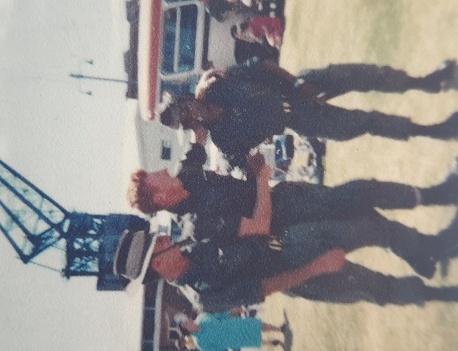
Andy was an indigenous man from Carnarvon WA. He was a volunteer regular soldier, and he held the position of platoon scout, one of three in the platoon. He won that job, considered the most dangerous because of his natural ability. He had a wonderful awareness of his surrounds, combined with eyesight which was above and beyond. This combined with an ability to note signs left by other individuals in the jungle, he was a stand-out. He joined the 5th battalion (5 RAR) in Holsworthy in western Sydney, training with the battalion as part of 4 Platoon in preparation for our deployment to South Vietnam in Jan 1969. He was about 28 years old at that stage, a little older and wiser that almost all the platoon. He had a dry sense of humour and was respected as he kept an eye on the boys when they went to town. As a non-drinker, he often looked after the wallets of those he considered needed that assistance. He had a word written on his bush hat ULURU, which always puzzled me. One day on parade I asked him what it meant. He answered with a grin that “we know what it means, and it is up to your mob to find out”. That was typical of his sense of indigenous humour which caused the platoon to burst into laughter. I shook my head and moved on, not offended as I got it.
Andy (on right) on departure for SVN.
On operations Andy fulfilled his job well. It was not unusual for him to halt and call the section commander forward to see what had alerted him. We never unknowingly walked into an ambush, a tick for Andy and the other scouts. I will enclose stories from other platoon members who were closer to him than I was as the Platoon Commander.
On Operation Twickenham 2, Andy was killed. It was 30 May 69. The platoon as part of B company was tasked to clear a section of the Nui Thi Vai hills which are close to the Task Force Base at Nui Dat. My Platoon was given the job of clearing one side of a large hill which was part of the system. I decided to clear the jungle covered area top down for obvious reasons. 1 Section with Andy as the scout took the lead. The section commander CPL John Hinchey was on R & R leave, his job now the responsibility of the Section 2 IC, Cookie. After about 300 metres Andy stopped and called me forward. I moved forward to see what bothered him. He said, “Skipper, can you see the doorway down there?” I looked hard but could not see the dark shape in the thick jungle as a doorway. I spoke to Cookie and decided to continue the move down the hill on high alert. I directed 3 Section to move to the left to provide a larger front should we take fire. After about 100 metres two shots rang out. I responded by calling for the machine gun in the left section to commence firing. After about 5 seconds Cookie shouted, “I’ve shot Andy.” From here it was all downhill. The medic doubled up to me and Andy who was lying on the ground with a terrible throat wound amid a lot of blood. The medic looked up at me and shook his head. Death came quickly.
We dusted Andy’s body off with great sadness and continued with the task. A sad day.
We never ever saw Andy again nor marked his death as an individual. There were no ramp ceremonies in those days, only our thoughts on days of reflection. The boys chipped in and purchased a bust of him which is in Carnarvon. I think it is the only one.
Lest we forget.
Moose Dunlop OAM, AIMM

