The first three pages of this document form an article written for the First Term 2025 edition of *The Modernian,* the newsletter of the Perth Modernian Society. The remainder of the document consists of the research material that supports the article.

<https://www.perthmoderniansociety.org.au>

**Clarence Arnold Manuel**

**Perth Modern School Student 1912-1914**

At 4:20am on 8 August 1918, Clarence Manuel and the men of the 43rd Battalion stood up and walked in heavy fog behind their own artillery towards the German front line east of the town of Le Hamel in Northern France. They were a small part of the largest Allied offensive of World War 1. It was so successful that Erich Ludendorff, the German Chief of Staff, called 8 August the “Black day of the German Army”. The battles that followed, collectively known as the “Hundred Days Offensive”, brought the war with Germany to an end on 11 November 1918.

Clarence was born in Kerang, Victoria, on 8 October 1897 to parents Clarence and Annie. Clarence Sr died in November 1906 aged 37 and Annie in August 1909 aged 39, making Clarence Jr an orphan at the age of 11.

Clarence attended Donnybrook Primary School where John Jones, his maternal uncle and now his guardian, was a teacher. Clarence commenced at Perth Modern School on 7 February 1912 in the agricultural stream. His uncle John was posted to Jolimont Primary School, three kilometres from Modern School.

After three years at Modern School, Clarence left in December 1914 and worked on a farm in South Australia before enlisting in the Australian Army on 25 April, 1916, the first anniversary of Anzac Day. He was staying with another maternal uncle, Fred Jones, in Belair, 10kms south of Adelaide. Clarence’s brother, Roby, enlisted with Clarence and both were posted to the 43rd Battalion, a unit raised in South Australia early in 1916.

On 9 June 1916, the Battalion left Adelaide on HMAT *Afric,* arriving in Southampton on 24 July. After several months of intense training on the Salisbury Plain in southern England, the Battalion arrived on the Western Front in December 1916 and spent much of 1917 bogged in bloody trench warfare.

On 17 February 1917, while the Battalion was in the Armentières area, Clarence was shot in his right wrist. It was a relatively quiet day and he was the Battalion’s only casualty. The wound required medical attention and he was sent to the 3rd London General Hospital in England.

After two months in hospital, several weeks in a convalescent unit and a period of further training, Clarence rejoined the Battalion on 4 August, 1917. During his absence, Roby had been transferred at his own request to the Australian Flying Corps. Roby went on to win two Distinguished Flying Crosses for shooting down 12 German aircraft and finished the war with the rank of Captain.

Clarence’s absence also caused him to miss the Battle of Messines in June 1917; however, he took part as a newly-promoted Lance Corporal in the successful but costly attack on Broodseinde in early October 1917.

Clarence was sent on an NCO’s course two days after Christmas 1917. He returned to the Battalion in January 1918 and was promoted to Corporal. He was given three weeks’ leave in England in February and returned to France in March. A month later on the third anniversary of Anzac Day, the Battalion helped stop the massive German Spring Offensive at Villers-Bretonneux. On 4 July the Battalion was part of General Monash’s spectacular victory at Le Hamel, six kilometres north-east of Villers-Bretonneux, which resulted in a knighthood for General Monash.

Clarence was promoted to Sergeant on 26 July 1918, 13 days before the opening of the Hundred Days Offensive. Tragedy struck on the first day – Clarence was one of three soldiers killed in the Battalion on a day on which 120 prisoners, 25 machine guns and an artillery piece were captured.

Two other students who were at Modern School in 1912 died in the Hundred Days Offensive. Louis Bromham was killed in action near Harbonnières the next day, 9 August. Clarence and Louis were born within three months of each other and were in the same year at school in 1912 and 1913. Arthur Bacon was killed near Bellenglise on 18 September 1918, the last day that his battalion was in action. Arthur had previously been wounded three times: in the face at Gallipoli and again in France, and in his left foot at Ypres in Belgium. He is buried at Jeancourt.

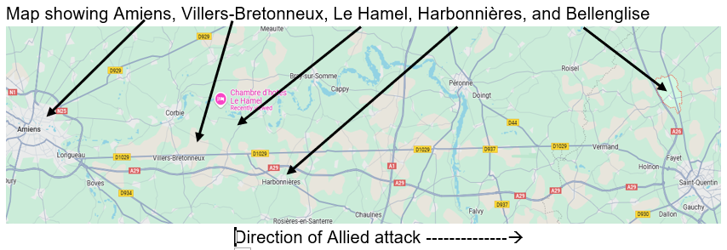

Clarence was 20 years and 10 months old when he died, Louis had just turned 21 and Arthur was six days short of his 22nd birthday.

**LEST WE FORGET**

**References**

Perth Modern School archives

Websites:

AIF Project <https://aif.adfa.edu.au/showPerson?pid=187052>

AWM Roll of Honour entry <https://www.awm.gov.au/collection/R1646469>

AWM Circular <https://s3-ap-southeast-2.amazonaws.com/awm-media/collection/RCDIG1068882/document/5580936.PDF>

Carnamah Teachers (JE Jones) <https://www.carnamah.com.au/teachers?search=jones&page=30>

CWGC <https://www.cwgc.org/find/find-war-dead/results?lastName=manuel&serviceNumber=1727>

Geni <https://www.geni.com/people/Clarence-Manuel/6000000025446450135>

Metropolitan Cemeteries Board

NAA service file <https://recordsearch.naa.gov.au/SearchNRetrieve/Interface/ViewImage.aspx?B=8216052>

PMS Honour Board <https://honour.perthmodern.wa.edu.au>

Red Cross

<https://s3-ap-southeast-2.amazonaws.com/awm-media/collection/RCDIG1051721/document/5639392.PDF>

Victorian Birth Deaths and Marriages

<https://my.rio.bdm.vic.gov.au/efamily-history/677611e759c17025944f1ef6/results?q=efamily>

War Diary of 43rd Battalion, March 1918

<https://s3-ap-southeast-2.amazonaws.com/awm-media/collection/RCDIG1005588/bundled/RCDIG1005588.pdf>

AIF Project (Roby) <https://aif.adfa.edu.au/showPerson?pid=187069>