**HARRIS Allen Dawe RAAF**

**Service Number 407119**

**Enlisted** June 1940 **Last Rank:** Flight Sergeant - Airforce HQ Malta

**Born** Broken Hill 15/7/1913 **Hometown** Cowell

Son of Alfred and Edna Brother of Keith & Jean

**Killed** - Air Operations, flying battle over N-W Europe 15/06/1942

At the time of the war, **Allen Dawe Harris** worked for his parents Mr Alf and Mrs Edna Harris (formerly of Broken Hill and Gladstone), who owned a general store in Cowell. He was well educated, having studied accountancy and had many other qualifications to work as a bookkeeper and clerk. He also worked in this field for other businesses in Cowell. On his application for the RAAF, Harris listed golf, tennis and rifle shooting as sports he played and schools he attended – Birdwood High School and Norwood High School.

Excerpt from Eyre’s Peninsula Tribune 24 April 1941

***Sergeant Observer Allan Harris*** *of the R.A.A.F. who returned to Cowell last week on leave was entertained in the Franklin Harbour Institute on Thursday, 17th April, by the Cheer-Up Society.*

*Chairman of the evening, Mr H Shillabeer opened proceedings. “Allan had just settled into a comfortable little business, yet he was one of the first to answer the call. I think, Ladies and Gentlemen, that it is that spirit and that volunteer service, which is carrying our men so far.”*

*The next speaker, Mr G.L. Sykes said- “personally I would like to congratulate Sergeant Harris on his decorations. It is not the same as his stripes, it is the decoration, I can assure you, which requires of the Observer much hard work, as the actual work and responsibility that the Observer takes exceeds that of the Pilot……*

*…..Allan could not at first get a uniform to fit him, but we see he has one now and I think they made a pretty good job of it. He is a credit to the uniform, and the uniform is a credit to him. And now I must conclude in wishing Allan a thousand happy landings.”*

Excerpt from Eyre’s Peninsula Tribune 25 June 1942

***Airman Reported Missing***

*Mrs. E J Harris, storekeeper of Cowell, received word from the Air Board last week to the effect that her eldest son, Flight Sgt Observer Allan Harris, of the R.A.A.F. was reported missing in air operations over the Middle East. Flight Sgt Harris who is 29 years of age, is the eldest son of Mrs E J Harris and the late Mr. Alfred Harris and he was born at Broken Hill. He moved with his parents to Gladstone and assisted in his father’s business and later entered business on his own account at Crystal Brook. He joined the Air Force in June 1929 and trained in Victoria and New South Wales.*

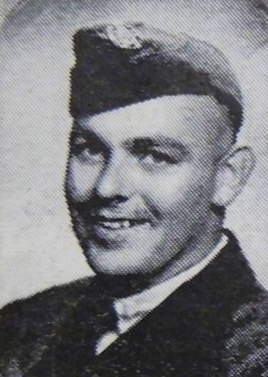Flight Sergeant Harris was on the crew of Baltimore MK1 AG715 of 69 Squadron that took off from Luqa, Malta, 0350 hours to attack Essen. The remainder of the crew were RAF. Nothing further was heard from the aircraft or crew. Flight Sergeant Harris is presumed to have lost his life on 15 June 1942 and is commemorated at the Malta Missing Memorial*.*

Links/Information:

National Archives Australia RecordSearch -Allen Dawe Harris

Trove – Eyre’s Peninsula Tribune Thu 24 April 1941 [https://trove.nla.gov.au/newspaper/article/219493400](https://trove.nla.gov.au/newspaper/article/219493400?searchTerm=Sergeant%20Observer%20Allan%20Harris)

Trove – Eyre’s Peninsula Tribune Thu 25 June 1942 [https://trove.nla.gov.au/newspaper/article/219495729](https://trove.nla.gov.au/newspaper/article/219495729?searchTerm=airman%20reported%20missing%20Harris)