**Douglas McPherson PEARSE** was born in CARLTON, Victoria, in 1895 to **Mrs Minnie (Marion or Marianne McPHERSON)[1]** and **Mr George Ernest PEARSE** of ‘Dunedin’ Acropli Terrace, St Kilda Road, ST KILDA. His parents later moved to ‘Bundaleer’ 48 Albert Road, South Melbourne.

Douglas had several siblings including a brother George, born in Clifton Hill in 1890[2], a sister Florence Fernleigh born in Geelong in 1888,[3] and a sister Lorna Berenice, born in Armadale in 1901 (m. Ernest Arthur Weeks-Chalmers).[4] Other siblings include Robert Graham Malpas and Francis George Malpass.

He enlisted on 6 July 1915 at age 20 with his parents’ permission to join the expeditionary force**., service no. 3903**. He was clerk prior to enlistment and had previously been a cadet. Doulgas was 5 feet 91/2 inches tall, with a fair complexion, blue eyes, and dark brown hair. He was Presbyterian. Douglas has a vaccination mark on his left arm and a scar on his left calf.

On 23 November 1915 Douglas embarked from Australia.

On 14 August 1916 he was promoted to A/g Corporal in France.

On 6 October 1916 he was wounded in action in the field in France. On 10 October 217 he was admitted to hospital with suspected dysentery. In France in November 1916, he sustained a disability by way of neurosis followed being buried by shell and becoming nervous and abnormally self-conscious and easily disconcerted since then.

On 24 October 1917 he disembarked in Southampton on leave from France. On 12 November 1917 he was admitted to hospital in France with VD.

On 12 April 1919 he returned to Australia aboard the ‘Suffolk’ and was discharged on 22 September 1919.

Douglas was awarded the 1914-15 Star, the British War Medal and the Victory Medal.[5]

Doulgas died on 3 January 1962 at age 66. He is buried at Springvale Botanical Cemetry, Springvale, Greater Dandenong City, Victoria, Australia [*Show Map*](http://maps.google.com/maps?q=-37.944425,145.1722333&spn=0.004205,0.005249)GPS-Latitude: -37.944425, Longitude: 145.1722333 **Plot** Boronia, Wall X, Niche 132 **Memorial ID** 233129754

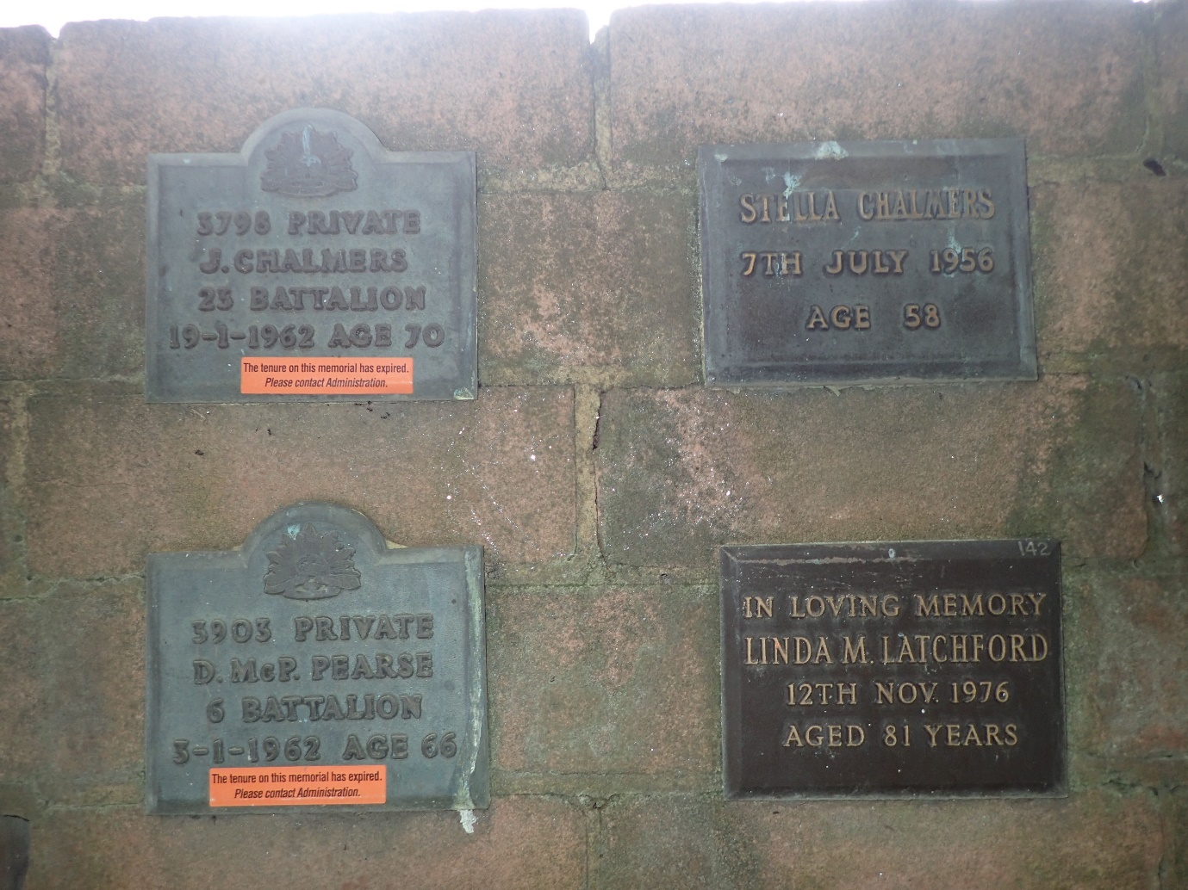

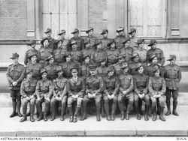[6][7]

Group portrait of the Headquarters Staff of the Australian Base Section, of 3rd Echelon. c 24 September 1918. AWM E03526 3903 Sgt D. Mc. Pearse, second row, fourth from left.

[8]

**1907**

***ABOUT PEOPLE.***

***….***

*Mr. and Mrs. George E. Pearse, two old colonists, and well known residents of Moonee Ponds, celebrate their golden wedding today. Mr. Pearse is well known in Melbourne as housekeeper to the Legislative Council for 48 years dating from 1851. When he was first appointed Dr. Palmer was Speaker, and Mr. John Barker Clerk of the House. The Council then met in the old St. Patrick's Hall, it being before the time of constitutional government. Mr. Pearse retired in 1902, having served under the Federal Parliament. He was married on 3rd October, 1857 — three years after his appointment — to Miss Louisa Jane Mitchell, at St. Mary's Church, Collingwood.*[9]

**1919**

***ROMANCE OF YOUNG GIRL WHO RAN AWAY FROM HOME TO MARRY***

*There were all the elements of the first couple of acts of a moving picture feature connected with the appearance of a well-dressed young lady at the Central Police Court last week. She was arrested, torn from her comfortable rooms in Macquarie-street, Sydney, locked up in the cells for two nights, and prevented from marrying the man of her choice, all at the behest of her father, a well-to-do citizen of Melbourne. Lorna Pearce, a tall, slight girl of 18 years, was charged at the Central Police Court on Tuesday* ***with absconding from her home in Victoria****. Inspector Mitchell said the girl had been arrested on a provisional warrant taken out by her father in Melbourne. The girl was remanded till the following day to permit of the father's presence. As bail could not be granted on the charge, she was returned to the cells. On Wednesday she came before Mr. Payten again. This time her father was with her. Inspector Mitchell asked that she be discharged in view of an undertaking that she would return to Melbourne with her father. NO FURTHER PROCEEDINGS. The father gave his name as* ***George Ernest Pearce****, and his address as 48 Albert road, South Melbourne. He said he had taken out the warrant for his daughter's arrest, but now asked thit no further proceedings be taken in the matter. The magistrate said that it was unjust and oppressive to return the gin to Melbourne under the conditions mentioned, and discharged her. The girl left the court with her father.*

***DESIRED TO GET MARRIED.***

*Miss Pearce arrived in Sydney on Friday week, and was arrested by Detective Rankin at The Astor, a well-known Macquarie-street boarding establishment. She seems to have possessed a desire to see the world and then get married. She and her cousin, a young officer in the Royal Horse Artillery, now stationed in India, had decided to get married. For months she worked away on her glory-box, and often declared her intention to marry her cousin. Her father, however, disapproved of the match because of the close relationship of the young lovers. But Miss Pearce was not to be turned from her plans. She secured her passports secretly, and made all the arrangements for her passage to India via America and to England.*

***TROUSSEAU AND MONEY.***

*With her trousseau snugly packed away, a goodly supply of money and jewellery, she slipped away from home* [10]*last Thursday week. She arrived in Sydney on Friday and went to the Astor. As soon as her father knew she had fled, he got the Melbourne police to communicate with Sydney headquarters, and some judicious inquiries led to Detective Rankin locating her. Her father was told, and he took out a warrant for her arrest, which was duly put into execution.*

***PUT IN THE CELLS.***

*Miss Pearce, who had given the name of Lena Dubois while in Sydney, was taken to the Central Police Station and locked up In the cells. It was a trying situation for her, but the matron made her comfortable. She was not allowed to mix with the other woman prisoners, but was kept in a cell by herself. Her fur coat was sent for, and, as her stay threatened to be of some length, the detectives brought her her toilet ware and some 'spare clothlng. There is no doubt that the police did their best for the girl. Her meals were supplied from the police barracks diningroom, and the matrons excelled themselves to make the enforced confinement as light as possible. The girl made the best of a bad job. Orders were given that she should not be taken to Long Bay Penitentiary.*

***WOULD TRY TO ESCAPE.***

*The second day it was thought that Misa Pearce might like some exercise and the matrons were told to allow her to walk about the station as much as she desired, but, as soon as she knew of the proposal, Miss Pearce warned the matron that if she were allowed so much liberty, she would try to escape. The possibility proved too much for the matron's peace of mind, and Miss Pearce was carefully guarded all the time. When she was released Miss Pearce bade the matrons and the station sergeant good-bye, but, before she left, she told the matron that she was glad she was going home again because she was convinced she would have been stranded very soon. But she declared she would never give her cousin up, and at the first opportunity she would try to escape again. The father and daughter took Wednesday night's train back to Melbourne.*

**1919**

***Engagements (Announcements of engagements and approaching marriages may be forwarded direct to "Table Talk" Office. In all cases, to facilitate verification, the announcements must bear the signatures and addresses of the persons giving authority for publication.—Manager, "Table Talk.")***

*The engagement is announced of Dorothy Jean Berwick, only child of Mr. and Mrs. J. A. Berwick, "Monterey," Bambra-road, Caulfield, to Mr. Douglas McPherson Pearse, late sergeant 6th Battalion, A.I.P., youngest son of Mr. and Mrs. George E. Pearse, of 18 Albert-road, Albert Park.*[11]

1. [VIC BDM 19299/1895](https://my.rio.bdm.vic.gov.au/efamily-history/67318e74f00978156a585ed2/results?q=efamily).
2. [VICBDM2132/1890](https://my.rio.bdm.vic.gov.au/efamily-history/67318e74f00978156a585ed2/results?q=efamily), noting that the mother’s name as given as Marion and not Minnie.
3. [VIC BDM3375/1883](https://my.rio.bdm.vic.gov.au/efamily-history/67318e74f00978156a585ed2/results?q=efamily).
4. [VICBDM 7997/1901.](https://my.rio.bdm.vic.gov.au/efamily-history/67318e74f00978156a585ed2/results?q=efamily) [VIC BDM11926/1921](https://my.rio.bdm.vic.gov.au/efamily-history/67318e74f00978156a585ed2/results?q=efamily).
5. [NAA Service Record](https://recordsearch.naa.gov.au/SearchNRetrieve/Interface/ViewImage.aspx?B=8011236).
6. <https://www.findagrave.com/memorial/233129754/douglas-mcpherson-pearse#view-photo=238278094>
7. [Find a Grave](https://www.findagrave.com/memorial/233129754/douglas-mcpherson-pearse)
8. Ibid.
9. Age (Melbourne, Vic. : 1854 - 1954), [Thursday 3 October 1907, page](https://trove.nla.gov.au/newspaper/article/204990347?searchTerm=moonee%20ponds%20George%20E%20Pearse) 7. This George E was a George Edwin, not Ernest.
10. Mirror (Sydney, NSW : 1917 - 1919), [Sunday 13 April 1919, page 3](https://trove.nla.gov.au/newspaper/article/136733864?searchTerm=48%20Albert%20Road%2C%20South%20Melbourne).
11. Table Talk (Melbourne, Vic. : 1885 - 1939), [Thursday 9 October 1919, page 9](https://trove.nla.gov.au/newspaper/article/146472249).