**Rodney William PETTIT**

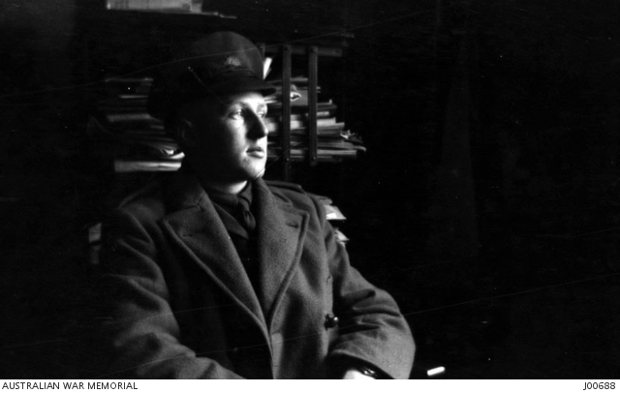[1]

Rodney William PETTIT was born on 20 November 1894. He was the son of **William Arthur PETTIT** and **Helena Vance Burton HAWKEN**.[2] Helena died of a stroke in 1931. His maternal grandfather was Mr Nicholas HAWKEN, NSW Member of Parliament.[3] His maternal grandmother was Mary Jane HAWKEN (VANCE).[4]

At the time of his enlistment (AIF No: 5396) on 20 January 1916. Rodney was a university student (scholar) who was 21 years and 2 months of age. He was of fair complexion, with fair hair and blue eyes. He was 5 feet 11 inches tall. Rodney departed Sydney on 22 August 1916 and arrived in Plymouth, UK, on 13 October 1916.

Rodney was wounded in action, mentioned in dispatches, and awarded the Military Cross.

Rodney married **Rutha E BRODRIBB** in 1921 in the district of Mosman, Sydney.[5] The previous year he was the best man and she was a bridesmaid at the marriage of Miss Constance (Connie) Riedel, only daughter of Mr. and Mrs. W. Riedel, Cremorne and Lieutenant G. Bowman.

Ruth died in 1929.[6] She was buried at Rookwood Cemetery. Rodney and Rutha had two sons children, **Peter R PETTIT** (born in Mosman in 1922),[7] **Geoffrey.** [8] Rodney appears to have had a third son, **David**, who may have been from his second marriage to Amy.[9]

In 1932, Rodney remarried Amy Florence McKIRRICK (MACKITTRICK) in Sydney.[10] Amy died on 1966.[11]

At the time of his second enlistment on 27 March 1942, Army No: N318161, Rodney was an auctioneer aged 47 years and six months. He lived with Amy at 1 Edwards Bay Road, Mosman. He resigned his appointment on 28 November 1944. He is recorded as having a gun shot wound to his left thigh and a past medical history of scarlet fever, pneumonia, and appendicitis (November 1933).

Rodney died in Sydney, in the district of St Leonards in 1972.[12]

**1917**

***AMONG THEUNRETURNING* *BRAVE.***

***PTE. HUBERT HOWLETT.***

*The greatest sorrow was expressed in Kyneton, Malmsbury and Taradale when it became known. on Friday evening that Mrs Lawrence Howlett; of Taradale, - had received word that her youngest son, Pte. Bert Howlett, had-made the supreme sacrifice in France on September 26, having been killed in action. Pte. Bert Howlett was a young man of about 28, of fine soldierly bearing. He enlisted in Melbourne; where he was engaged as a motor mechanic and has been at the front some 12 months. He was born in Malmsbury, where his father, Mr' Lawrence Howlett, who died at Creswick some eight years ago, lived for many years. He was educated at Malmsbury State School, and leaves many-friends there to mourn his early passing, and in addition his sister, Mrs White. He is nephew to Mr and Mrs John-Howlett, sen., and Mr and Mrs Kidder, of Kyneton, and Mr John Howlett, jun. of Piper street, is his elder-brother. His widowed mother and sister, Miss Howlett reside with his sister, Mrs Fred Hookey of Taradale, and to them all unstinted sympathy in their sad bereavement goes out. To add to this family's burden of sorrow; comes the news that* ***another nephew, Pte. Rodney Pettit, of Sydney,*** *has been wounded in three places, in the thigh, shoulder and back, but happily the wire conveying- the sad news contains the words. "Not dangerous."*

**1918**

*HIS MAJESTY THE KING has been graciously pleased to approve of the following awards to the undermentioned Officers and Warrant Officers in recognition of their gallantry and devotion to duty in the field :—…..*

***Lieutenant Rodney William Pettit, 17th Battalion****.*

*During an advance in a thick fog at Warfusee, east of Amiens, on the 8th August, 1918, he took charge of numerous parties of several units, which had become detached, led them forward, and cleared the village. Later, when held up by two machine guns, which could, not be located in the fog, he went forward alone, found them, and personally charged the position at the head of his men, and captured both guns and crews. He showed splendid courage and determination*.[13]

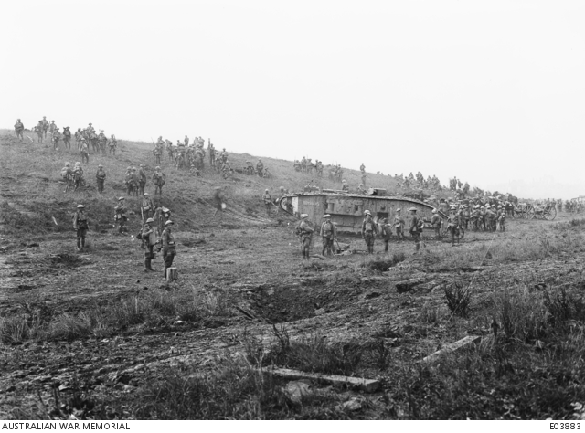[14]

[15]

**1920**

***BOWMAN— RIEDEL .***

*A military wedding was celebrated at Scots' Church, Church Hill, on Au-gust 28 by the Rev. J. Tate, when Miss Constance (Connie) Riedel, only daughter of Mr. and Mrs. W. Riedel, Cremorne, was married to Lieutenant G. Bowman (late 56th Battalion), eldest son of Mr. and Mrs. P. Bowman, of Glen Innes. The bride wore a dainty dress of white georgette over blush pink crepe do chine, with hand-made flowers and silver trimmings. Her hand-embroidered veil was arranged in mob cap fashion.* ***Miss Rutha Brodribb was bridesmaid, and wore a frock of lime crepe de chine, embroidered with touches of blue, and hat to match.******Lieutenant R. Pettit (late 17th Battalion) was best man****, and Lieutenant F. Rae (late 17th Battalion) officiated at the organ. A reception was held at Petty's Hotel, where a hundred guests were received. The happy couple motored to Blackheath, for the honeymoon, the bride travel-ling in a green tailored costume, and hat to match. Their future home will be at Cremorne.*

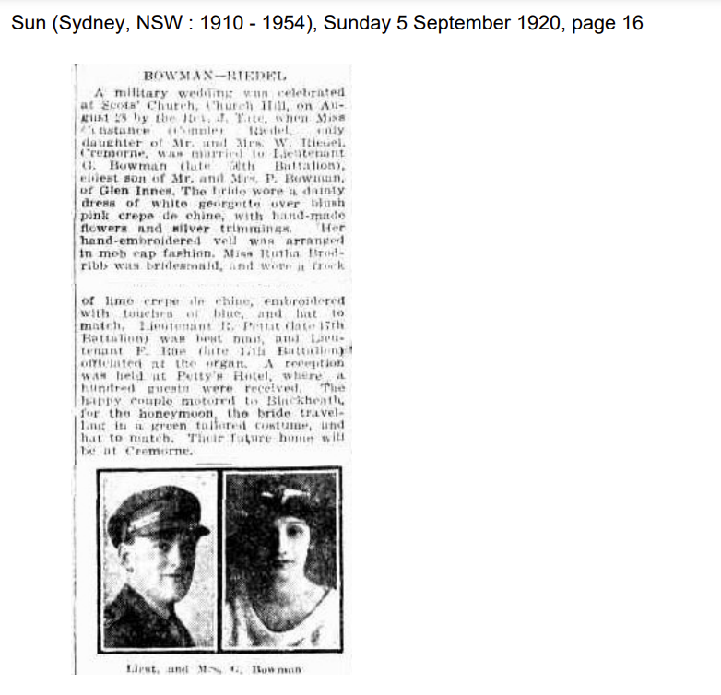[16]

**1921**

***GRANT OF SUBSTANTIVE RANK****.*

*The undermentioned Non-Commissioned Officers and Men who have served as Commissioned Officers in the Australian Imperial Force and have been noted for honorary rank (antedated), being granted substantive rank on the Reserve of Officers as follows, on ceasing to serve with the Australian Military Forces, dated 1st October, 1920, except where otherwise stated:—……..*

*……Corporal Rodney William Pettit, M.C., 2nd Battalion, 36th Infantry Regiment;….*.[17]

**1922**

**FIRE IN CITY.**

A fire broke out in a two-story building In Barlow-lane, city, late last night. The premises, which were used as a furniture factory and salesroom, were occupied by Brodribb and Pettit. The fire, which originated on the ground floor, severely damaged both floors be-fore it was extinguished by firemen.[18]

**1926**

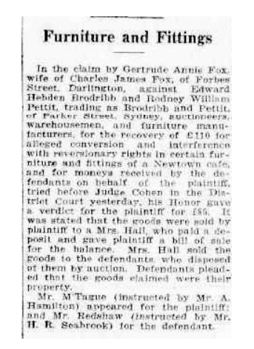[19]

**1929**

*PETTIT-The Relatives and Friends of Mr RODNEY PETTIT and Mr and Mrs E H BRODRIBB are invited to attend the Funeral of his b loved WIFE and their DAUGHTER, Rutha Edith Pettit; to leave Wood Coffill's Mortuary Chapel, 810 George-street, city, THIS SATURDAY, at 2.30 p m for the Crematorium, Rookwood, by road. Motor Funeral.*

*WOOD COFFILL LIMITED Motor Funeral Directors[20]*

**1929**

***RETURN THANKS.***

*Mr. and Mrs. E. H. BRODRIBB desire to THANK the many kind friends who so generously sent telegrams, letters, telephone messages, and beautiful floral tributes which were so much appreciated as a loving token to their only and much beloved daughter,* ***Mrs. Rodney William Pettit****. We would ask all to kindly accept our thanks and this notice generally in our recent sad bereavement.*[21]

**1929**

***IN THE SUPREME COURT OF NEW SOUTH WALES.-****Probate Jurisdiction - In the Estate of RUTHA EDITH PETTIT late of Mosman In the State of New South Wales. Married Woman, deceased Intestate. Application will be made after fourteen days from the publication hereof that Administration of the Estate of the abovenamed deceased may be granted to RODNEY WILLIAM**PETTIT the husband of the said deceased and that the usual Administration Bond may be dispensed with or reduced herein. All notices may be served at the offices of the undersigned and all creditors If any are requested to send particulars of their claim* to the undersigned within such fourteen days. Dated the twenty-third day of December one thousand nine hundred and twenty-nine. ROWLEY, ROSEBY, and CO., Proctors for the Administrator, 4 Castlereagh-street, Sydney.[22]*

**1932**

*THREE HOURS' SEARCH*

*POLICE SURROUND BUILDING, SYDNEY, Sunday.*

*The police surrounded a large block of buildings in Hay and Parker streets, Haymarket, last night, and after an extensive search lasting three hours found three men hiding-in the section of the building occupied by Brodribb and Pettit, auctioneers.* ***A parcel of gelignite and a fuse were also secured. The men submitted' to arrest quietly****.*[23]

*ALLEGED BURGLARY*

*Four Men Charged SYDNEY, Monday.*

*At the Central Police Court in day William Croft (48), Timothy Ryan (28), Arthur Allard (32) and Edward Gardiner (25) were charged with having broken and entered the warehouse of Brodribb and Pettit, of Parker street, Sydney, with in-*

*tent lo steal. Croft said that he could prove that he was at home at the time of the alleged offence, but the po-lice alleged that he was the man who broke the door. All were remanded until October 29th.*[24]

**1932**

*PETTIT—MCKITTRICK.—May 12, 1932, at St. Phillip's Church, by the Rev. F. W. Tugwell, B.A., Rodney W. Pettit of Mosman to Amy Florence daughter of Mr. and Mrs. A. S. McKittrick of 31 Redan-street, Mosman.[25]*

**1933**

[26]

**1949**

**BRODRIBB, Annie Maud** - January 16 1949 at a private hospital late of 54 The Grove Mosman beloved wife of E H Brodribb and mother of Rutha (deceased) and Edward (deceased) und grandmother of Peter and Geoffrey Pettit Privately cremated Northern Suburbs Crematorium January 18, 1949.[27]

**1950**

*IN the Will of* ***EDWARD HEBDEN BRODRIBB*** *late of 54 The Grove Mosman, near Sydney In the State of New South Wales* ***Retired Auctioneer****. Application will be made after 14 days from the publication hereof that Pro-bate of the last Will and Testament dated 12th February. 1949 of the abovenamed deceased may be granted to Rodney William Pettit. William Hope Ridgeway Radford and Alan Henry Brodribb the Executors named In the said Will and all notices may be served the undermentioned address. All creditors in the Estate of the deceased are hereby required to send In particulars of their claim to the undersigned. J. FOORD HUGHES. Proctor for the Applicant. 133 Pitt Street. Sydney*.[28]

**1953**

***CANBERRA DIARY***

*Mr. and Mrs. Geoffrey Pettit, who were married on December 5, returned on Monday from their Queensland honeymoon. They are staying with Mrs. Pettit's parents, Mr. and Mrs. J. T. Pinner, until they move into their home at Yarralumla*.[29]

[30]

***Former Commerce Students Marry***

*A couple who met while studying Commerce at Canberra University College, were married at St. Andrews Presbyterian Church on Saturday afternoon.*

*They were Miss Jean Pinner and Mr. Geoffrey Pettit, who is a graduate in Arts and Commerce The bride is the second daughter of Mr. and Mrs. J. J. Pinner of Deakin, and the bridegroom the second son of Mr. R. W. and the late Mrs. Pettit, of Mosman. Rev. Hector Harrison officiated. IA silver locket over 100 years old, a present from her great aunt, was carried by the bride under her bouquet of gardenias. It opened to reveal a minute powder puff. Her frock was of white embroidered nylon. She wore a coronet of orange blossom with a finger, tip veil.*

*Her sister, Dr. Gwen Pinner, was bridesmaid, and Pamela Hipsley was flower girl.*

*Dr. Pinner's frock was of blue organdy patterned in white and she wore a small white straw hat. The flower girl wore a short frock of white spotted blue org. and and had a wreath of blue hydrangea in her hair. Bouquets were of gardenia and blue hydrangea. The bridegroom was attended by his younger brother Mr. David Pettit.*

*One hundred and thirty guests attended a reception at the Hotel Canberra. Leaving for a honeymoon at Yamba, the bride chose a blue faille frock with matching hat. Mr. and Mrs. Peters will live in Canberra.[31]*

**1954**

***NOTICE*** *of Dissolution of Partnership-Notice Is hereby given that the Partnership heretofore subsisting between the undersigned* ***ALAN HENRY BRODRIBB****,* ***RODNEY WILLIAM PETTIT*** *and* ***WILLIAM HOPE RADFORD*** *carrying on business as Auctioneers Valuers and Dealers In second-hand furniture and New Furniture at 28 Campbell Street Sydney under the firm name of Brodrlbb Pettit and Radford The Haymarket Auction Rooms has been dissolved by mutual consent as from the first day of July 1954. All debts due and owing by the said firm will be received and paid by Rodney William Pettit and William Hope Radford who continue to carrv on the business at the same place Dated at Sydney this 6th dav of July 1954 A H BRODRIBB R W PETTIT W RADFORD Signed in the presence of J FOORD HUGHES Solicitor, 133 Pitt Street Sydney*.[32]

**1960**

[33]

**1961**

*IN the Supreme Court of New South Wales.—Probate Jurisdiction.—In the will of* ***ARTHUR SCRIVEN McKITTRICK****, late of 31 Redan-street, Mosman, near Sydney, in the State of New South Wales, retired manufacturer, deceased, testate. —Probate granted by the Supreme Court of New South Wales on 24th November, 1960.—Pursuant to the Wills, Probate and Administration Act, 1898-1940, Testator's Family Maintenance and Guardianship of Infants Act, 1916-1938, and Trustee Act, 1925-1940, Rodney William Pettit, the sole executor of the will of the said Arthur Scriven McKittrick, who died on the 25th day of August, 1960, hereby gives notice that creditors and others having any claim against or to the estate of the said deceased are required to send particulars of their claims to the said sole executor, in care of N. J. Bell & Cadogan, Solicitors, 117 Pitt-street, Sydney, on or before the 27th day of March, 1961, at the expiration of which time the said sole executor will distribute the assets of the said deceased to the persons entitled, having regard only to the claims of which he then has notice.—Dated at Sydney, this 4th day of January, 1961. N. J. BELL & CADOGAN, Proctors for the Sole Executor, 117 Pitt-street, Sydney.*

*18—£1 5s*.[34]

1. <https://www.awm.gov.au/collection/C2041>.
2. NSWDBM 49514/1972.
3. Parliament of NSW, [Mr Nicholas Hawken (1836-1908](https://www.parliament.nsw.gov.au/members/Pages/member-details.aspx?pk=701)).
4. Geni, [Mary Jane Hawken](https://www.geni.com/people/Mary-Hawken/6000000078963203396).
5. NSWBDM 8182/1921.
6. Sydney Morning Herald (NSW : 1842 - 1954), [Monday 22 July 1929, page 10](https://trove.nla.gov.au/newspaper/article/16550169?searchTerm=rodney%20william%20pettit).
7. NSWBDM 48084/1922.
8. <https://www.myheritage.com/names/geoffrey_pettit>.
9. Sydney Morning Herald (NSW : 1842 - 1954), [Wednesday 7 July 1954, page 21](https://trove.nla.gov.au/newspaper/article/18424740?searchTerm=rodney%20william%20pettit),
10. NSWBDM 4537/1932.
11. NSWBDM 29056/1966. She was the daughter of Arhtur Scriven (or Nicholas Hakwen and Mary Jane Vance): [Helena Hawken](https://www.genealogy.jvans.co.uk/getperson.php?personID=I8421&tree=2). Helena married William Pettit in about 1893. [The Hon MLA, MLC](https://www.parliament.nsw.gov.au/members/Pages/member-details.aspx?pk=701)
12. NSWDBM 49514/1972
13. Commonwealth of Australia Gazette (National : 1901 - 1973), [Tuesday 3 June 1919 (No.67), page 937](Commonwealth%20of%20Australia%20Gazette%20(National%20:%201901%20-%201973),%20Tuesday%203%20June%201919%20(No.67),%20page%20937).
14. Warfusee-Abancourt, France. Troops of the 5th Australian Infantry Brigade with Australian,

    [Unknown Australian Official Photographer, France: Picardie, Somme, Warfusee-Abancourt, 8 August 1918](https://www.awm.gov.au/collection/C1326).
15. <https://heurist-usyd.cloud.edu.au/heurist/?db=ExpertNation&file=23f922fe4fdcdb590686a686b17892d660150936>
16. The Sun, [Sunday 5 September 2020, Bowman-Reidel, page 16](https://trove.nla.gov.au/newspaper/article/221496046?searchTerm=pettit%20brodribb).
17. Commonwealth of Australia Gazette (National : 1901 - 1973), [Thursday 13 January 1921 (No.6), page 73-75](https://trove.nla.gov.au/newspaper/article/232181640/25022535).
18. Sydney Morning Herald (NSW : 1842 - 1954), [Wednesday 22 November 1922, page 16](https://trove.nla.gov.au/newspaper/article/16051505?searchTerm=pettit%20brodribb).
19. Daily Telegraph (Sydney, NSW : 1883 - 1930), [Thursday 2 September 1926, page 10](https://trove.nla.gov.au/newspaper/article/246356637?searchTerm=rodney%20william%20pettit).
20. Sydney Morning Herald (NSW : 1842 - 1954), [Saturday 20 July 1929, page 13](https://trove.nla.gov.au/newspaper/article/16562730?searchTerm=rutha%20pettit),
21. Sydney Morning Herald (NSW : 1842 - 1954), [Monday 22 July 1929, page 10](https://trove.nla.gov.au/newspaper/article/16550169?searchTerm=rodney%20william%20pettit).
22. Sydney Morning Herald (NSW : 1842 - 1954), [Thursday 26 December 1929, page 2](https://trove.nla.gov.au/newspaper/article/16612967?searchTerm=rodney%20william%20pettit).
23. Northern Star (Lismore, NSW : 1876 - 1954), [Monday 17 October 1932, page 5](https://trove.nla.gov.au/newspaper/article/94305559?searchTerm=pettit%20brodribb).
24. Mudgee Guardian and North-Western Representative (NSW : 1890 - 1954), [Monday 17 October 1932, page 1](https://trove.nla.gov.au/newspaper/article/160975969?searchTerm=pettit%20brodribb).
25. Sydney Morning Herald (NSW : 1842 - 1954), [Saturday 4 June 1932, page 12](https://trove.nla.gov.au/newspaper/article/16893976?searchTerm=Amy%20Pettit).
26. Sydney Morning Herald (NSW : 1842 - 1954), [Friday 19 May 1933, page 6](https://trove.nla.gov.au/newspaper/article/16980702?searchTerm=rodney%20william%20pettit).
27. Sydney Morning Herald (NSW : 1842 - 1954), [Thursday 20 January 1949, page 18](https://trove.nla.gov.au/newspaper/article/18090547?searchTerm=a%20private%20hospital%20late%20of%2054%20Tho%20Grove%20Mosman).
28. The Sydney Morning Herald, [Thursday 18 May 1950, page 15](https://trove.nla.gov.au/newspaper/article/27572633?searchTerm=rodney%20william%20pettit).
29. Canberra Times (ACT : 1926 - 1995), [Wednesday 23 December 1953, page 4](https://trove.nla.gov.au/newspaper/article/2910294?searchTerm=Mr.%20and%20Mrs.%20Geoffrey%20Pettit%2C%20who%20were%20married%20on).
30. Canberra Times (ACT : 1926 - 1995), [Monday 7 December 1953, page 4](https://trove.nla.gov.au/newspaper/article/2902303?searchTerm=Geoffrey%20Pettit).
31. Canberra Times (ACT : 1926 - 1995), [Monday 7 December 1953, page 4](https://trove.nla.gov.au/newspaper/article/2902298?searchTerm=Geoffrey%20Pettit).
32. Sydney Morning Herald (NSW : 1842 - 1954), [Wednesday 7 July 1954, page 21](https://trove.nla.gov.au/newspaper/article/18424740?searchTerm=rodney%20william%20pettit)
33. Government Gazette of the State of New South Wales (Sydney, NSW : 1901 - 2001), [Friday 30 December 1960](https://trove.nla.gov.au/newspaper/article/220319859?searchTerm=rodney%20william%20pettit).
34. Government Gazette of the State of New South Wales (Sydney, NSW : 1901 - 2001), [Friday 6 January 1961 (No.1), page 31](https://trove.nla.gov.au/newspaper/article/220242576?searchTerm=rodney%20william%20pettit)