James Hugh Smythe 1882 – 1962
10th Battalion AIF (September 1914 to November 1918)

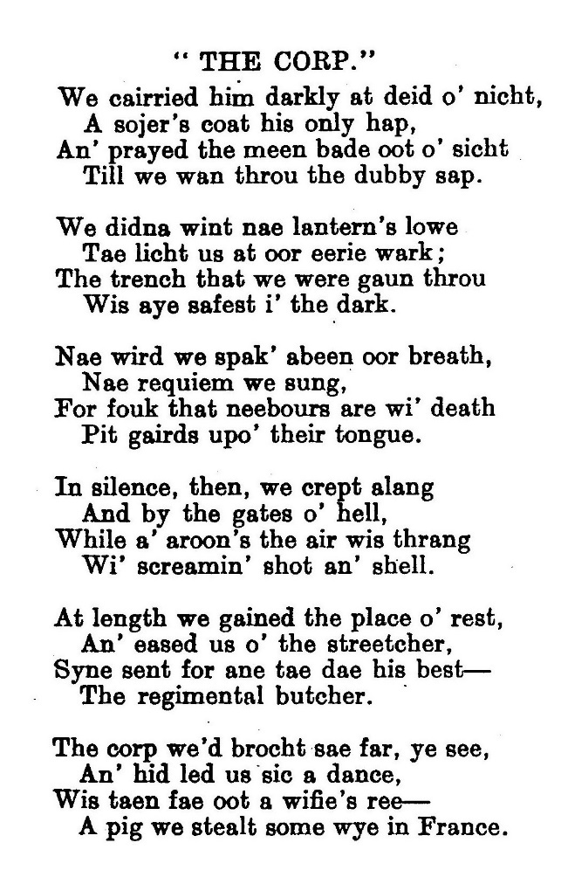

THE CORPSE
We carried him darkly at dead of night,
A soldiers coat his only quilt.
And prayed the moon stayed out of sight,
Till we’d got through the muddy squelch.
We didn’t want a lantern’s glow
To light us at our eerie work;
The trench that we were going through
Was always safest in the dark.
No word we spoke beneath our breath,
No requiem we sang.
For folk whose neighbours are with death
Put guards upon their tongue.
In silence, then, we crept along
And by the gates of hell,
While all around the air was thronged
with screaming shots and shells.
At length we reached the place of rest
And eased down the stretcher
Because, sent for one to do his best -
The regimental butcher
The body we’d brought so far, you see,
And had led us such a dance
Was taken from a woman’s yard ---
A pig we stole somewhere in France

