REASON Terence Shelton
Sales analist, Army Officer, Business Director and now retiree. 1947-

Born in Shorncliffe QLD in July 1947, I moved to Brisbane with my family and attended Villanova College at Coorparoo till Senior in 1964. I belonged to the Villanova College Cadet Unit for four years rising to the rank of SSGT. After school I held several jobs and settled with GMH in the sales analysis area. Not entirely happy with civilian life I enlisted in the CMF (as it was in those days) with 2 Coy RAASC at Frasers Paddock (Enoggera). Along with another Villanova old boy Brian Gillespie. I enjoyed the CMF, rising to the rank of LCPL. In 1966, along with Brian Gillespie and Rick Elliot we applied for and were accepted to attend OCS in 1967.

Commissioned from OCS in December 1967 into RAASC (later in 1973 transferred to RACT) I attended a six months Junior Officers Course at the RAASC Centre Puckapunyal and was then posted as 2IC 12 Tpt Pl in 1 Coy RAASC stationed at Ingleburn NSW. 1 Coy was working up for deployment to SVN. Duly in February 1969 I was posted as 2IC 85 Tpt Pl Nui Dat. Shortly after arrival the Pl OC was moved to the TFMA as adjt and I effectively had command of the PL as a 2LT. This was a great opportunity for a 2LT having 100 men and 50 vehicles under my command. Our role was to support 1ATF on a daily basis which saw us suppling ammo, rations, water, engr supplies and troop tasks, as well as heavy equipment and tank transport In addition we supplied troops for TAOR patrols and close in support for the Cav Units. After six months and many road miles I was detached to the Thai Base at Bearcat as the AS LO. Never sure if that was a good or bad thing.

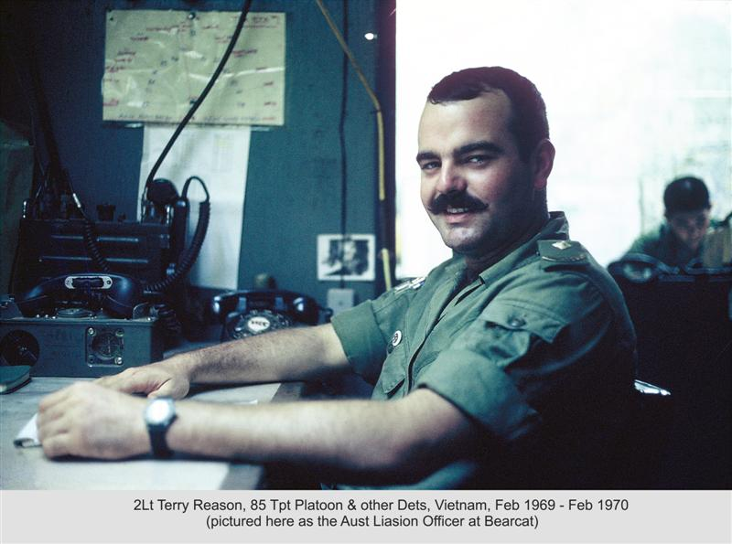

On RTA I was posted as the Asst ADJT at the RAASC Centre and then promoted to CAPT to serve on OPS Wing. In 1971 I was married and posted to Singapore as OC 90 Tpt Pl as part of the ANZUK Force based in Kangaw Barracks Singapore. I found this posting most enjoyable with the combined responsibility of road transport and aerial delivery. The unit provided tpt and air support to the multi national force in both Singapore and Malaysia. The unit was a combined AS NZ unit which provided some interesting moments. It did provide us with a good rugby team. The position was to be two years but was extended to almost three as in Aust the Whitlam Government had come to power and called all troops home. I stayed in Singapore to close the unit down, which was a bit disappointing after all the effort to set up the ANZUK such is the misguided advice to Politicians!!!!

RTA was a shock being posted to Albert Barracks in Melbourne and then 366 St Kilda Road (The Towering Inferno) in a series of Corps staff appointments. Posted to Canberra to the hallowed halls of DGCO I gained a better understanding of the staff process and the Army organisation and how the Staff process worked.. Promoted to MAJ in Canberra attached to the Office of the CGS working in the Secretariat.

In 1979/80 I was posted to Brisbane to be OC of Brisbane Transport Unit (BTU) based where my Army career started, at Frasers Paddock. I enjoyed the challenges associated with the BTU as the RACT had recently taken over the Movements function which had many issues in the early days. 1981 saw me at Army Staff College Queenscliff. As some wise person said to pass Staff College all you need is a good set of colouring in pencils and a years subscription to Actors Equity. Armed with my Social C Pass on graduation I was back in Canberra at Log Branch involved with the new B Vehicle acquisition of the Mack and Unimog vehicles and responsible for the Equipment Management of the Army’s B Vehicle Fleet.

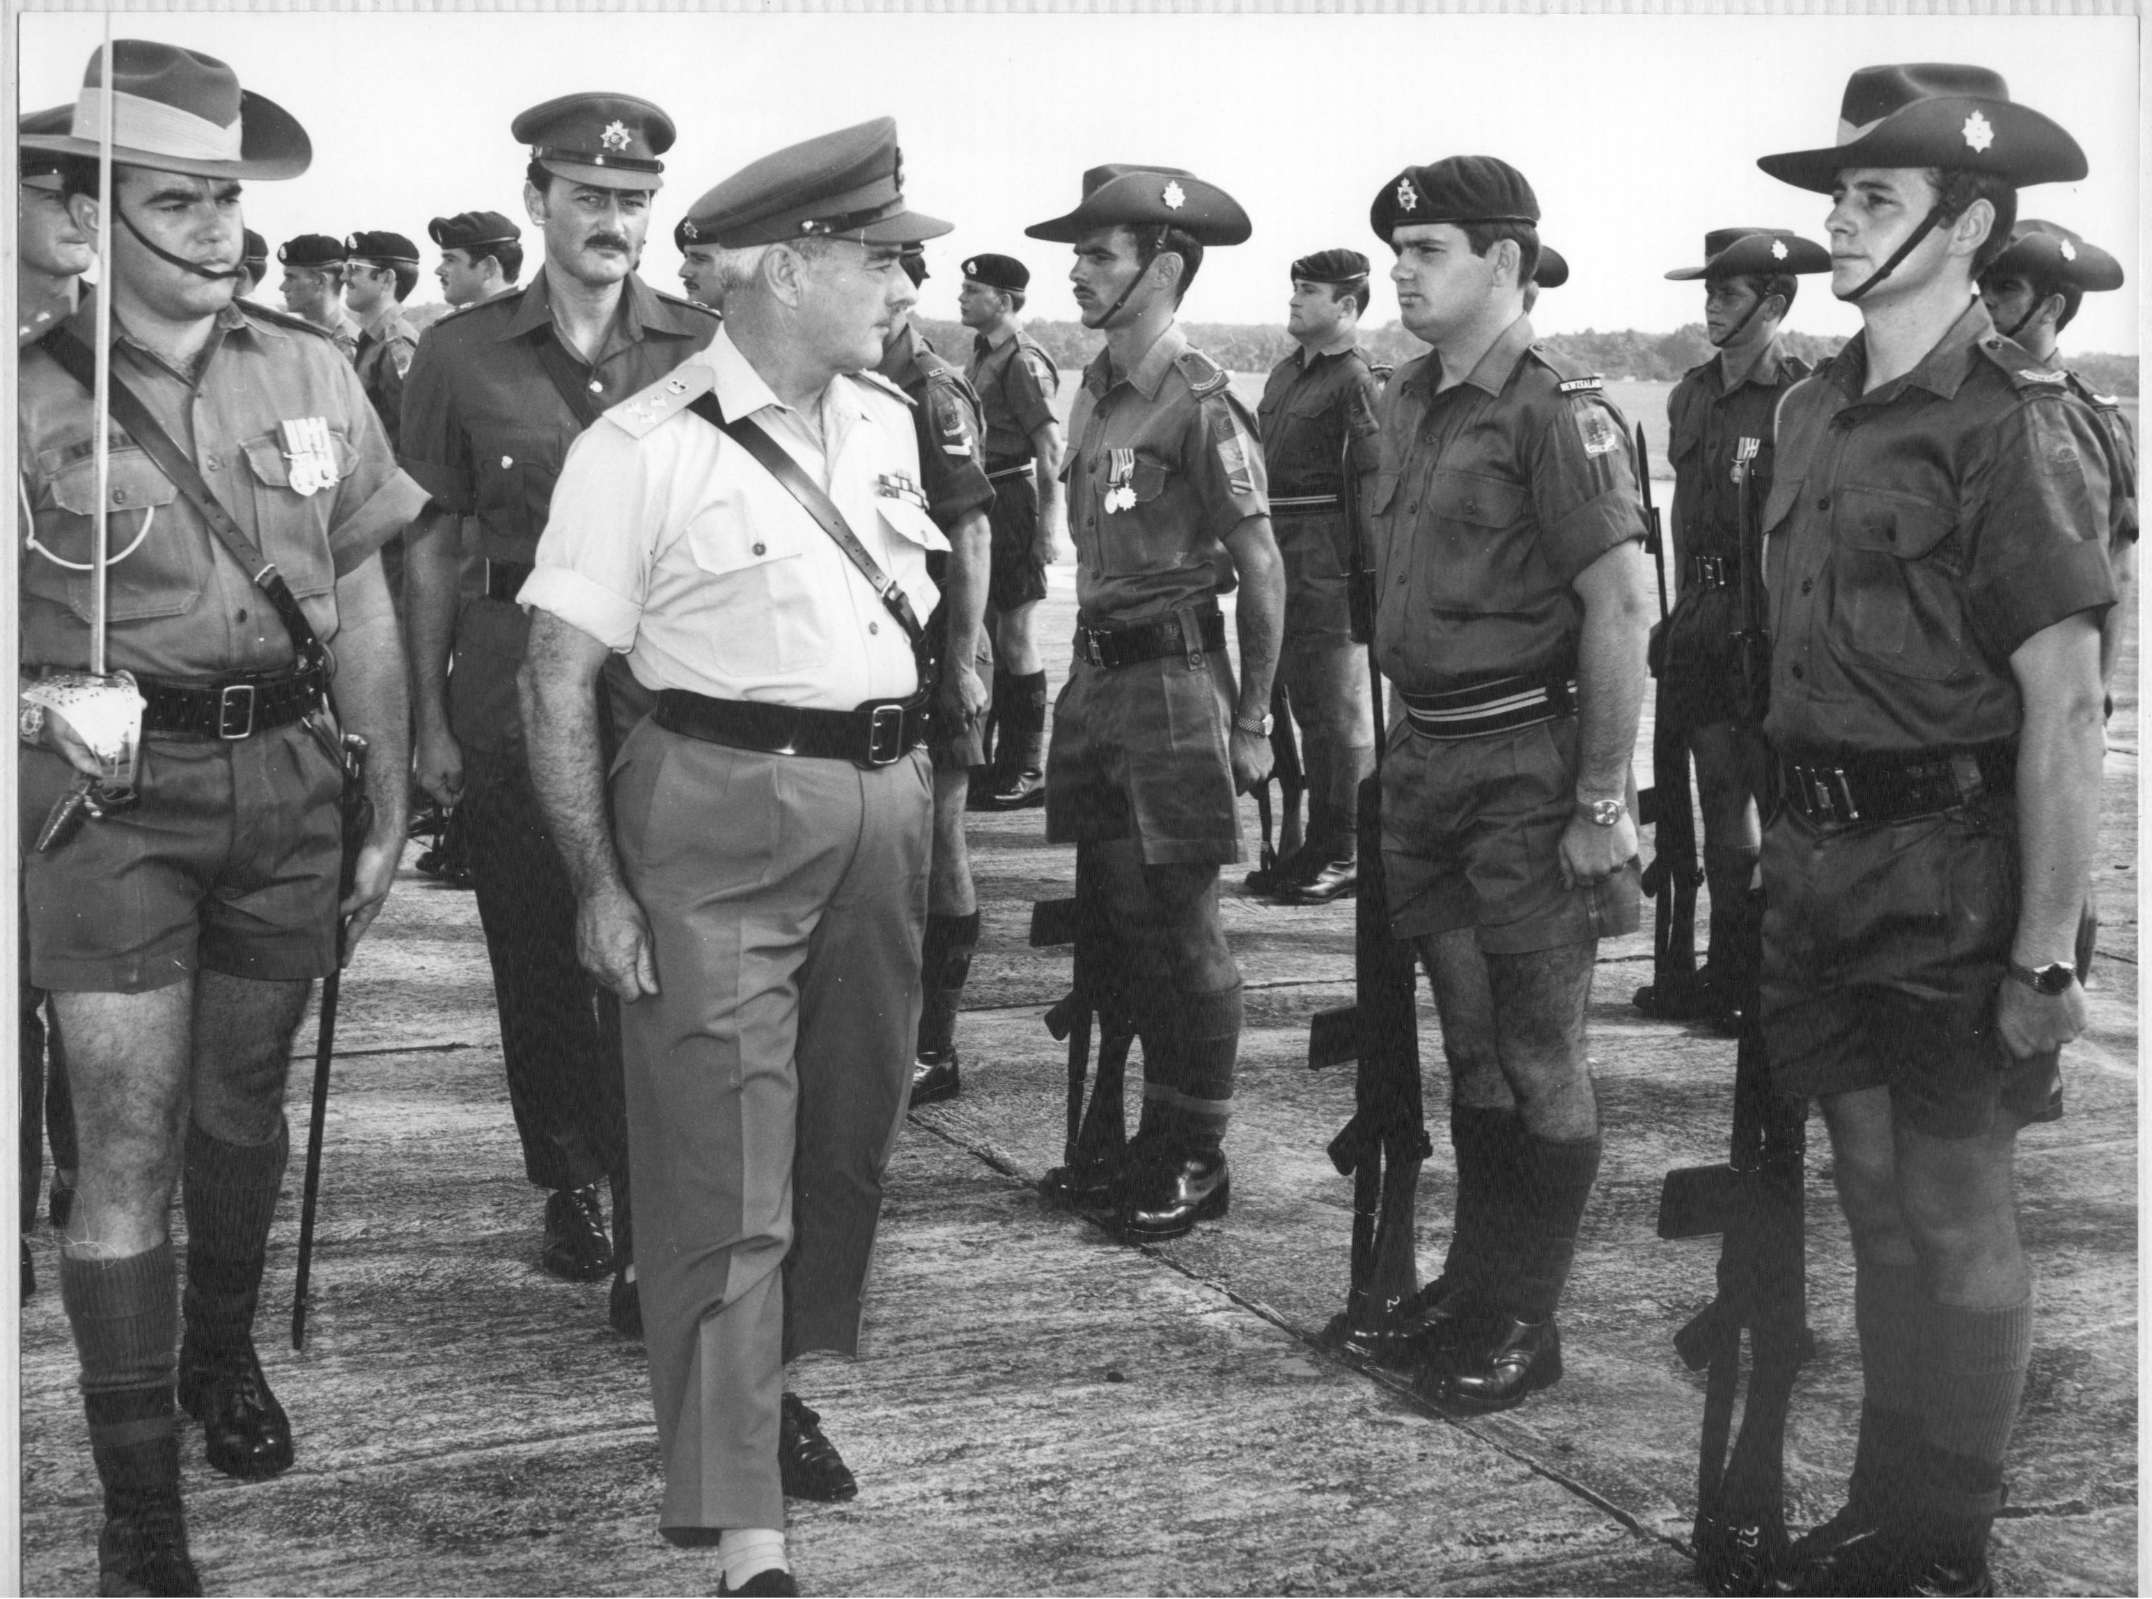

PARADE COMMANDER IN SINGAPORE. BEING INSPECTED BY DST BRIG BUNTING

In 1984 I was selected to go to the USA to Rock Island Arsenal to attend a computer/management course. This was a most enjoyable twelve months being introduced into the computing environment and was promoted LTCOL in August 1984 on return from the USA. Military computing was in its infancy then and this provided many opportunities to be involved with the introduction of both operational and administrative computing into the Army. After four years in the computing environment in Canberra and as a result of a family breakup I resigned. On discharge in Brisbane I was offered an ARes appointment at HQ 1 Div as the SO1 Computing (1 Div had no IT staff at that time). My role was to act as an IT Staff Officer and write staff papers to get whatever IT hardware we could. I was reasonably successful within an Infantry environment. When MAJGEN Arnison arrived he was very progressive and gave the IT environment a great shove This short term appointment lasted ten years with me finally hanging up his Hat KFF for the last time in 1999.

Living now on the Sunshine Coast in 1989 I met and married Coral-Anne who was the Principal of Morayfield High School. Together we started and ran a small engineering business building steel framed sheds. After too may bottles of wine one evening we decided to sell everything and go feral.. Subsequently we established a Rural Wilderness Retreat in the Noosa Hinterland and ran it as a holiday farm. After ten years we got sick of people and I moved back into computing and Coral-Anne established herself as the Principal of the Sunshine Coast Grammar School. I then became the IT Manager at Noosa Council and retired after the amalgamation debacle in 2009. Thank you Teflon Pete. The slimy Labour Premier. We sold the farm in 1999and built on the high ground just outside the Village of Pomona.

We have three children and at this stage four grandchildren and we were happily retired at Pomona in the Sunshine Coast Hinterland enjoying life and raising a menagerie of animals. However we have now moved closer to the grandchildren and as at 2022 we are building a new house in Morayfield 50 kilometres North of Brisbane. We also have a wide range of animals including A toy poodle, a blue heeler and German Shepard. Not to mention chooks, love birds and a sulphur crested cockatoo. I thoroughly enjoyed my military career with the highlights being time in command in SVN, Singapore and Brisbane. One of the most enjoyable aspects is the lasting friendships established in OCS that have survived untill today.

1969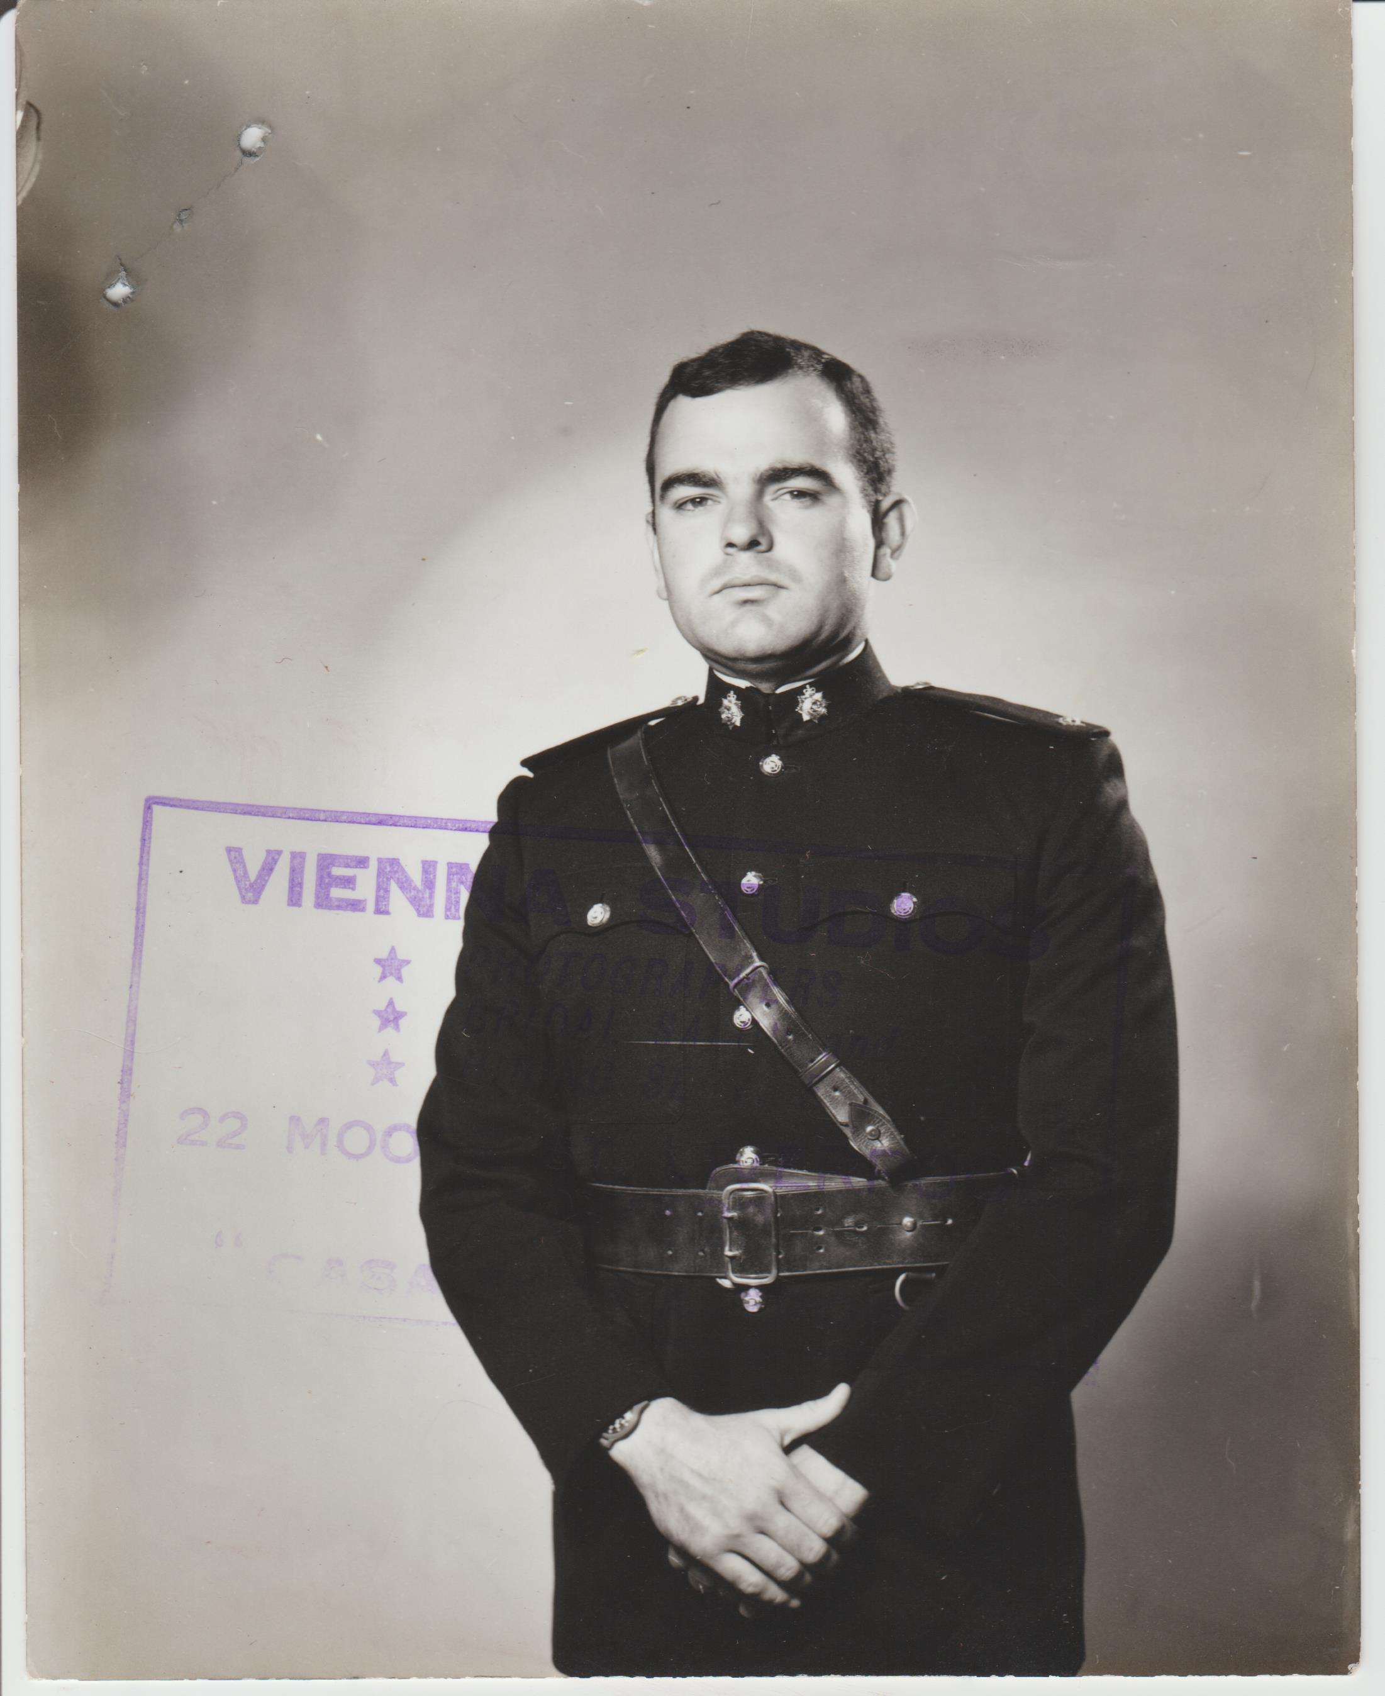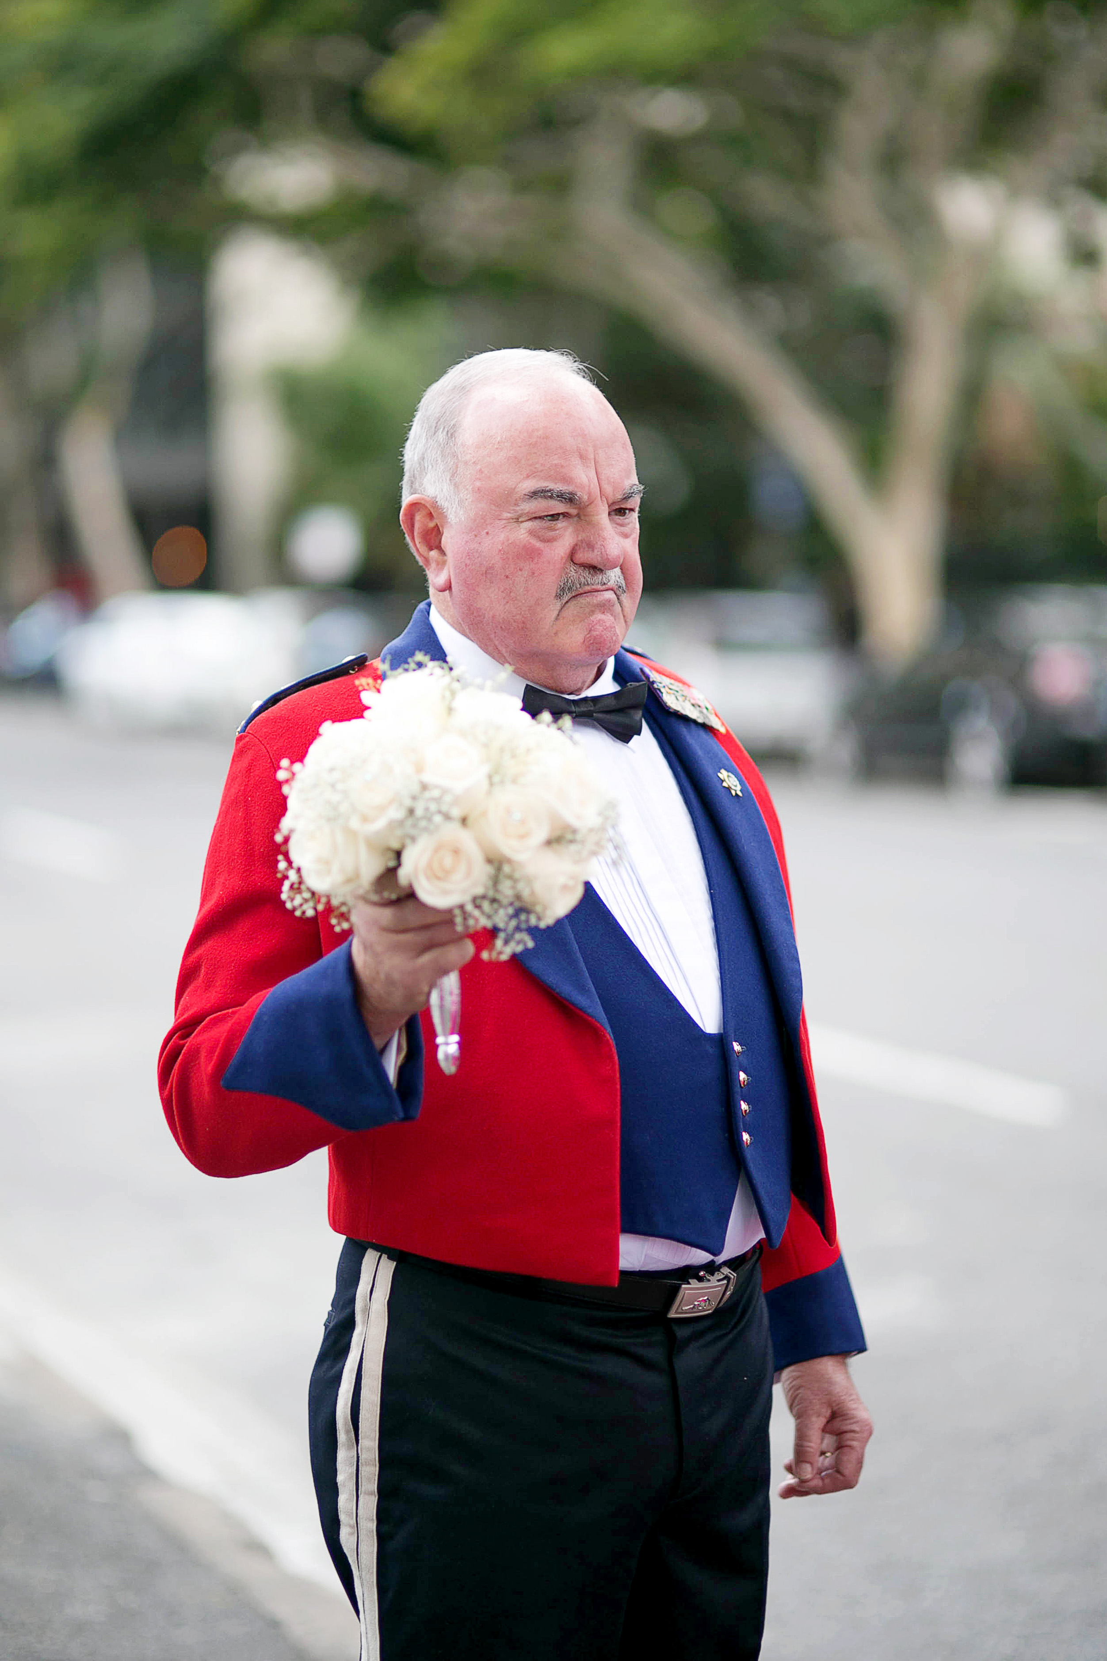2014

