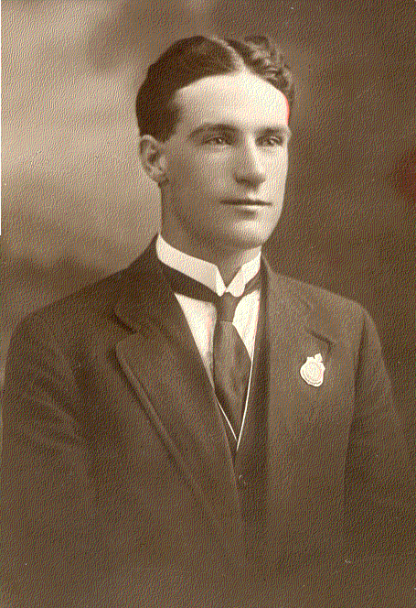
The War Diary of

29330 Driver, John Henry PARKER
2nd Division Ammunition Column
Australian Imperial Force
World War I (1914-1918)

The following text is word for word writing from the only known pages of the war diary of John Henry Parker.

We went into camp on the 3rd of July 1916. Left Sydney on 30th September 1916. Sailed on S.S Aeneas, a Blue Funnel Liner. Eleven hundred troops, thirteen hundred comprising trench mortars, Artillery Engineers, Siege Artillery and Infantry.

We left Sydney at 0630, Saturday 30th September 1916. Warren boys on board; Jack Reinhardt, George Wilds, Will Normand, Ted Robinson, Sid Brigden and Clem Shakespeare.

Arrived Melbourne, October 2nd ,1916 and picked up three batteries of Artillery; 400 men. Had six hours leave. Hotels open till 9.30p.m. Streets and railways much wider than in Sydney; cable trams. Anchored at Port Melbourne and went into city in a cab. Ten minutes drive. Munro Ferguson, the Governor General inspected our ship and spoke a few words to us.

It was very rough the first night out. We were in the Great Australian Bight and it is very rough and a strong wind is blowing.

Thursday, 5th Oct 1916; We are in the Great Australian Bight and it is very rough. We have to sleep in our life belts tonight. We are over the worst of the storm.

Friday, 6th Oct 1916; It has been raining all day. It is a pretty sight, raining at sea. The ship had to be turned to go with the wind last night. The troop ship ‘Vester’ is in a storm about 50 miles ahead of us. We had a good night of singing and dancing.

Monday, 9th Oct 1916; We called at Fremantle but the ship was quarantined and we were not allowed to go ashore. Some of our boys had to leave the ship with sickness. Fremantle is an artificial harbour. I did not like it much.

Wednesday, 11th Oct 1916; We had a fire alarm today. We had to get out on the deck with our life belts on, ready to jump into the boats or the sea.

Friday, 13th Oct 1916; We are having calm weather now. I saw the sun set; the prettiest sight I have ever seen.

Sunday, 15th Oct 1916; We are in the middle of the Indian Ocean about half way between Fremantle and Cape Town. I got the mumps on 21st October and when we arrived in Cape Town on 25th Oct 1916 I was not allowed to leave the ship but I jumped off as soon as it got a bit dark and was uptown for about two hours. The streets are a credit to the town. The people are nearly all black and very few speak English. The boys were given a concert by the white people in the café the first night they arrived and sports in the day at the markets. About 100 blacks loaded our ship with coal. They were good workers. They work 24 hours for nine shillings.
We left the Cape on 28th October 1916. We are in the Atlantic Ocean now. We crossed the Equator Line on 6th November 1916. A lot of our boys dressed up in different costumes. Some were policemen and they caught some of our boys and painted them with white-wash and black-lead and finished up by hosing them down in their clothes. I have seen plenty of flying fish.

We arrived in Dakar on the 8th November 1916 and left on the 10th of November. We got our gun on there. It is a very pretty place, some very pretty scenery. Nearly all black people. There was a few French Man-o-Wars there. We used to throw pennies into the water and the backs would dive after them. We had very rough weather for three days before we arrived at Plymouth. It was 0600 on Sunday, 19th November 1916. We were in a train for 6 ½ hours and then we had to march 4 ½ miles to the camp. It was raining and snowing most of the way. The name of this camp is Fouvant, camp number 20. Our next camp, number 21, Larke Hill, Salisbury.

Left England for France on Sunday 7th January 1917 and arrived at Etaples Camp, France on the 9th January 1917. We arrived at Etaples in the night. It was raining and we walked for 2 hours in the rain with kit and finished up sleeping in the Mess huts with only one blanket.

Left Etaples 25th January 1917 and arrived at Albert on 26th.
Left Albert on the 28th January for St. Gratien. Joined the 2nd D.A.C. on the 29th January 1917.

Arrived at Mametz on 6th February 1917. Started to re-fuse American munitions. We were shelled by the Germans the day we arrived. The first time I have been under German fire. Helped Dick George to carry his swag to the Clearance Station with mumps on Sunday 11th February.
14th February 1917; Left Plateaux Dump for Lavieville and joined the unit again. Plateaux Dump was blown up by a German Taube the day after we left.

Left Plateaux Dump near Mametz and Bray on Thursday 15th February and arrived at Lavieville near Henencourt that night.

17th February 1917; My Birthday. I was on guard duty for the first time in France at Laverville, a French Village.
Left Laverville and arrived at La Boiselle.

Left Bapume on 1st June 1917 and camped at Spring Garden Camp near Poziers that night.

Left Spring Garden Camp and arrived at Dog Leg Hut Camp on the 2nd June. Left Dog Leg Hut Camp on the 9th July and arrived at Dickebusch, (Dikkebus) Belgium on the 16th July 1917. First experience of German gas and tear shells at Dickebusch (Dikkebus) on 27th July. Nearly struck by lightning on Sunday 29th July 1917.

