**Solider folio**

**Part 1**

Research area:

The Name of the soldier I am currently researching is Frederick Clifford Lavis. He Born on the 24th of October 1892 and passed away on the 25th of December 1953. Before he went to the war he was a furniture warehouseman. He was born in Gawler, South Australia and lived on Kensington road, Norwood. He was single with no children but after returning from the war he became married to grace Evelyn and was a loving father to John and David.

Life on the western front:

Frederick Lavis signed up for the war on the second of February 1916 in Adelaide and embarked on the 31 of May 1916 at the age of 23.4. His service number was 12636. At the time of his enlistment he was 5 foot 10 with brown hair and brown eyes and weighed 154 lbs. (69.8532 kg.) He embarked on the ship HMAT Suevic A29. His unit was the 11th Field Ambulance and his job mainly was to drive ambulances to collect and deliver injured people to hospitals. Before he went off to the war the unit embarked for England in four different groups on different ships named the Suevic, Berrima, Wandilo and the Afric. The ships left between 31 May 1916 and 30 June 1916. The first group arrived at Plymouth on 21 July 1916 and soon after the unit joined together again at the Salisbury Plain for further training. After four horrible months, they embarked at France on the way to the western front. On the 1st of December they eventually took over the Divisional Rest Station at Steenwerck on a cold and horrible night. It was here that they spent the next two Christmases. Their next step was to take up various duties to try and help out the Third Division. These duties included running sector medical posts and stations as well as working in Advanced Dressing Stations and running rest areas. The unit first casualties happened in the Le Bizet sector, when the enemy shelled the Advanced Dressing Station. They in turn were supported by unit stretcher bearers, generally from the Battalion's Band. The men were trained to use First Aid sufficient to clear airways, stop bleeding and perhaps splint fractures so that casualties could be evacuated to the Battalion RAP. Unfortunately, the casualty’s would be hand carried by about four men.

Huge wounds with little chance of survival would generally have a low priority when evacuation resources were short. Soldiers with serious wounds who needed surgery have what is called "The Golden Hour" to receive the treatment they need. After that time their chance of survival decreases rapidly due to conditions such as bad weather, water, mud, shell torn ground and enemy action. At the time, infection known as sepsis was very common. Many soldiers including Frederick Lavis got this infection. When men were injured and then healed, they kept returning to the Front because they wanted to return to support their mates, particularly as the war drew on and reinforcements began to slow. During it’s time on the Western Front the Ambulance was involved in numerous areas and sectors including, Ploegsteert, Messines, Charing Cross, Ypres, Passchendaele and Flanders Ridge, the Somme and Villers Bretonneux. The casualties were numerous, and the bearers had a very hard task getting them them from the various posts. In the final stages of the war the Ambulance was involved in the last Somme operations in 1918. From the time of its first casualty in April there were 19 killed in action, 56 wounded in action in the unit, as well as 41 men were gassed of which only one died. So for a period of just under two years active service the unit had 116 casualties. The unit returned to Australia and was demobilized in 1919. Frederick Lavis Rank – private - Returned to Australia 23 March 1919 and later went on to marry and have children.

Anzac spirit:

ANZAC stands for the Australian and New Zealand Army Corps. To have some ANZAC qualities you have to be courageous, have great endurance, show initiative, discipline, and mateship. The ANZAC spirit means Australian and New Zealand soldiers possess shared characteristics. You can demonstrate the ANZAC spirit by being kind, generous and grateful to others. Frederick Clifford Lavis showed ANZAC spirit during the war because he drove ambulances around helping out people he didn’t even know by trying to save their lives and heal their wounds. He risked his life every day trying to save other people from dying on the battlefield. He showed bravery, courage, strength and mateship during his time in the war.

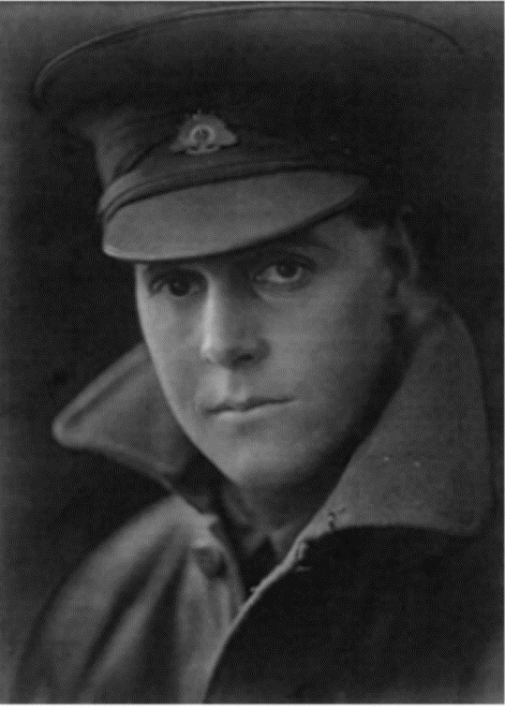

Above is an image of Frederick Clifford Lavis

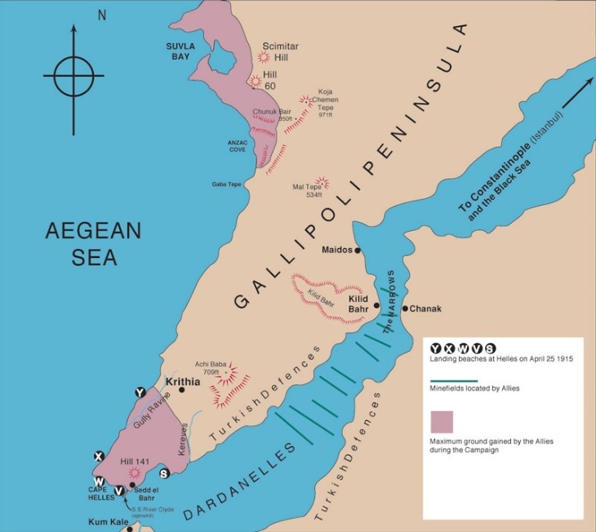

Above in an image of the Gallipoli peninsula