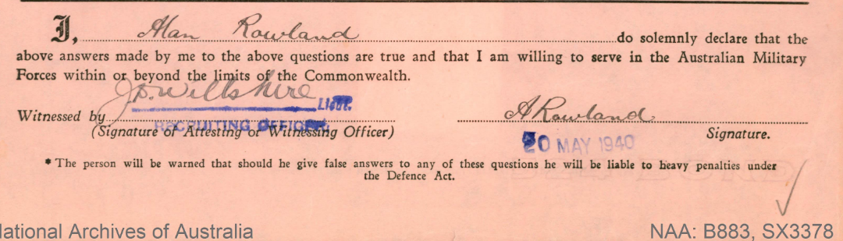

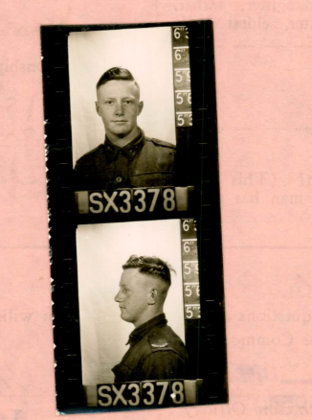

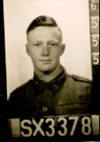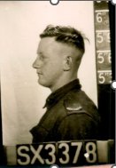

*Stratheden* reached Bombay on 15 September 1940 and left a week later carrying 268 passengers and 418 troops with Convoy BM 1.[[14]](https://en.wikipedia.org/wiki/SS_Stratheden#cite_note-14) Some of her passengers disembarked at Colombo, whence *Stratheden* continued with Convoy BM1 to Singapore.[[15]](https://en.wikipedia.org/wiki/SS_Stratheden#cite_note-15) From there she sailed unescorted via Fremantle, Adelaide and Melbourne and reached Sydney on 17 October.[[10]](https://en.wikipedia.org/wiki/SS_Stratheden#cite_note-Hague-10) *Stratheden* did not see Australia again until after the war was over, in October 1945.[1]

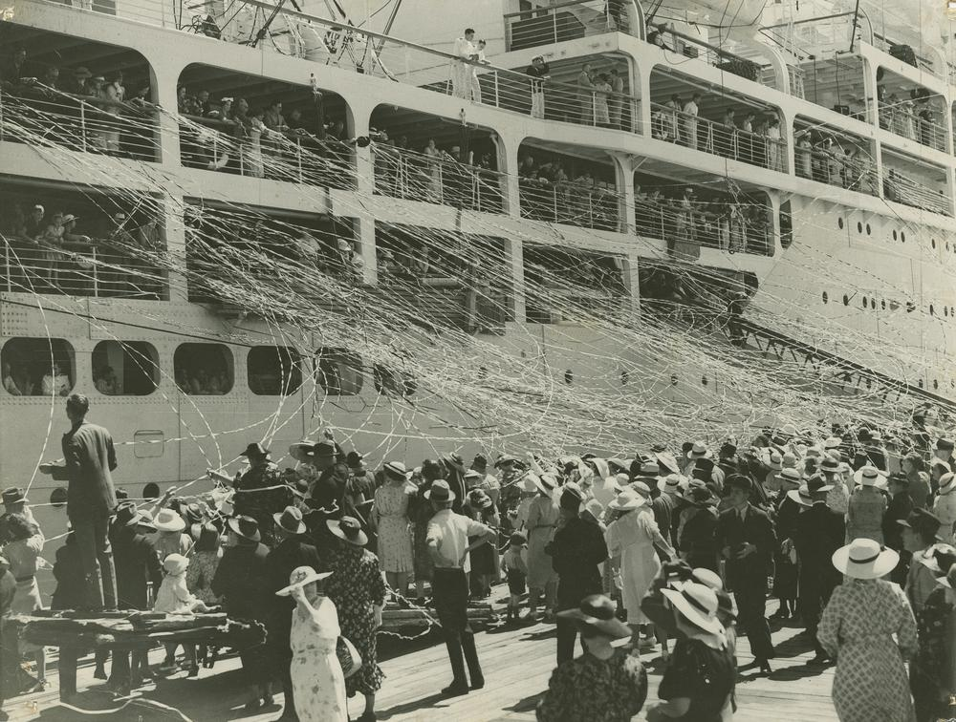

Passengers aboard *Stratheden* and people on the quay at [Hamilton, Queensland](https://en.wikipedia.org/wiki/Hamilton,_Queensland) bidding each other farewell

<https://discovery.nationalarchives.gov.uk/details/record?catid=5039853&catln=6>

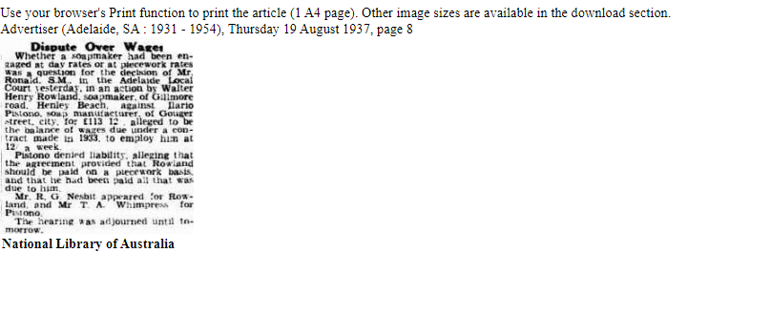

[Advertiser (Adelaide, SA : 1931 - 1954), Saturday 21 August 1937, page 15](https://trove.nla.gov.au/newspaper/rendition/nla.news-article74204557.txt)

Soapmaker's Action Discontinued

When the hearing of an action for £113 12/ brought by Walter Henry Row land, soapmaker, of Gilmore road. Henley Beach, against Ilario Pistono. soap manufacturer, of Gouger street. City, was resumed before Mr. Ronald. S.M., in the Adelaide Local Court yesterday. Mr. R. G. Nesbit (for Rowland) intimated that he had been instructed

to discontinue the case. Mr. Ronald, by consent, entered a non-suit, having the effect of judgment for Pistono, who was awarded costs. Rowland had sued for the balance of wages alleged to be due under a con-tract, made in 1933, for his employment by Pistono. Pistono alleged that the contract provided for the payment of Rowland on a piecework basis, and that he had been paid all that was due.

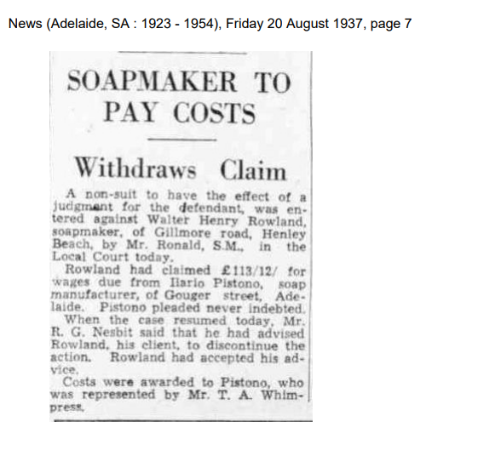

<https://trove.nla.gov.au/newspaper/rendition/nla.news-article130964294.3.pdf?followup=e39f660486fab011b44e93d5fe0c90ba>

Walter Kelsey, brother, 18/2/1918, Mile End Died 9/9/1942 aged 24, Adelaide, died abroad

Mother: Maud Emily Tilly KELSEY

Dad, Walter died aged 80, 12/4/1956 in Adelaide, buried Cheltenham Cemetery

Kelsey Walter ROWLAND died aged 15, 25/9/1960, at Riverton, living at Kapunda. Relative Allen Kelsey Rowland (father) – **so born around 1945**

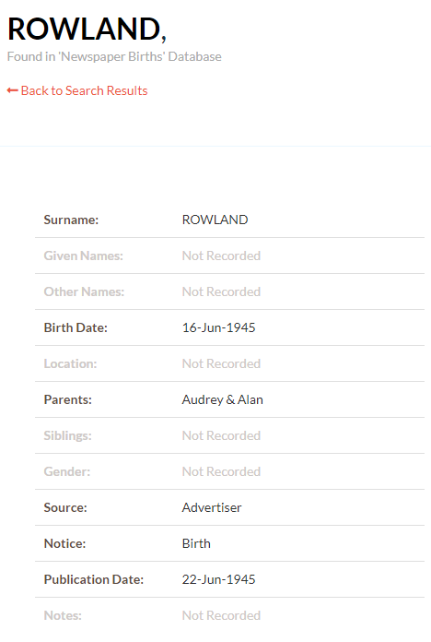

ROWLAND.-On June 16. at Henley Private Hospital, to Audrey and Alan—a son. Thanking Dr. Moody and staff.

Advertiser (Adelaide, SA : 1931 - 1954), Friday 22 June 1945, page 12

Joseph Roland, father of Walter, Edward Kelsey, father of Maud Maud and Walter married Holy Trinity Church Adelaide, Walter 29, Maud 20

Audrey Beryl Rowland died 26/10/1995 aged 77

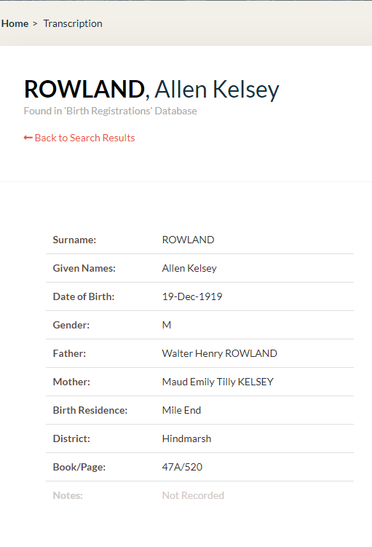

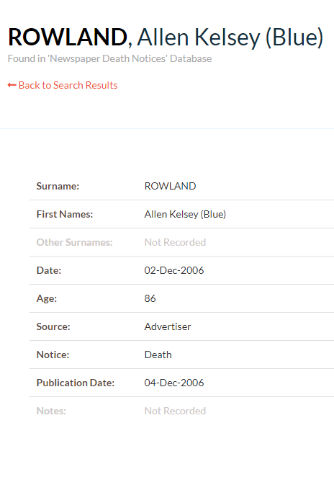

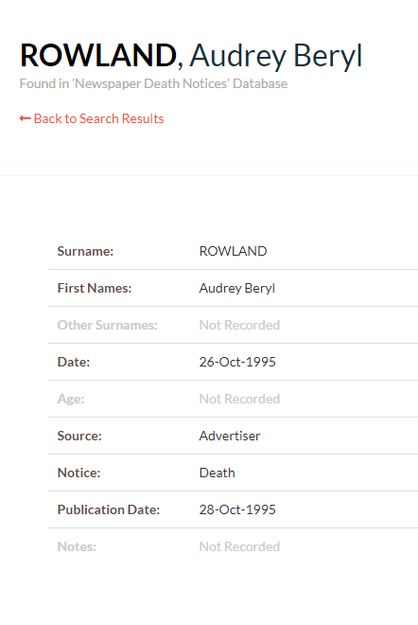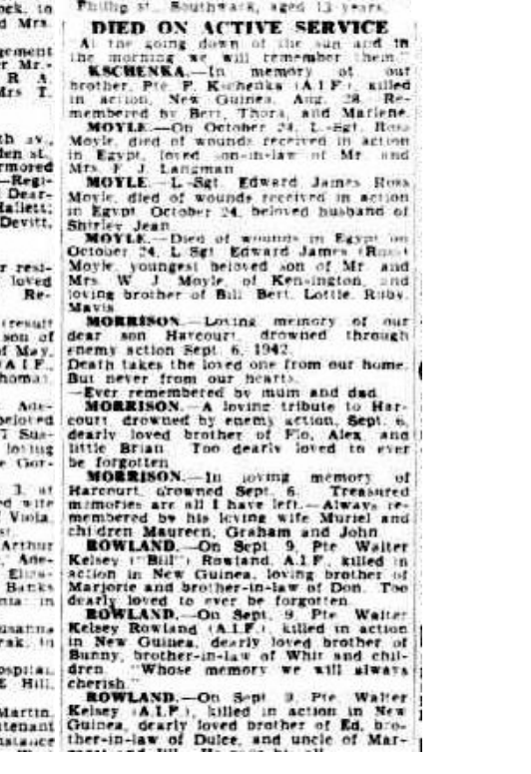

Advertiser (Adelaide, SA : 1931 - 1954), Wednesday 4 November 1942, page 8

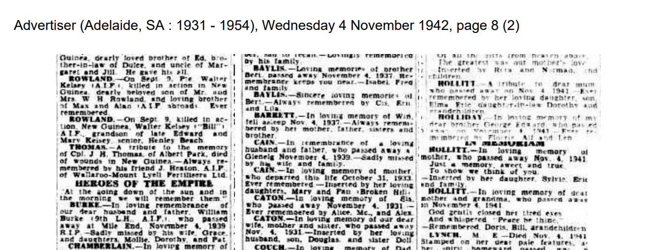

ROWLAND.— In loving memory of our dear son Bill, killed in action in New Guinea. September 9. 1942. 2/27th a attallon. He has walked beside me in my lonely years, Through all my sadness. joy and tears. And as the older I do get. He still walks beside me so I won't forget. -Sadly missed by mum and dad. ROWLAND. 2/27th Batalion - In loving memory of my dear brother Bill, killed in action New Guinea. Sep- 9 smber 9. 1942. Always in my thoughts. -Sadly missed by Allen. ROWLAND.— In loving memory of my dear brother Bill, killed in action New Guinea September 9. 1942. b A better brother, hard to find. He was noble, kind and true. -Max.

<https://trove.nla.gov.au/newspaper/rendition/nla.news-article45662350.txt>

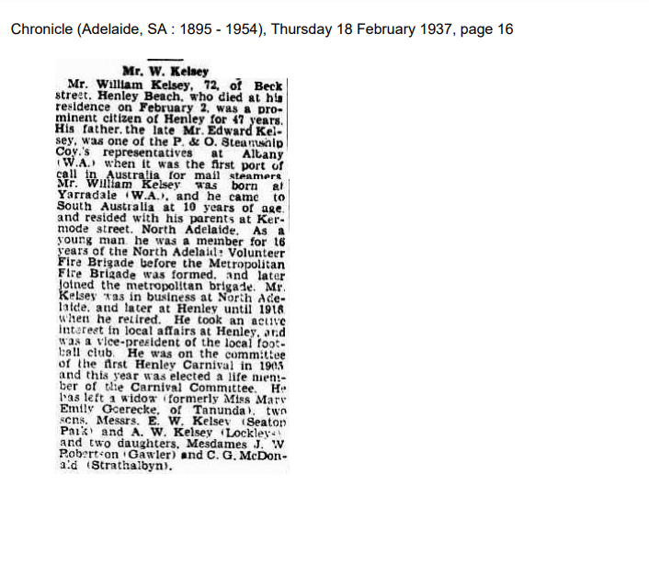

ROWLAND.—In loving memory of my dear brother Bill, killed in action, New Guinea, September 9, 1942. Treasured memories live forever.— Allen, Audrey, **Kelsey**.

Advertiser (Adelaide, SA : 1931 - 1954), Saturday 11 September 1948, page 14

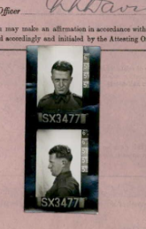

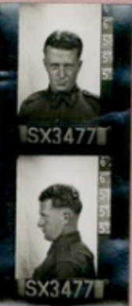 Walter Kelsey Rowland

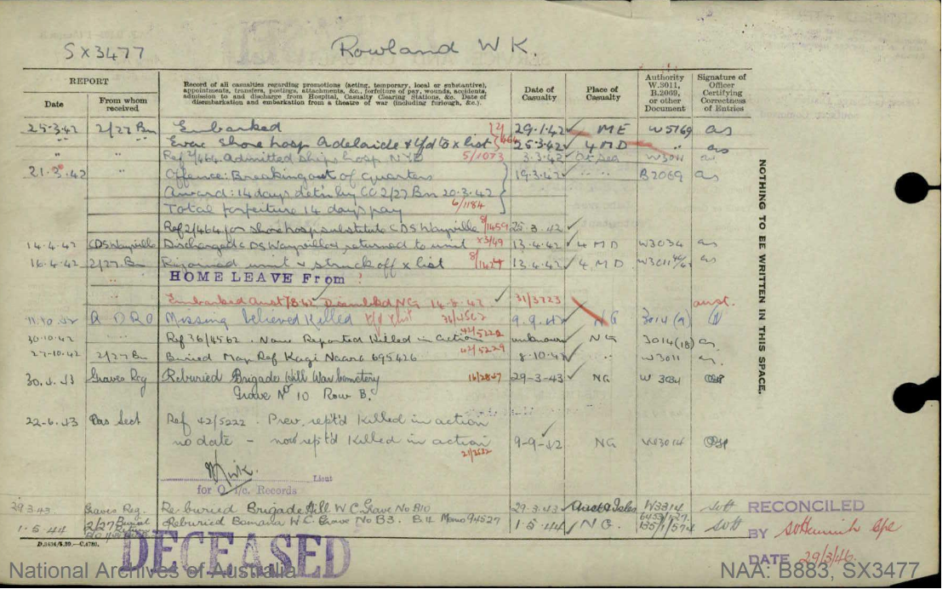

1. https://en.wikipedia.org/wiki/SS_Stratheden