Enlisted November 25, 1940

Training at Flinders Naval College, Leeuwin, HMAS Cerberus, HMA Anti-Sub school Rushcutters as ASDIC, Sydney, MV Kybra. The Kybra had been a coastal ship on the W.A. coast supplying the North-west and would bring cattle down to Fremantle.

Postings included to HMAS Waterhen in the Mediterranean, which was cancelled at the last moment when the Waterhen was sunk off Tobruk. HMAS Hiawatha, then Leeuwin XDO Swanbourne (Loop Station), where he helped install cables on the seabed of Gage Roads, designed to detect shipping movements into the Port of Fremantle.

ML Hiawatha

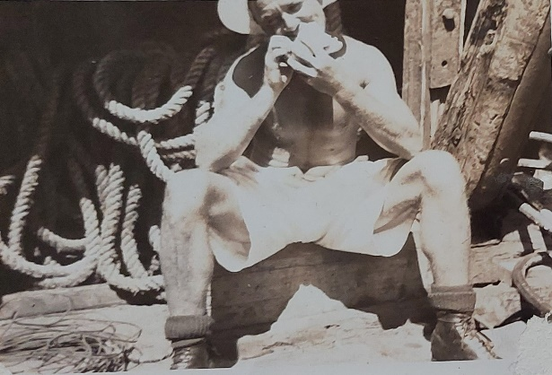

Bert Splicing cables Bert on the right

Swanbourne

Sleeping Quarters at Swanbourne XDO

To and from the lookout over the Indian Ocean at Swanbourne

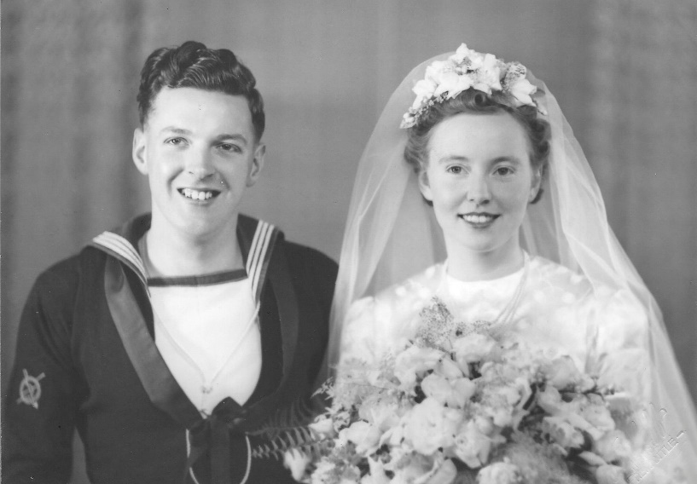

Married September 19, 1942 in Fremantle Wesley.

1945: ML818, deployed to Bougainville and the Solomon Islands.

The crew of ML818

At the end of the war, ML818 was ordered to Buin, then Torikino, to transport one of the Japanese surrender parties to the signing of the surrender. Returned to Sydney on the RMMV Stirling Castle, Arriving 19th June. To HMAS Leeuwin for discharge. Demobilised 6 – 12 - 1945,