(ISAAC) VICTOR JONES
DOSSIER WITH IMAGES - Collated June 2022
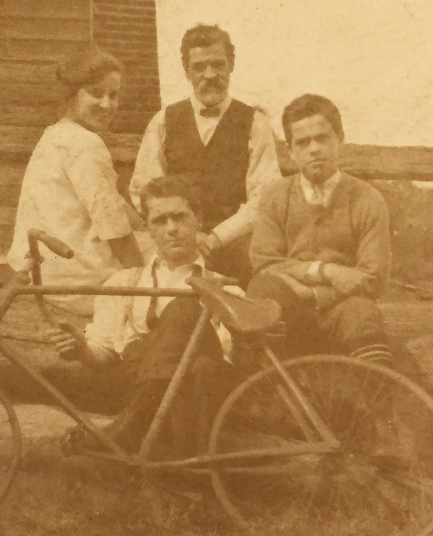
Personal Details
Born: 8 March 1898 Isacc Victor Jones
Religion: Methodist
Parish: Newcastle; Town: Adamstown
Father: William Jones (1858 – 1941)
Mother: Sarah Anne Jones (1862-1936)
Siblings: 1 sister & 3 brothers:
Description:
- Height 5 foot 3 inches; Weight: 9 stone, 6 pounds
- Complexion: dark; Eyes: brown; Hair: brown
Died : 28 October 1964, Epping NSW
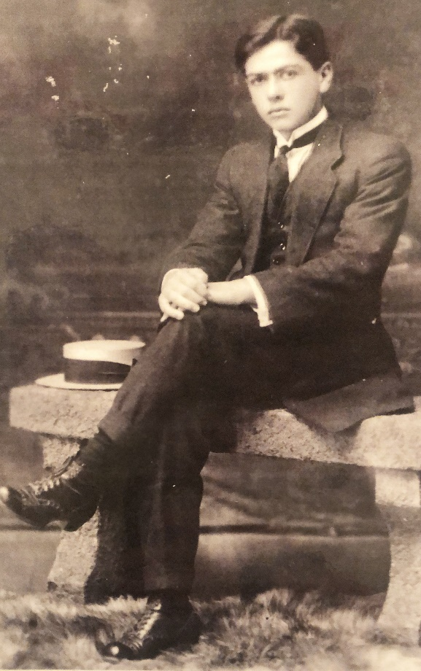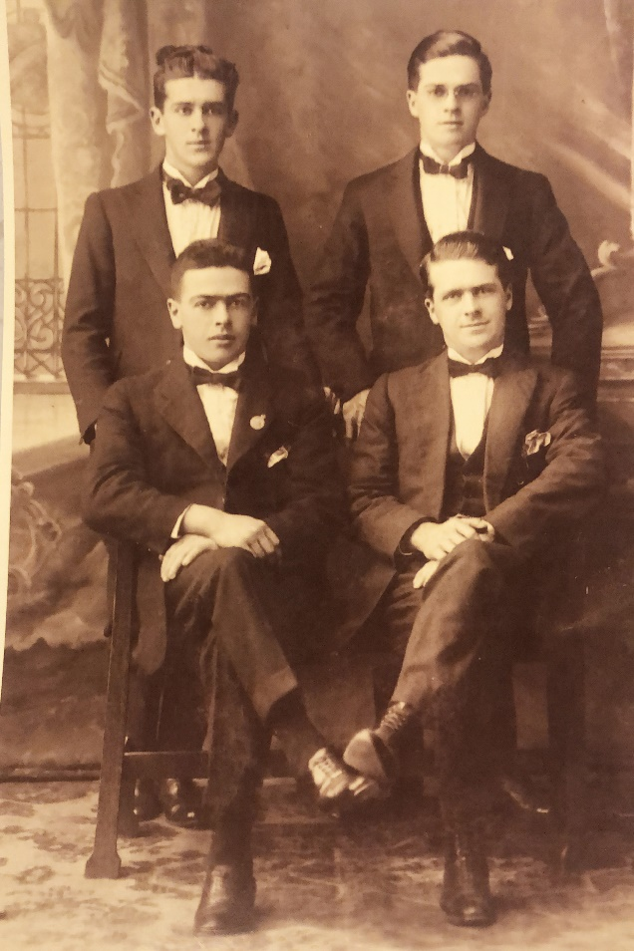
Pre-war
Interests: Senior Cadets, singing and sport (swimming, life saving and boxing)
Of the four brothers, only Victor Jones enlisted and served.
Identified occupation at enlistment was Clerk
Living in Aberdare a suburb of Cessnock in the Hunter Valley
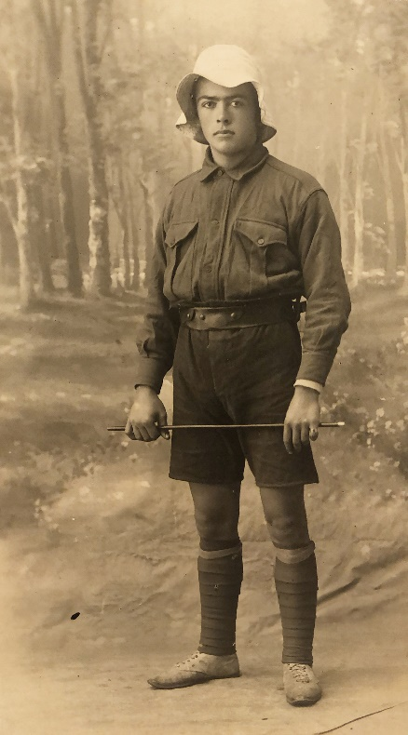
Cadet around 15 years Boxer (date unknown)
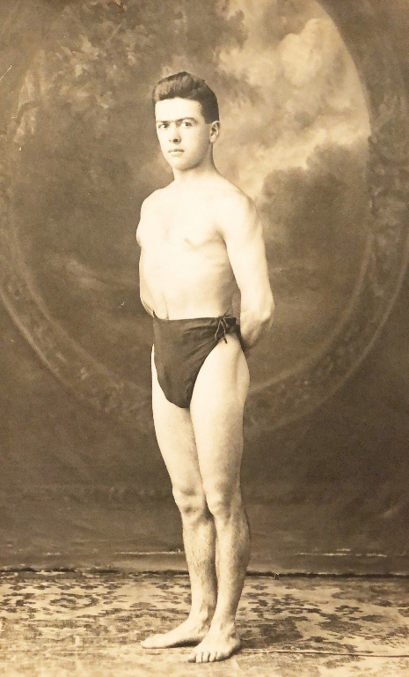
Newcastle Surf Life Saving Club
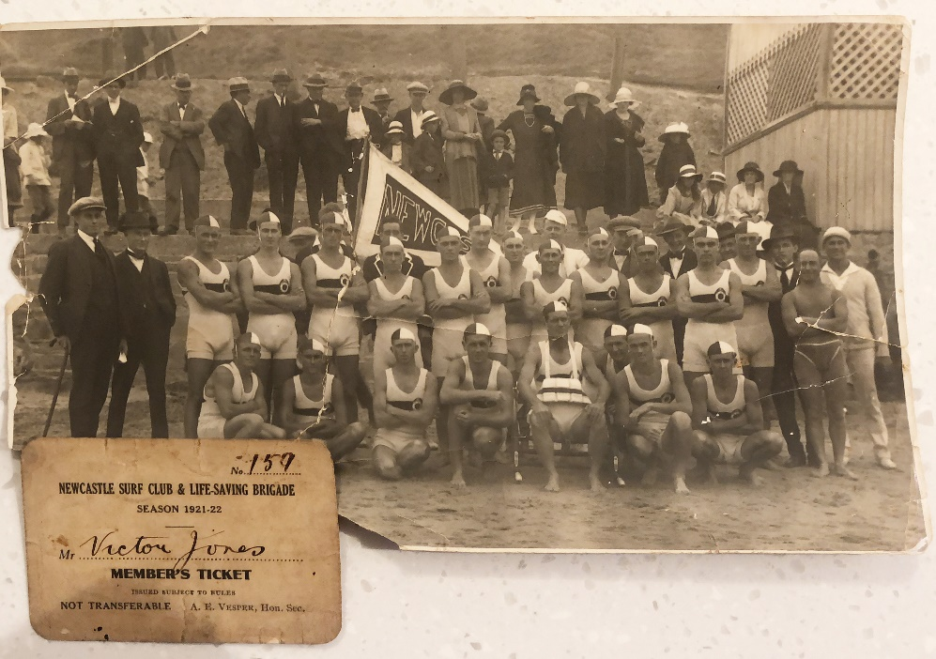
Core Service Information
Service Number | 1929
Rank | Private, age at enlistment 18 years and 3 months
Roll | 34 Infantry Battalion – 2nd Reinforcements (May-November 1916)
Enlisted | 26 June 1916 at Rutherford NSW (address Rawson Street Aberdare)
Embarkation | 04 September 1916 on HMAT A15 -SS Port Sydney (formerly the HMAT Star of England) from Sydney via Port Melbourne, Durban, Capetown, Plymouth approx 60 days.
Returned to Australia | 12 June 1919 (approx. 6 months after end of war on 11.11.1918) on the Themistocles
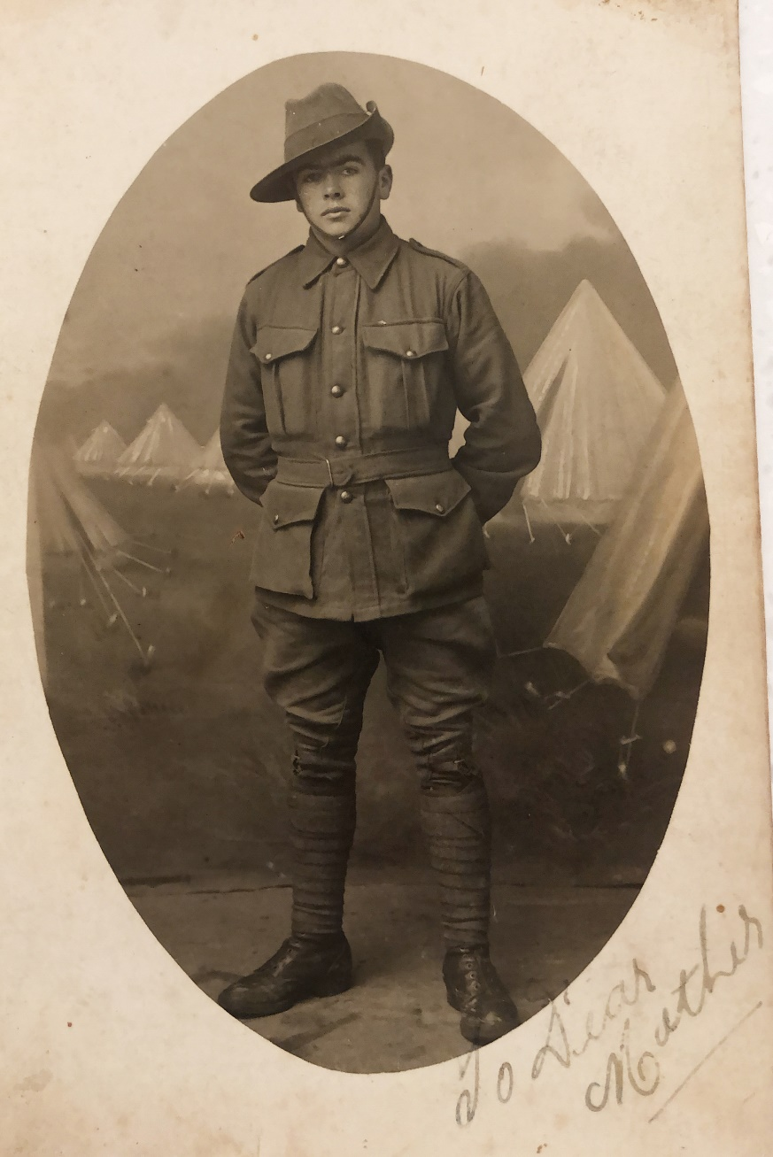
Additional materials
Personal Diary of troop transport 60 day journey from Sydney to UK on A15 SS Port Sydney via South Africa and Caribbean (Transcript attached separately)
A15 SS Port Sydney
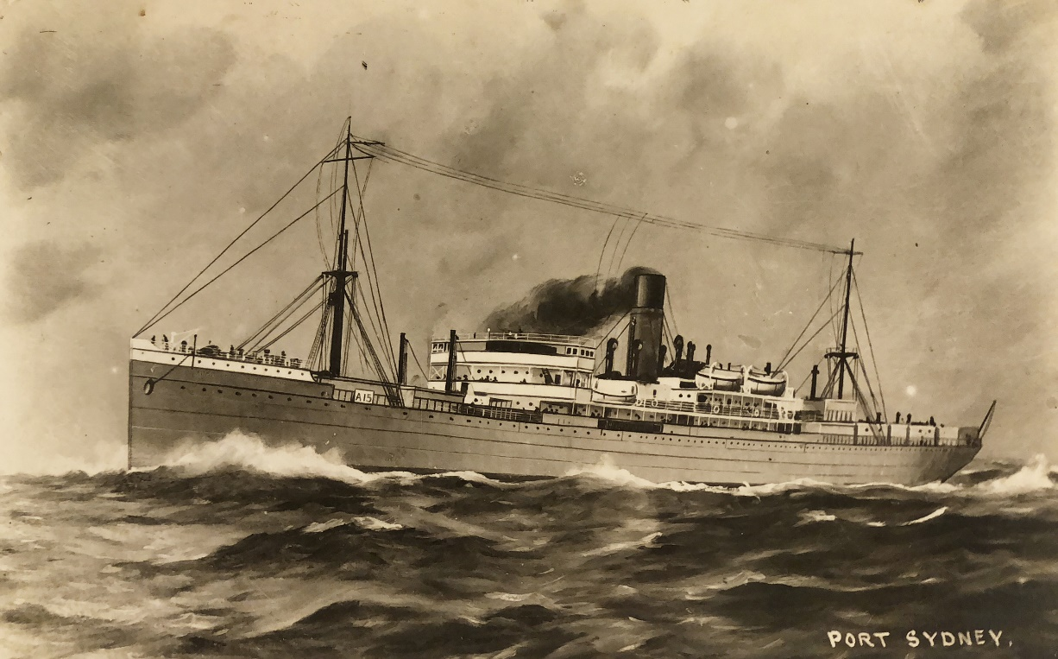
Funeral at Sea
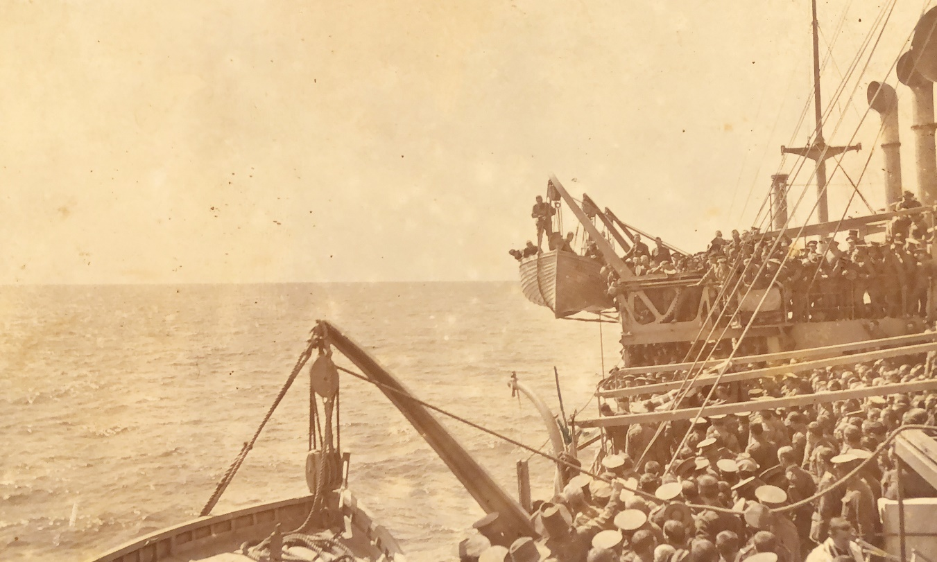
Durban Rickshaw Ride 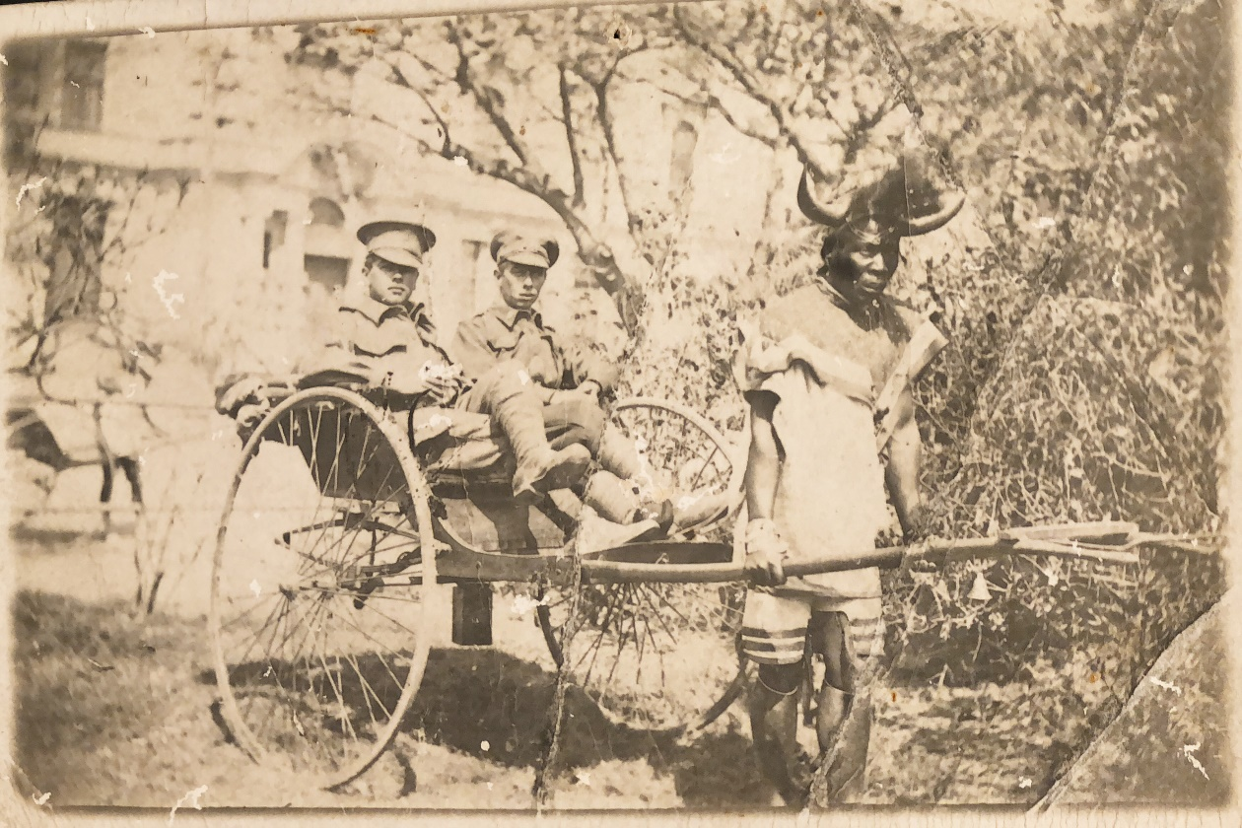

Active Service History Summary (based on Service Record)
Dates* | Activity | Comment
29 Oct 1916 | Disembarked Plymouth | Approx 4 months training provided in UK prior to deployment. Initial training campsite Wilton, and onto Salisbury
28 March 1917 | Proceed to France ex Folkstone
29 March 1917 | Arrives Etape
1 April 1917 | Rouen, France active duty | The following 12 months are listed as in field.
9 Feb 1917 | Leave to England
2 April 1918 | Exeter, UK sick | Septic Finger
14 June 1918 | AWOL for 5 days with 11 days pay forfeited
3 Dec 1918 | Re-joined Battalion in France
12 Jun 1919 | Embarked to Australia on H T Themistocles
10 Aug 1919 | Disembarked Australia
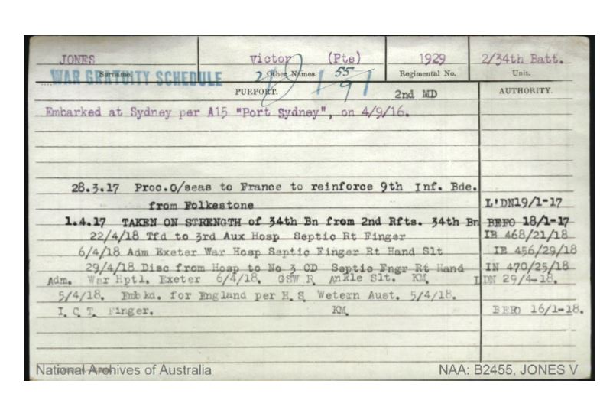

Training in UK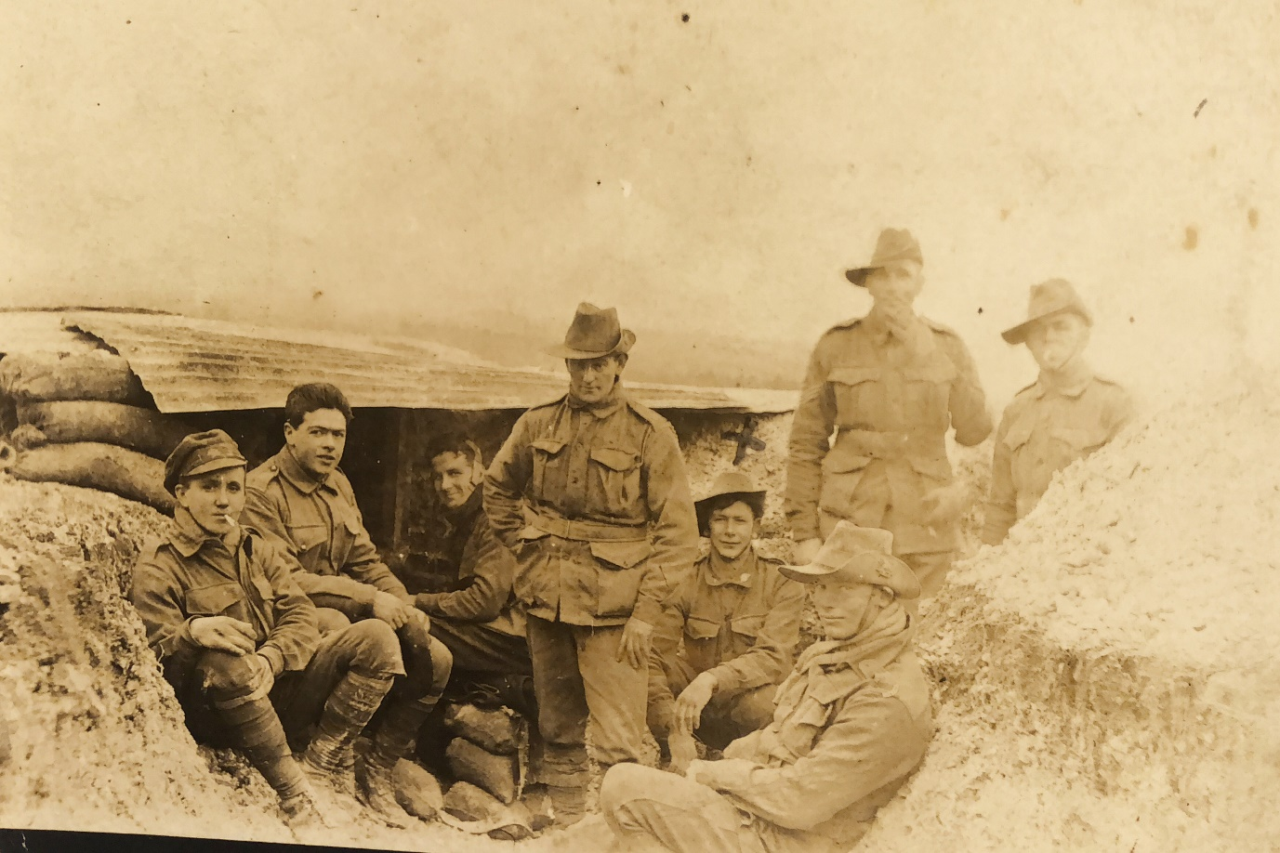
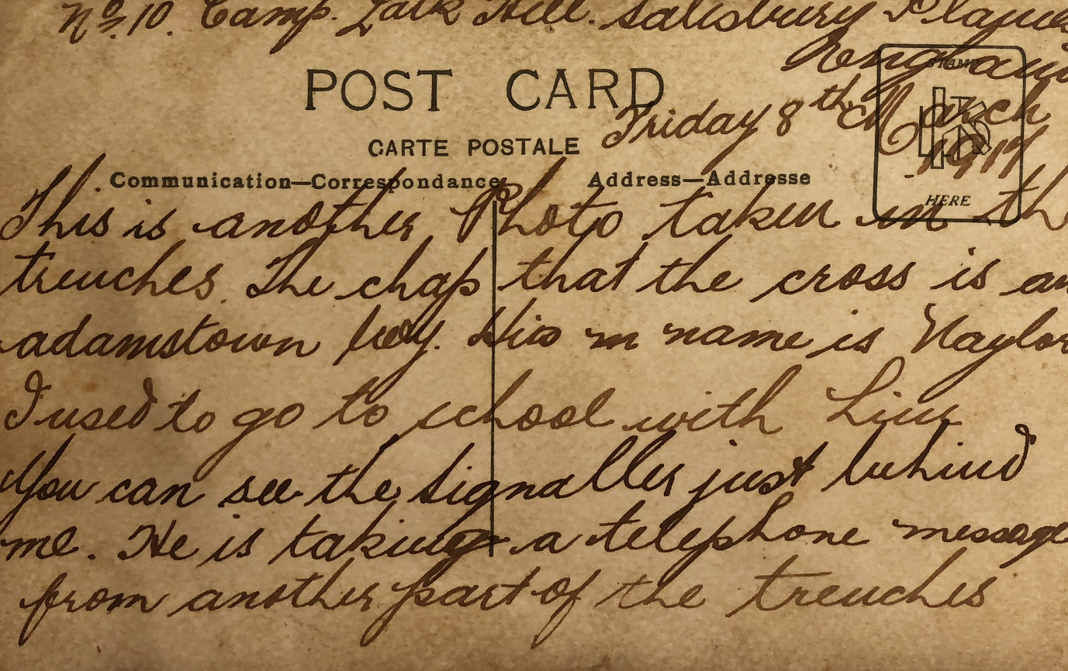

Training in UK
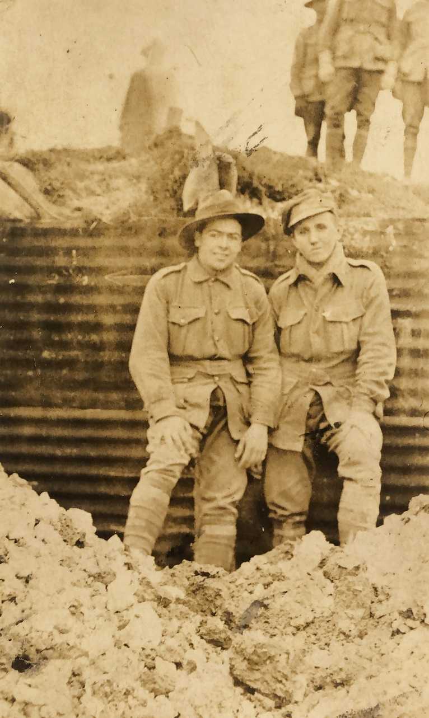

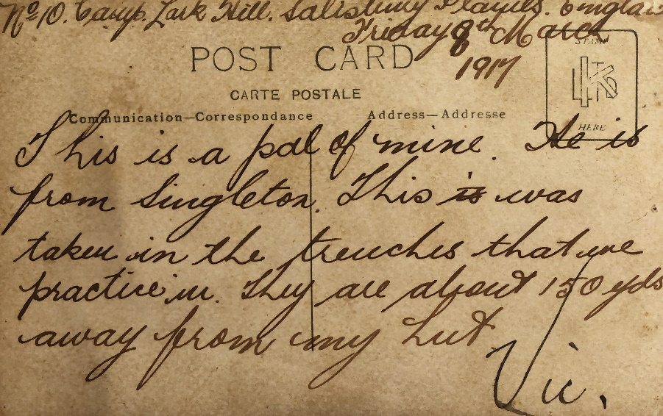

Combat History of the 34th Battalion
Image of the 2nd reinforcements of battalion arriving in UK in 1916
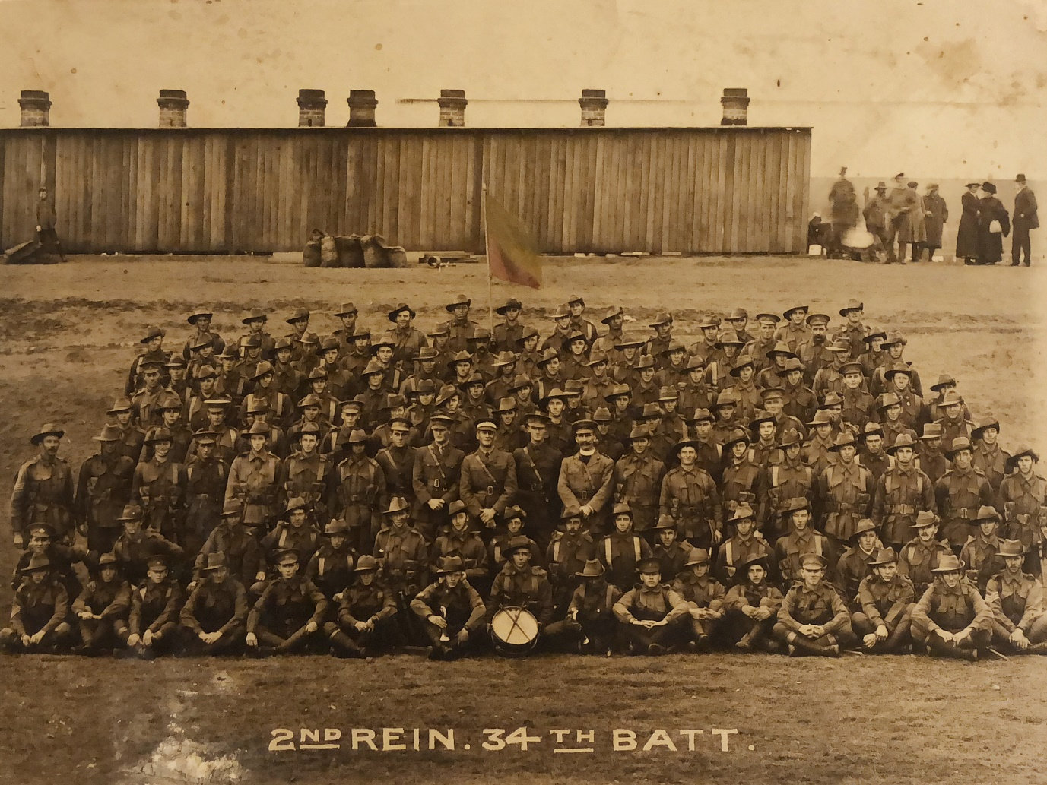
The 34th Battalion A.I.F was formed at West Maitland in January, 1916 and was chiefly composed of men from the Maitland and Northern Districts, the nucleus being those who took part in the Wallaby March from the North West of NSW.
After initial training at Rutherford Camp, it embarked on H.M.A.T Hororata (A20) on the 2nd May 1916 under the command of the Lt Col M Sj Lamb, and arrived at Larkhill on Salisbury Plains, England on 23 June 1916, where training was completed in conjunction with other units of the Third Division.
On 21st November, 1916, the Battalion embarked for France and received its first baptism of fire at Armentieres on 27 November, 1916. From this date until 6 June 1917, it held various sectors of the front line in that area, including the battle scarred Polegsteert Wood. During this period Lt.Col E E Martin D.S.O, V.D, took command of the Battalion on the 12 April 1917.
In its first major engagement was the attack on Messines Ridge on 7th June, 1917, which was an outstanding success in spite of the initial difficulties encountered in the form of gas and heavy bombardment.
During the following four months the Battalion alternately occupied the front line in the Messines and Ypres area, carrying out a number of local raids. Intensive training was also indulged in for the coming Third Battle of Ypres.
The Battle of Passchendale on 12th October, 1917, provided a gruelling test for all ranks, owing to the battle area being a quagmire of mud and slush into which , at times, men and horses completely disappeared. Great gallantry was displayed by all and more particularly by Captain C S Jefferies, who was posthumously awarded a Victoria Cross for outstanding bravery. The severity of this action is demonstrated by the fact that of the 22 Officers and 640 other ranks who took part, 15 officers and 250 other ranks were either killed or wounded.
After some months of comparatively quiet trench warfare interspersed with raids, including two on a large scale at Warneton, the battalion on the 26th March 1918 was hurriedly transferred to the Somme to take over a sector at Villers Bretonneux, where, after several weeks of severe and hand to hand fighting, the enemy’s advance was finally stopped.
The enemy having been successfully held by all in units in the affected area, the battalion on 4th May 1918 took up the offensive in the Morlancourt Sector, and by the continued harassing tactics, materially assisted in lowering the morale of the enemy until the “Big Push” on 8th August 2018, when the Allied Armies took the general offensive.
From this date until its final withdrawal from the Line on 2nd October 1918 the Battalion was continually advancing; successful engagements being fought at Bray, Clery, and the approaches to Mont St Quentin and Peronne.
Its final engagement was the storming of the Hindenburg Line in the vicinity of Bony.
Battle Casualties | Officers | Other Ranks
Killed in Action | 18 | 343
Died of Wounds | 4 | 105
Wounded | 62 | 1665

V Jones far left
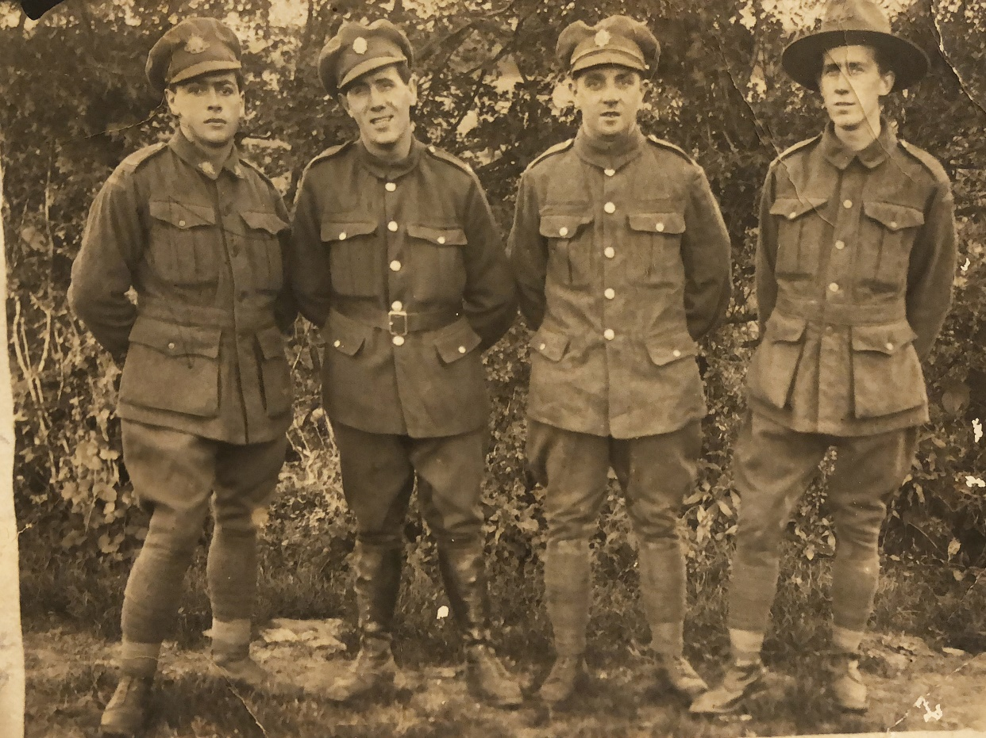
Unit photo (unconfirmed)
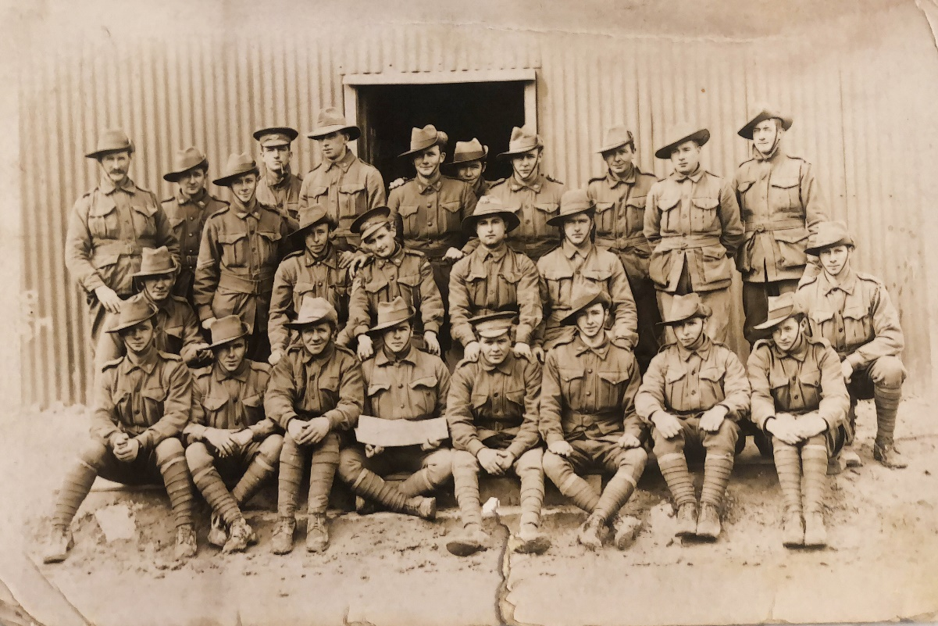

(persons unknown V Jones right )
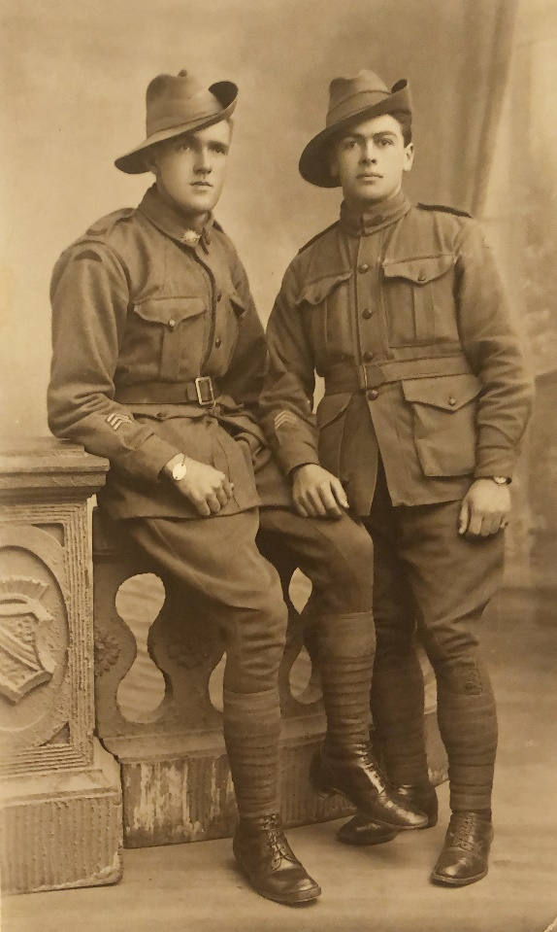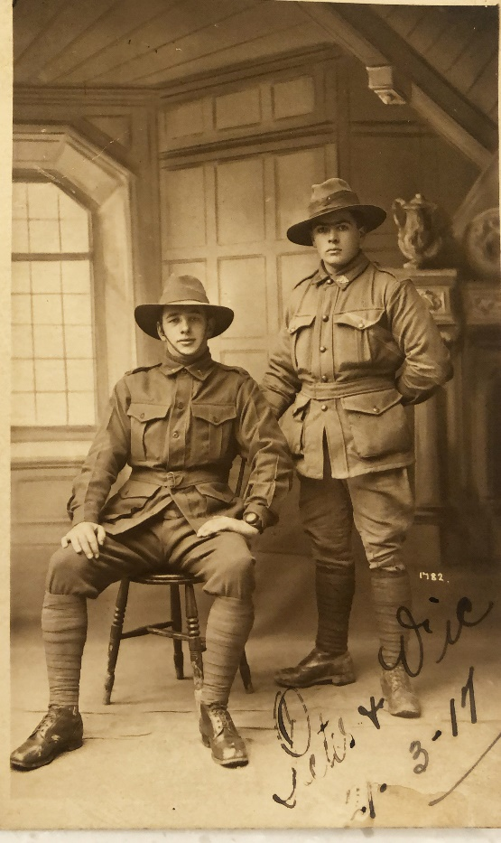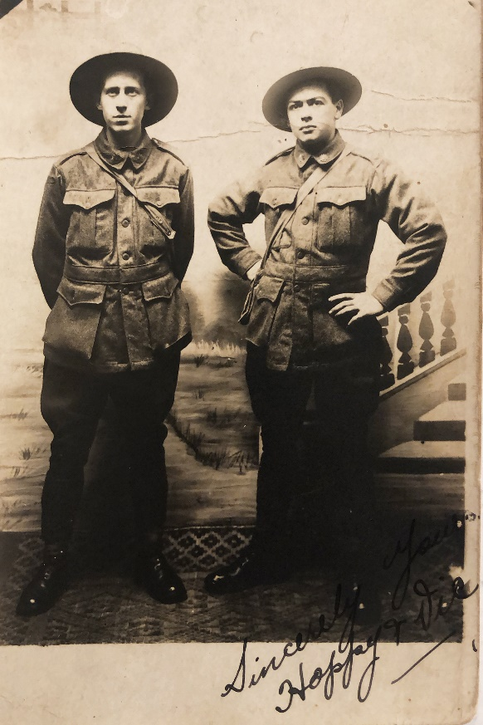

Leave and recreation
Miltary boxing (date unknown)
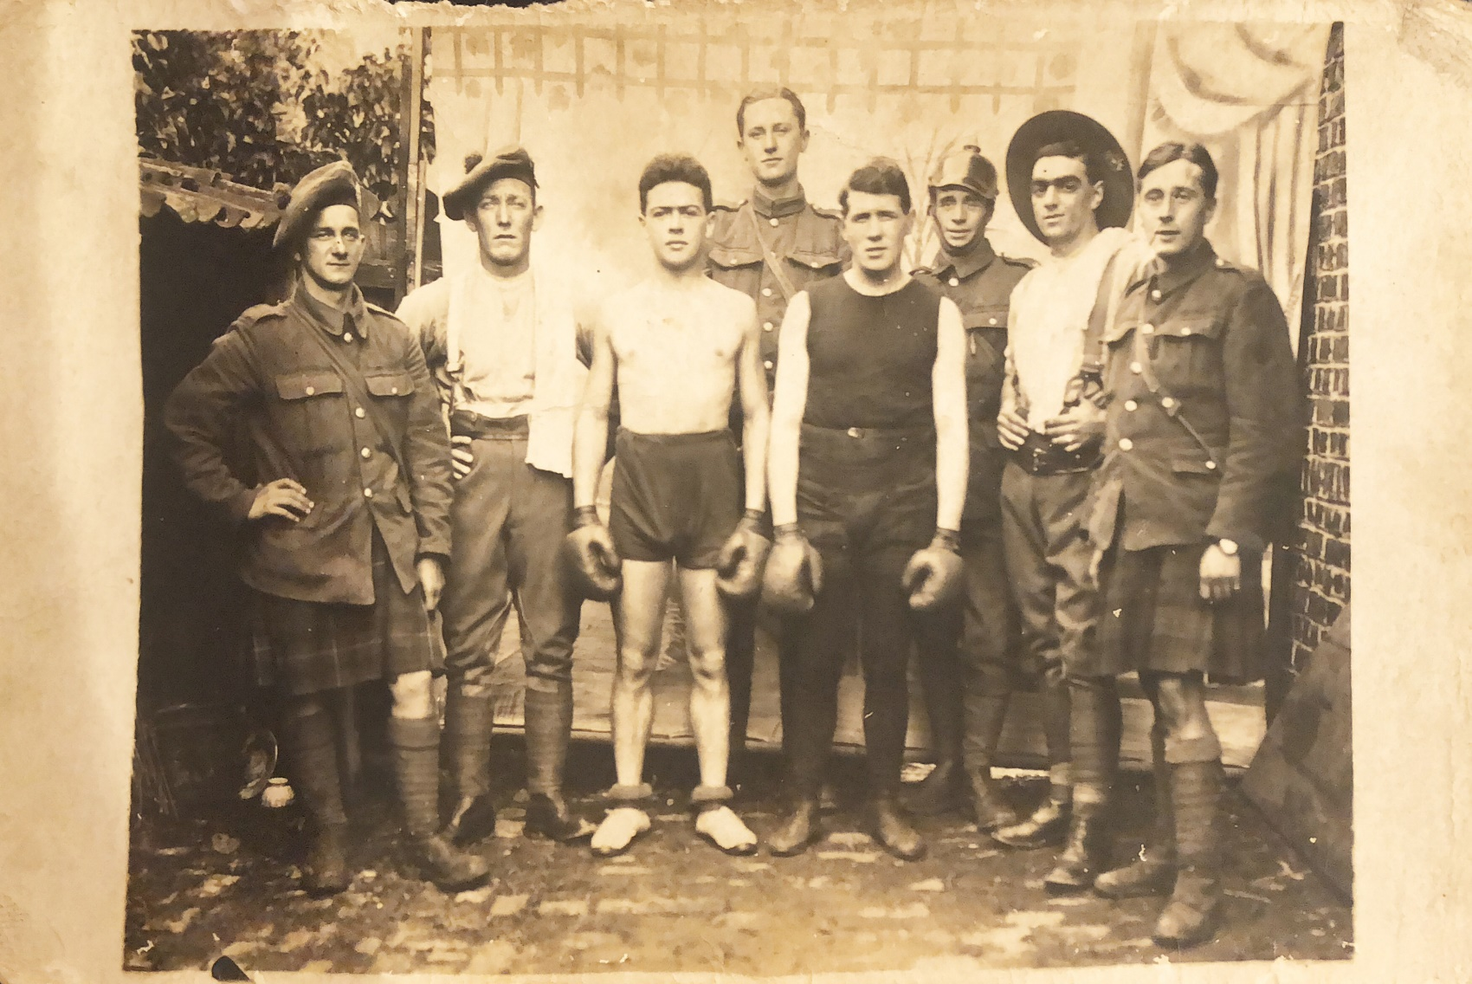
Victor Jones third from left

Winter photo France
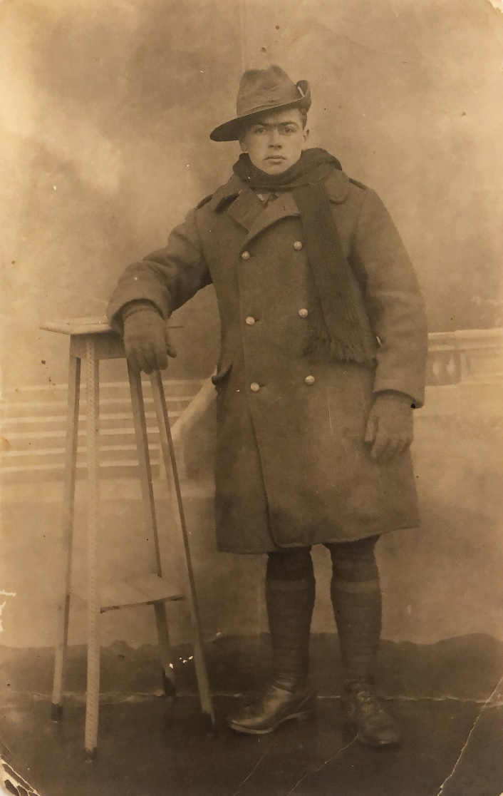
Leave pass and French tram tickets
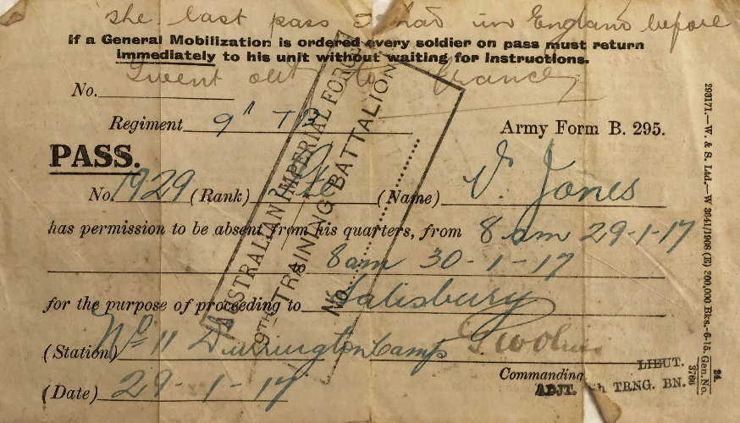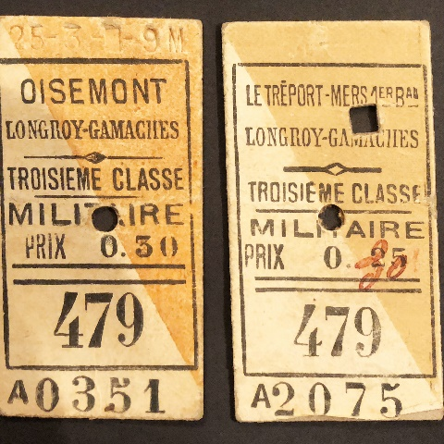

Post service life
Following the declaration of peace 11th November 1918, V Jones returned to France for some period. He returned to Australia on 19 June 6 months on the Themistocles after the declaration of peace and officially discharged on 19th September, 1919.
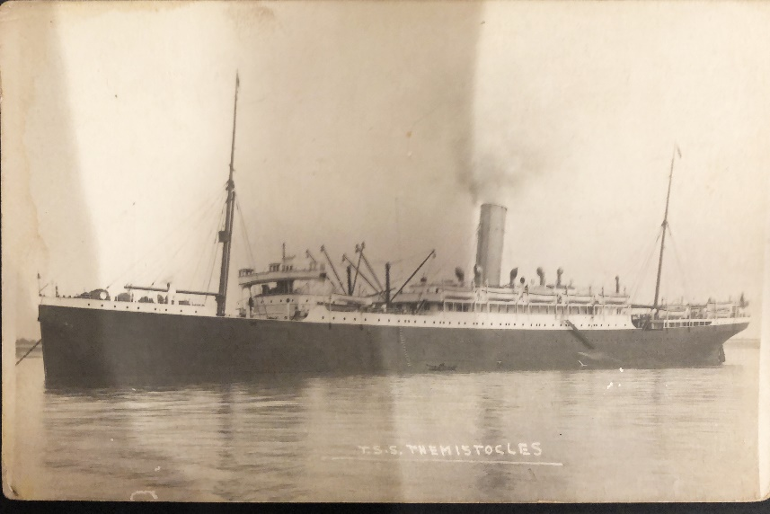
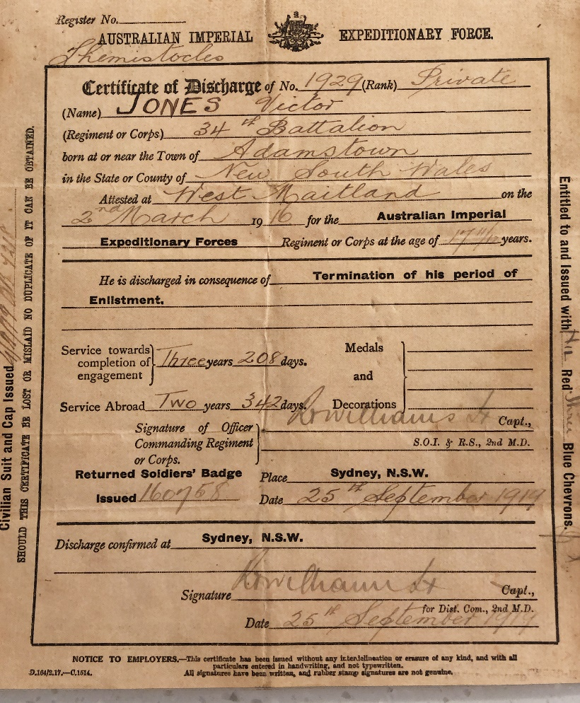

In repatriation Victor Jones was trained in Motor Mechanics (Vocational Training)
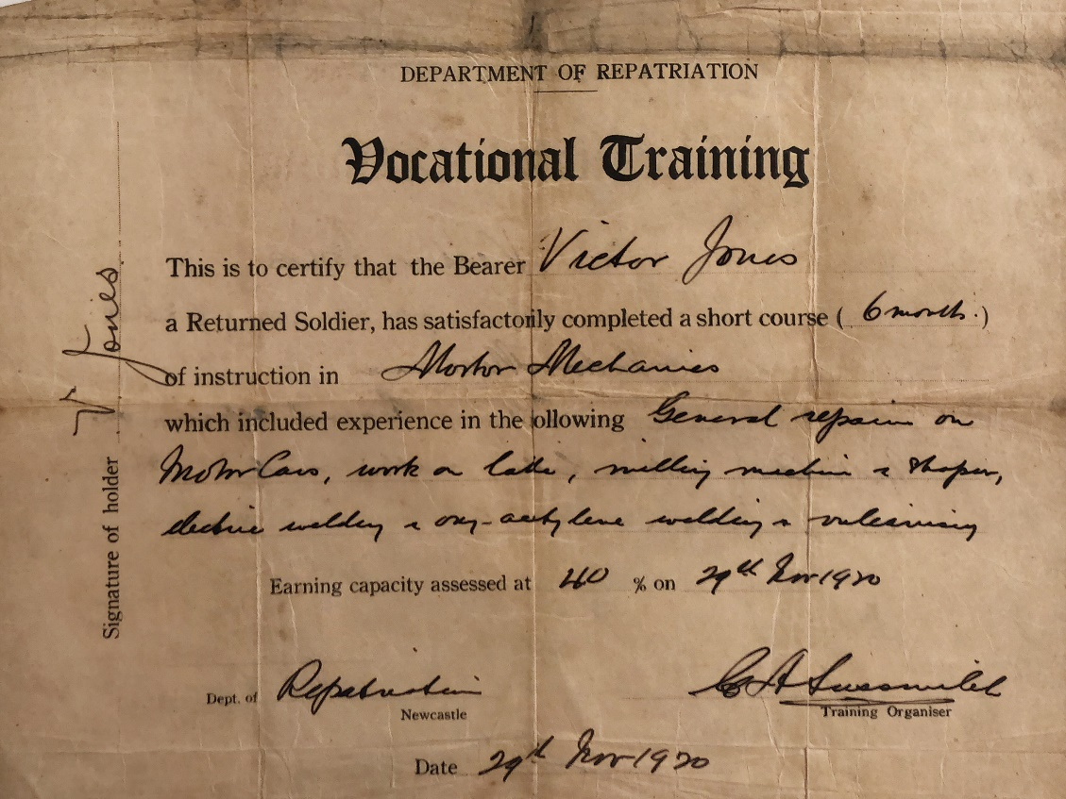
Victor Jones married Hazel Emily Foster on 13 September 1922.
They moved from Cessnock to Carlingford and established a motor garage.
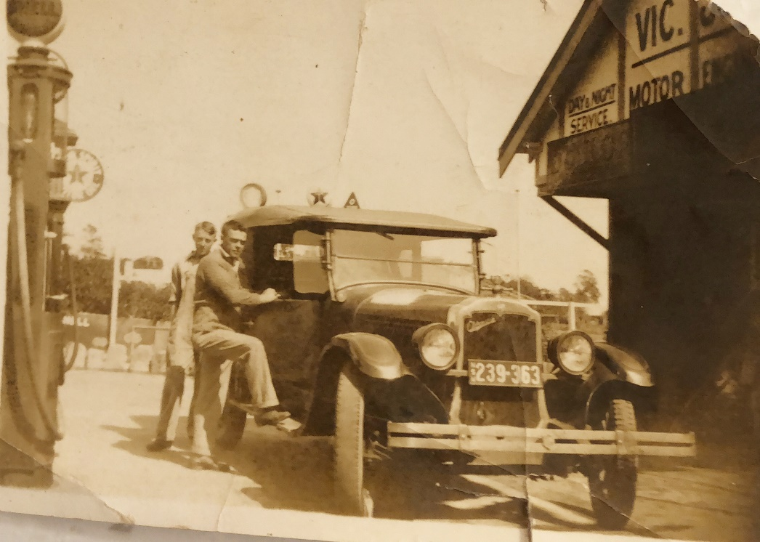

They had two surviving daughters: Margaret Jones and Jennifer Jones
- Margaret married Ronald Deakin of Merewether NSW
- Jennifer married Raymond Muddle of Epping NSW
Beach scene 1930’s
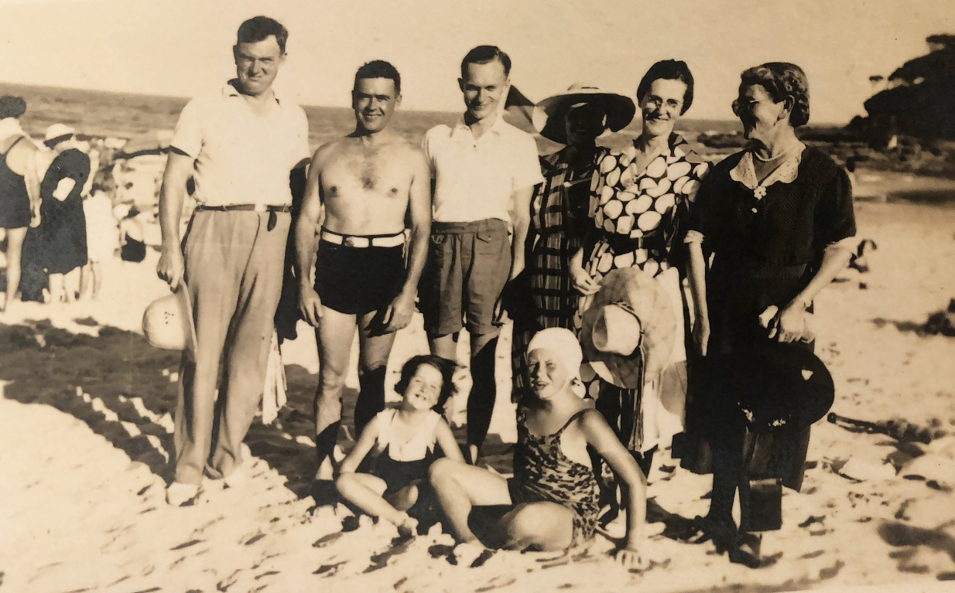
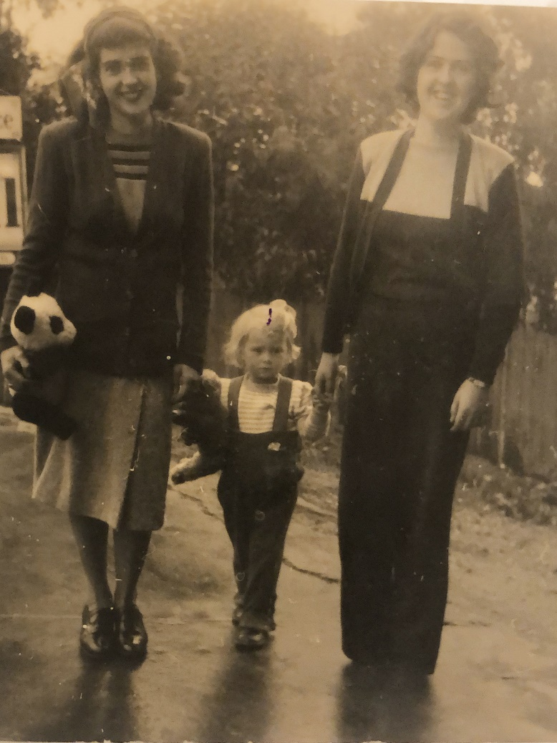

Birth Certificate
Attestation and Enlistment papers
Jones Family Ephemera
Statement of Service and Casualty Forms
Information sheet with battalion insignia, undated, author unknown, included in family documents.
Note Victor Jones was in the 2nd reinforcement transported under the A15 Port Sydney in September 1917.

