**Jacob (Jack) Victor LILWALL**

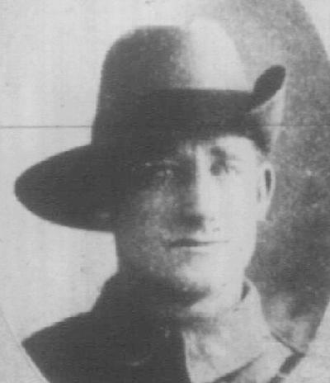

**Service number 5145**

Jacob (Jack) Victor LILWALL was born on 27 January 1892. Jacob volunteered to serve overseas with the Australian Imperial Force (AIF) at the age of twenty-three. Jacob lived in Gympie, Queensland, Australia with his mother Ms Elizabeth J Lilwall. At the time of enlistment 8th October 1915 Jacob had blue eyes, dark hair, fresh skin complexion, height 5ft 5 inches, chest size of 34-37 inches, he also weighed 132 pounds (59.87kg). When he first enlisted on 8th October 1915, Pte Lilwall was assigned to E Company 2nd Depot A.I.F. Pte Lilwall proceeded on embarkment overseas to France on the troopship HMAT Shropshire from Adelaide on 25th March 1916.

Upon HMAT Shropshire arriving in France on 25 August 1916 Pte Lilwall joined the 10th Infantry Battalion. Pte Lilwall remained in France for a period of 3 ½ years. He was able to travel to the United Kingdom whilst on leave for approximately 13 days which included travel time from France and return.

According to his Statement of Service record: Pte Lilwall had been admitted to several medical hospitals to overcome a number of illnesses and injuries. Pte Lilwall was transferred to Aust Corps School on 28/07/1918. He returned to Australia on the ship “Lancashire” from England on 4/02/1919.

As Jack was a serving member of the 10th Infantry Battalion it was made up of roughly 1,000 men with four battalions grouped together to form broader brigades. In 1917, the 10th Battalion participated in a number of offensives in Ypres including the Second battle of Bullecourt, Menin Road and Polygon Wood. 10th Battalion boarded HMAT Shropshire and arrived at Aden before sailing up the Suez Canal to Egypt.

|  |  |  |  |  |
| --- | --- | --- | --- | --- |
| **Statement of Casualty** |  |  | |  |
| **Report** |  | **Place** | **Date** | **Remarks, Doc Numbers** |
| DC 3T.B. | Proceeded overseas to France | Pers Doc | Entered 5/8/1916 | X3/6. AX1079 |
| 5/04/1917 Commanding Officer 10th Btn | Sick to hospital | France | 5/04/1917 | Doc Number A21/14 |
| 5/04/1917 2DRS | Accident sprained ankle |  | 5/04/1917 | A.K.1043/40 |
|  | Admitted sprained ankle |  | 5/04/1917 | A.K. 1043/57 |
| 29/04/1917 8th General Hospital | Sprained left ankle | Roven | 29/04/1917 1/05/1917 | A.K. 1149/65 |
|  | Sprained ankle and influenza |  | 25/04/1917 | A.K.1149/30 |
| 1/05/1917 2nd Company Depot | Administration | Roven | 1/05/1917 | A.K.1149/28 |
| 2/05/1917 C.O 10th Battalion | Certificate of Sickness. Accidentally injured at Brele while on foraging duty. Soldier not to blame | France | 2/05/1917 | AT 11961. 36/D.O. 2716 |
| 7/05/1917 2nd Company Depot | To 11 Hospital | Roven | 7/05/1917 | A.K.1149/65 |
| 7/05/1917 11Hospital Depot | Admitted Sprained ankle | Binchy | 7/05/1917 |  |
| 23/05/1917 11th Hosp Depot | Class A to 1st ADBD |  | 23/05/1917 |  |
| 26/05/1917 1ADBD | Transfer from Hospital | Haire | 23/05/1917 |  |
| 26/05/1917 | Admin signatories |  |  |  |
| 1/06/1917 C.O 10th Battalion | Rejoined from hospital | France | 29/05/17 | A21/22 |
| 22/09/1917 C.O 10th Btn | On leave to United Kingdom | France | 17/09/1917 | A21/38 B213 |
| 13/10/1917 C.O 10th Btn | Rejoined from leave U.K. | France | 1/10/1917 | A21/41 B213 |
| 10/05/1918 C.O. 10th Btn | Sick to hospital | Field | 10/05/1918 | A21/72 (37/2949) |
| 11/5/1918 3 Field Ambulance | Admitted Patient Under Observation (P.U.O.) to BBS | Field | 11/05/1918 | A.K. 2554/100 |
| 11/05/1918 15 BBS | Admitted P.U.O. | Field | 11/05/1918 | A.K. 2554/134 |
| 13/05/1918 14th Station Hospital | French Kever Admin |  | 12/05/1918 | Several paperwork numbers |
| 26/05/1918 14th Station Hospital | French Kever to 10th Battalion Depot |  | 26/05/1918 | A.K. 2554/179 |
| 26/05/1918 | Admin. French Kever |  | 26/05/1918 | A.K. 2554/179 |
| 9/08/1918 | Letter to 14th Station Hospital re:Admission |  |  |  |

Pte Lilwall was discharged from the Australian Imperial Force (AIF) on 4th July 1919 for being medically unfit.

Pte Lilwall (retd) applied for and received the Victory medal for his A.I.F. service on 19th May 1924.

Mr Jacob Lilwall died on 27th February 1977 at Tewantin, Queensland. He died at the age of 85 years old.

