Regimental number | 5027
Place of birth | Stockport South Australia
Occupation | Plaster
Address | Wallaroo, South Australia
Next of kin | Wife, Mrs Eliz Jane Lockwood, Wallaroo, South Australia
Unit name | 27th Battalion, 13th Reinforcement
Date of death | 21 June 1926
Age at death | 45
Private Leslie Herbert Lockwood was born circa January 1883, in Stockport, South Australia. There is very little information about his life pre-war. In 1904, he entered a gardening competition. In 1913, he was driving home in a horse buggy, when a motor car drove past and startled his horse. The horse was startled and galloped for a mile before Mr Lockwood turned onto someone’s property. However, the turn caused him to be flung off the buggy and onto the ground where he sustained a few bruises.
On 9/3/1916, Leslie Herbert Lockwood enlisted in the AIF in Kadina, South Australia. Over three months later, he boarded the HMAT Bulla to sail to Plymouth, England. He then proceeded overseas to France, where he was admitted into the ADBD (Australian Divisional Base Depot) In Étaples. After that, he took on the force in the 27th infantry battalion. He participated in the battle of Flers.
Almost 5 months later, he was wounded in action. He had suffered a bullet wound to the knee. He was then admitted to the 3rd Australian Casualty Clearing Station. He was then transferred to the hospital in Boulogne, and then again to a hospital in England. He stayed in the hospital for another 2 months and was discharged on 19/7/1917. He spent the next month recovering, but not in the field. On 28/9/1917, he was classified B1A4, which means that he was finally ready to go to a training camp once again. During the time that he was recovering, he marched in Perham Down multiple times.
On 5/11/1917, he embarked for Adelaide aboard the HMAT Themistocles. He was discharged from the AIF on 14/1/1918, due to being medically unfit from the gunshot wound in his right knee.
There is also very little information about his life after the war. However, it appears that one of his sons was a private during the second world war. Private S. R. Lockwood went missing overseas. His other son died from injuries from an accident that occurred on the 31st of December. Both of these events were during the space of a few months.

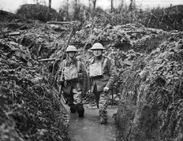
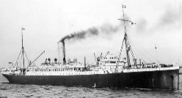
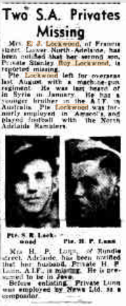
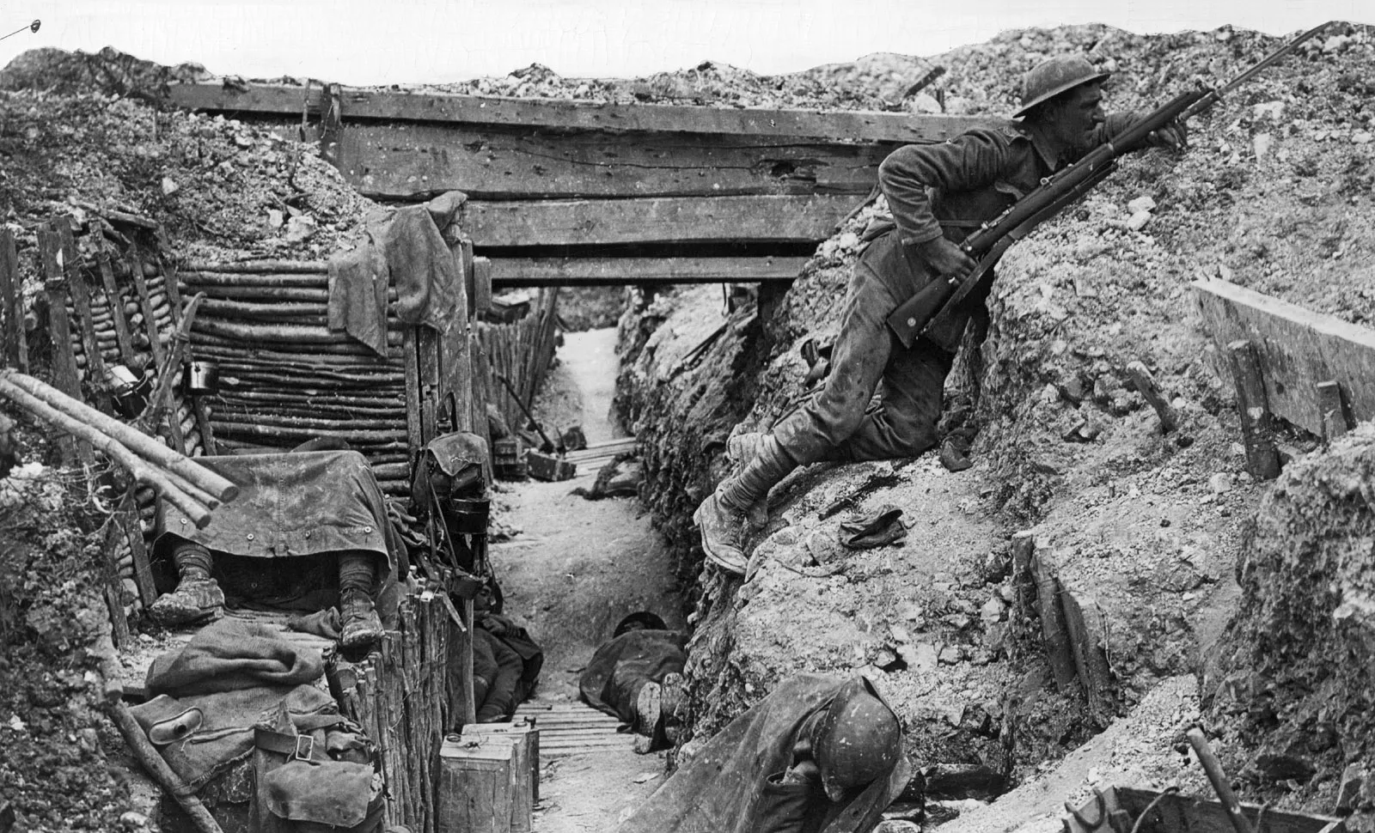
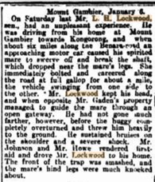
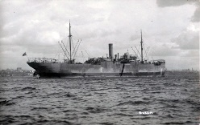
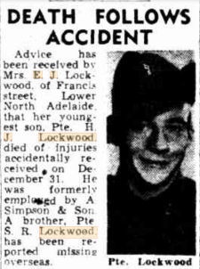
Trove. n.d. Two S.A. Privates Missing - News (Adelaide, SA : 1923 - 1954) - 14 Jul 1942. [online] Available at: <https://trove.nla.gov.au/newspaper/article/128365646?searchTerm=%22E%20J%20Lockwood%22> [Accessed 13 May 2022].

Trove. 2022. HANGED IN A SHED. - Saddleworth, January 7. - Chronicle (Adelaide, SA : 1895 - 1954) - 11 Jan 1913. [online] Available at: <https://trove.nla.gov.au/newspaper/article/88733982?searchTerm=%22L%20H%20Lockwood%22> [Accessed 16 May 2022].

Trove. 2022. DEATH FOLLOWS ACCIDENT - News (Adelaide, SA : 1923 - 1954) - 5 Jan 1943. [online] Available at: <https://trove.nla.gov.au/newspaper/article/128330602?searchTerm=%22E%20J%20Lockwood%22> [Accessed 16 May 2022].

Awm.gov.au. 2022. Battle of Flers. [online] Available at: <https://www.awm.gov.au/collection/E84320> [Accessed 16 May 2022].

Wiltshire-opc.org.uk. 2022. [online] Available at: <http://www.wiltshire-opc.org.uk/Items/Codford/Codford%20-%20Medical%20Classifications%20for%20Wounded%20&%20Sick%20Australian%20Soldiers.pdf> [Accessed 16 May 2022].

Recordsearch.naa.gov.au. 2022. View digital copy. [online] Available at: <https://recordsearch.naa.gov.au/SearchNRetrieve/Interface/ViewImage.aspx?B=8204195> [Accessed 16 May 2022].

