Charles George Clayton

Serial No. 67

Rank: Lance Corporal

Unit: 39th Battalion

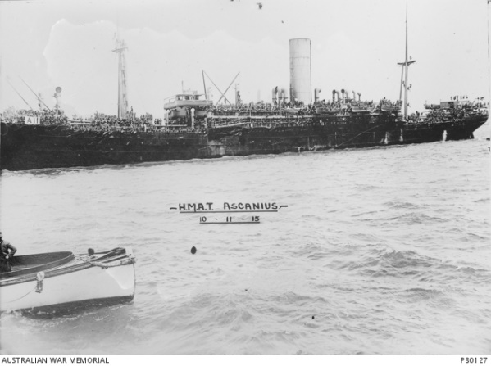Charles George Clayton was born in Fitzroy in 1897, the son of Frederick Clayton and Amy Ann Burkett. At the time of his enlistment the family was living at Greensborough. He was 18 years old and working as a labourer when he enlisted with his brother Ernest on 4th March 1916. They served together in the 39th Battalion.

After training in Ballarat he travelled on HMAT Ascansius A11 and saw active service in France. Charles was promoted to Lance Corporal on 15th June 1917. He was awarded the British War Medal and Victory Medal.

Charles George Clayton is commemorated in Greensborough on the Greensborough and District Honour Board at the Greensborough RSL.

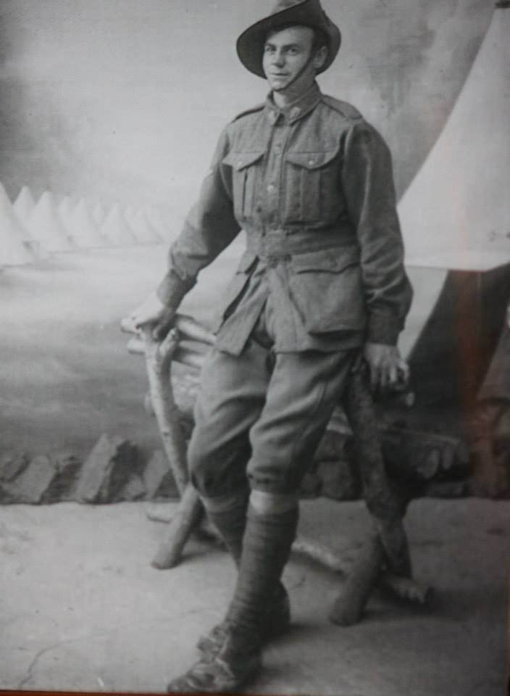

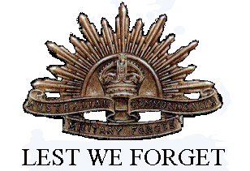

Charles’ daughter Mavis Cochrane was interviewed for the local paper (date unknown): ‘Grieving brother an unlikely hero. By Jim Tennison. Charles Clayton loved his big brother Ernest. As teenagers, both signed up in 1916 for the Great War. But only one was to return from the bloodbath of France and Belgium. The flip of a coin meant Charles saw his older brother killed in action. Yet it could easily have been the other way round. The tragedy happened at Messines on July 28 1917, when the Allies and Germans fought on the Western Front. The brothers from a family of 11 children were among 115,000 Victorian men to volunteer for service. Charles and Ernest were with the famous 39th Battalion. A forward party was needed that day to go into no-man’s land. Charles Clayton’s daughter Mavis Cochrane said:” The officer in charge asked for volunteers and Ernest stepped up. Of course anything Uncle Ernest did, Charles would also do. But the officer wouldn’t send two brothers out on such a hazardous job, so he tossed a coin. Ernest went out with a small party which was quickly under heavy fire. He was hit. When the stretcher bearers went to get him a shell exploded over their heads. The bearers were killed and Ernest died about an hour later from the shrapnel wounds. Dad just went out of his mind and started giving the enemy hell with his Lewis machinegun. Although the gunners either side of him were killed, he just kept firing and it’s estimated he took out 200 Germans.” Charles’s bravery was hailed by his comrades. But because all the officers had been killed, he could not be awarded a medal. Mrs Cochrane said her 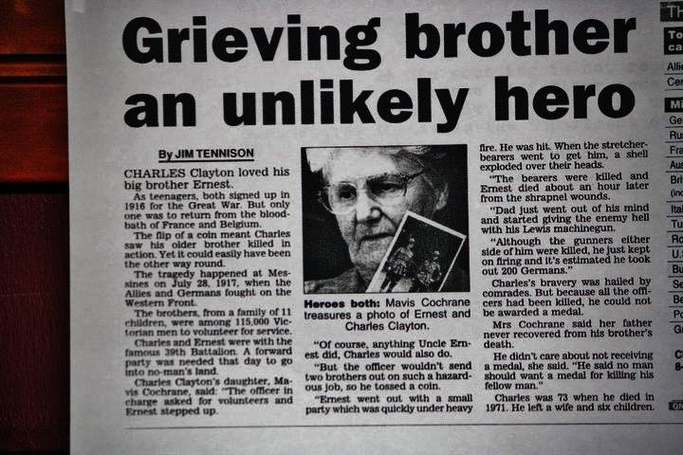father never recovered from his brother’s death. He didn’t care about not receiving a medal she said. “He said no man should want a medal for killing his fellow man.” Charles was 73 when he died in 1971. He left a wife and six children.’