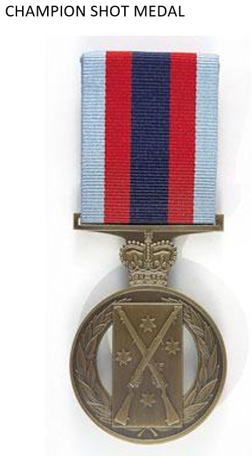 The **Champion Shots Medal** is a military award of Australia. In Australia the three armed forces, the [Royal Australian Navy](https://en.wikipedia.org/wiki/Royal_Australian_Navy), the [Australian Army](https://en.wikipedia.org/wiki/Australian_Army) and the [Royal Australian Air Force](https://en.wikipedia.org/wiki/Royal_Australian_Air_Force), conduct annual target-shooting competitions with standard issue weapons. Three medals – one for each force – are awarded to the winners.

No more than three medals can be awarded in each calendar year. If the same person receives a further Champion Shots award it is in the form of a date bar, which is attached to the ribbon of the original award.

**Australian Winners of King's/Queen's Medal**

|  |  |  |  |  |  |
| --- | --- | --- | --- | --- | --- |
| Year | Rank | Given Names | Surname | Unit/Formation | Score |
| 1928 | WOI (Hon Lt) | John | Hutchison | Australian Instructional Corps 2MD | 171 |

John HUTCHISON M.B.E.