

**SERVICE PERSON RESEARCH**

**SERVICE PERSON DETAILS**

|  |  |
| --- | --- |
| **Service Person’s Name** | Alfred Charles Roth |
| **Rank** | Private |
| **Service Number** | 2727 |
| **Regiment/Unit or**  **Ship or Squadron** | 52nd Battalion |
| **Date of Birth** | 7 Jan 1897 |
| **Place of Birth** | Eidsvold, QLD, Australia |
| **Family Details** | Single (engaged whilst serving in England)  Father: Charles Roth Mother: Lilly Roth |
| **Age at Enlistment** | 19 years 3 months |
| **Place of Enlistment** | Brisbane |
| **Date of Death** | 17 October 1917 |
| **Place of Death** | Broodseinde Ridge, Paschendale, Belgium |
| **Cemetery or**  **Memorial Name** | Menin Gate |
| **Grave or Memorial**  **Number** | Panel 7 - 17 - 23 - 25 - 27 - 29 - 31. |

**PHOTO**:

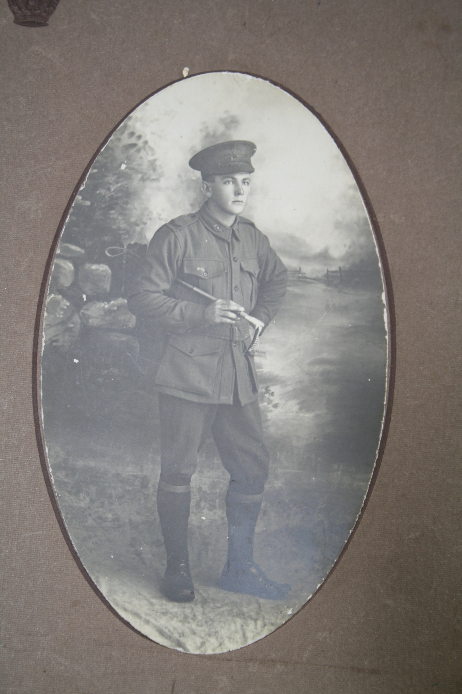

Source: Roth Family, scanned copy of family photo of Private Alfred Charles Roth

**SERVICE PERSON’S STORY/EULOGY:**

Prepared by Bailey Roth

Private Alfred Charles Roth (Alf) was born in Eidsvold, Central Queensland, a small rural community west of Bundaberg, renowned for timber and cattle. His parents were Charles and Lilly Roth who lived in a modest house raising 12 children, Alf being the eldest. Alf did not stay long at school and began work for his father as a carpenter and by the age of 16 was considered a master carpenter and job foreman, his father leaving him in charge of onsite projects. By personal letters of the time, he was very popular among his peers, led an active social life and was considered by many to be an excellent horseman.

In 1916, at the age of 19, Alf, with a few of his mates, heeded the call and joined up with the 1st Australian Imperial Force (AIF). He was soon on his way to the Western Front, arriving in early 1917 and joined the 52nd Battalion as reinforcement on the front lines. It wasn’t long before Alf had been lightly wounded and, suffering trench foot, was evacuated to England. While there recovering, he met Miss Edie Cooper and they soon became engaged, unofficially, as he had not yet told his mother.

In September 1917, Alf was again back in Belgium and very soon at the front with the 52nd. During the Battle of Broodseinde, at Paschendale and the Third Battle of Ypres, Alf was taking cover from shelling in his dugout with another man by the name of O’Neal, with the rest of A Company close by. At approximately 8am on 17 October 1917, an enemy shell landed directly on the dugout and the 20 year old was killed instantly. To quote eyewitnesses, the pair were “fairly knocked about” and were buried where they lay in the trenches. A small wooden cross was quickly erected to mark the position as the battle raged on, approximately a mile from Zonnebeck, near Paschendale. In the ensuing 12 months to the end of the war, the graves were lost amongst the mud and mire which was the Western Front.

Alf is now commemorated at the Menin Gate Memorial, simply a name on a piece of stone marking one of so many young lives cut short.

Alf is my great, great uncle, a boy from the North Burnett just like me, and only a couple of years older than me when he walked this same area. Thankfully our experiences are vastly different. Alf is certainly not forgotten. His saddle in which he rode as an excellent horseman, still hangs in my grandad’s shed in Eidsvold, just a few meters from where he lived with his parents. His personal effects, including letters to and from home, now almost 100 years old, are still held dear by his family, and his photo still takes pride of place in grandad’s library.

**BIBLIOGRAPHY:**

Australian War Memorial 2015, *Roll of Honour – 2727 Private Alfred Charles Roth*  
<https://www.awm.gov.au/people/rolls/R1664519/> (Accessed 21 February 2015)

Australian War Memorial 2015, *Embarkation Roll – 2727 Private Alfred Charles Roth*<https://www.awm.gov.au/people/rolls/R1917381/> (Accessed 21 February 2015)

Australian War Memorial 2015, *Red Cross wounded and missing, 2727 Private Alfred Charles Roth*  
<https://www.awm.gov.au/people/rolls/R1497924/> (Accessed 21 February 2015)

Browning, N, 2005, The 52nd Battalion: the history of the 52nd Battalion A.I.F. 1916-1918, Huntingale W.A.

Commonwealth War Graves Commission 2015, *2727 Private Alfred Charles Roth*<http://www.cwgc.org/find-war-dead/casualty/1600831/ROTH,%20ALFRED%20CHARLES> (Accessed 21 February 2015)

National Archives of Australia 2015, *ROTH ALFRED CHARLES*  
<http://recordsearch.naa.gov.au/SearchNRetrieve/Interface/ViewImage.aspx?B=8038483> (Accessed 21 February 2015)

**Personal Citations:**

Roth Family, personal effects including photographs, letters and postcards, medals

Mr Richard Roth (my grandfather), Oral Family History