My Great uncle Edward “Ted” Symons was born in Blinman in SA. After a argument with his father who did not allow Ted to go to the Boer War, he left and his family never saw him again. He went to Wiluna in WA. On his enlistment papers he had next to kin as none even though his parents George and Mary Ann Symons and 10 siblings were alive. His family were a very loving family and were devestated by him going. 5 brothers went to WW1 with Albert Gilroy Symons #2252 and John Malcolm Symons #26105 were killed in France andBelgium

**Edward Thomas Symons was born 11/8/1882 in Blinman. On your virtual memorial page, a dedication by Carol Foster is incorrect. Her relative is service number 1799**

I have done a intensive search on our Ted also with the help of Kerri Ward from National Archives of Australia. Ted changed his year of birth numerous times but not his actual birth day of August 11th. The WW2 service number W42795 papers were sent to me by Kerri about 5 years ago as I noticed his birth date was 11th August. Ted had put his birth year as 1897. I compared signatures from both enlistments and they were exactly the same. He was discharged from WW2 as they found out his correct age as he was over 60. He made out he was born in Katherine NT. Ted died in 1969 in WA aged 87. He never married. I have a lot more information on Ted if required.

(From my family book) I checked the NAA World War 2 records to see if there was an Edward Symons and there was. Service number was W42795. Born at Katherine in Northern Territory but the year date was 1897 so I thought maybe there was another Edward Thomas Symons until I noticed his birth date of 11th August which was too much of a coincidence. He made himself 15 years younger than he really was. I’m sure he changed his year of birth because if he kept his original service number from WW1, they would have deemed him too old to join.

I emailed NAA to see if they could assist as the war records for WW2 Edward were not yet examined and it may take a few months. Kerri Ward from NAA was most intrigued and assisted me by fast tracking with me obtaining the files.

I wanted to know if the Edward Thomas Symons were the same person in WW1 and WW2. (In WW1 on his form he was born in Blinman SA but the WW2 form stated he was born in Katherine in NT) Birth date on WW2 records were 11th August 1882. I then examined both signatures from Edward in both wars and they are exactly the same. Even though he stated he was born in 1897 for the WW2 papers, there is documentation that he was born 11/8/1882

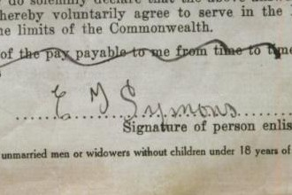 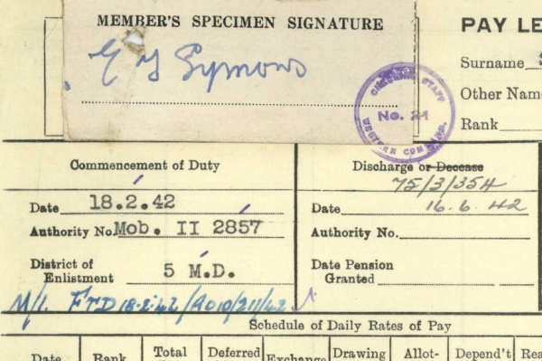

WW1 signature on enlistment form 1915 WW2 signature on WW2 discharge form 1943

Service number 4982 Service number W42795

The signatures were signed 28 years apart so it’s incredible how similar they are.

In both wars he stated next of kin – “none” in WW1 even though both parents and 10 siblings were alive. In WW2 his paper work for next of kin was “unknown”. Ted did not want to be traced.

On examining all his WW2 papers, he enlisted twice. On the 19th January 1942 he enlisted at Wiluna in Western Australia. Wiluna is about 800km north east of Perth and is the edge of the western desert at the gateway to the Canning stock route. It is a gold mining area. He was discharged on the 5th February 1943.

Ted then enlisted at Forrest in Western Australia for the Civil Construction Corps on the 8th May 1943 but was discharged on the 19th May 1943 due to being over the age of 60 years. Forrest is situated 200km north west of Eucla near the SA border.

On his WW2 “Mobilization Attestation form”, there was a section “Have you previously served in any Armed force” and he wrote “ Yes 1914 – 1918 AIF”. I know that in WW1 there were 2 Edward Thomas Symons with 1 born in Blinman in SA and the other in Sydney NSW so he definitely was not born in Katherine in NT as he stated in the news story.

I am sure that he decided he wanted to go to WW2 but changed his year date to make him younger but still kept the same birthday as 11th August.

His paperwork had his last employment as The Golden Horseshoe Retreatment Co at Kalgoorlie as a Sluice gunman in the mines. He was discharged from the WW2 Civil Construction Corps in May 1943 because they discovered that he was over the age of 60. He was 61 years of age and not 72 years old as stated in the news story.

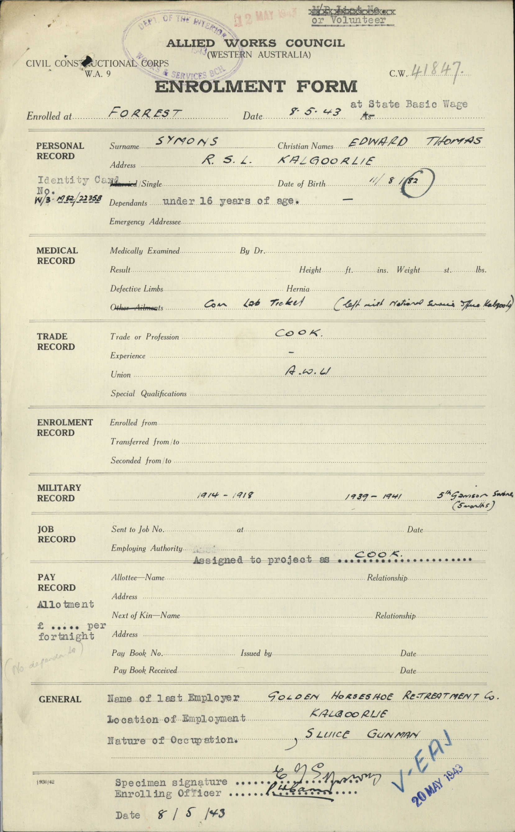

Edward’s enlistment form WW2 Civil construction Corps.

Note that he states his birth is 8/11/82 (1882)

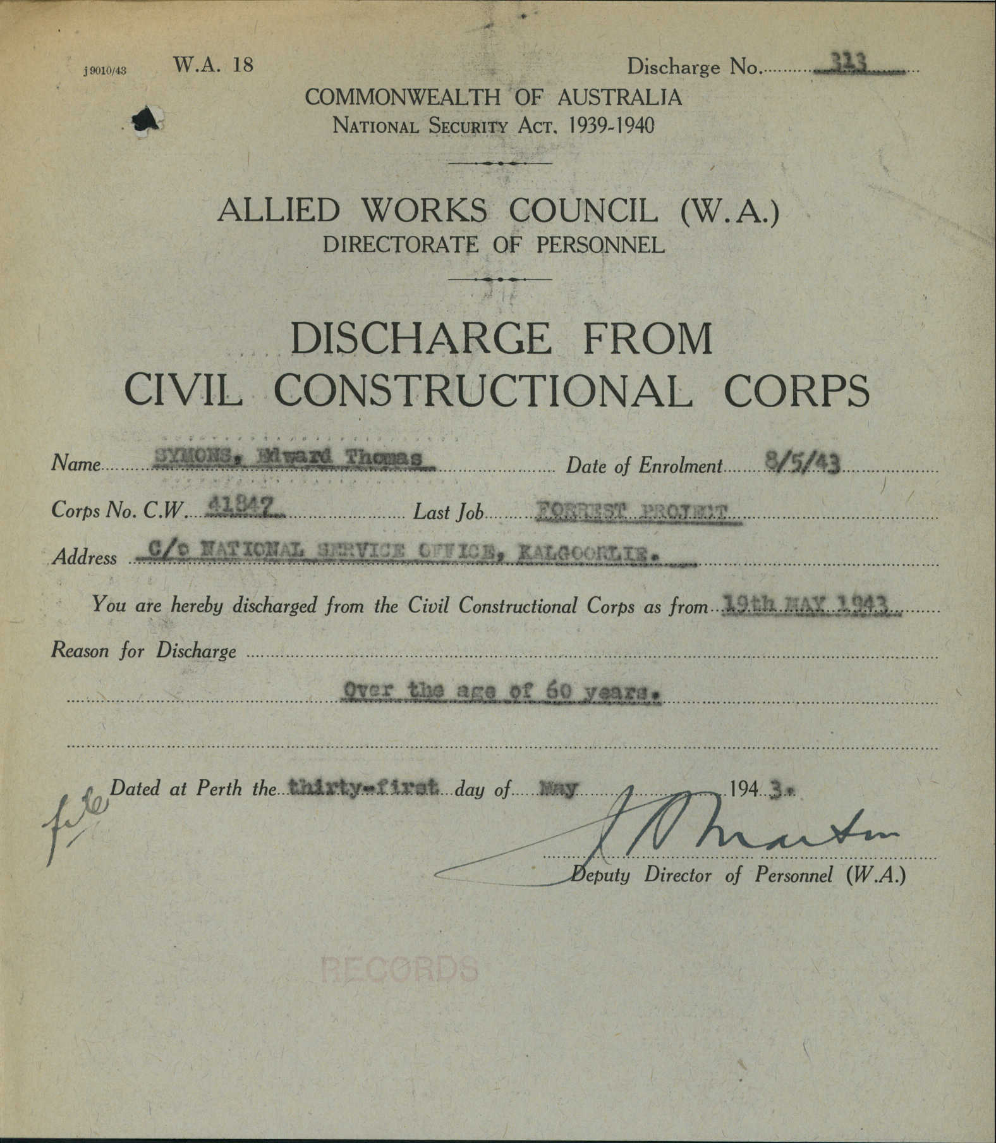

Copy of the discharge form from WW2 because he was over the age of 60 yrs

***I had his death certificate forwarded to me.***

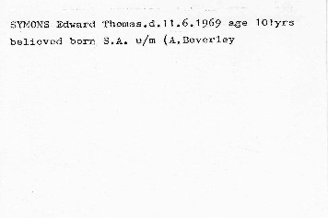

Even though in the story he said he was from the Northern Territory, the certificate states believed born in SA.

It was quoted also in the newspaper story that his birthday was 11th August but the year of birth was hard to verify.

I spoke in 2017 with Mal Symons (son of George Harold Symons) He also confirmed that Edward buried at Beverley is indeed Ted and that Mal visited his grave a few years ago. He was also able to give me a copy of his official death certificate (on the next page)

His age at death was 87 not 101 years

He did however was gassed and wounded in WW1. He was a stockman and a miner so he worked in the areas around Kalgoorlie and he enlisted for WW2 in the Civil Constructional corps but was discharged when it was discovered he was over the age of 61. He ended his final years at Brookton and Beverley hospitals in Western Australia. It was nice to know that he was affectionately known as “Pop”. He never married nor had children.

The family mystery has been solved and one day Ted will get some flowers on his grave in Beverley Western Australia to say that he was never forgotten.