**Reginald Wilfred (Bill) Rowed: Artist, Avid Skier and Raconteur**

Peter Vodicka

December 2019

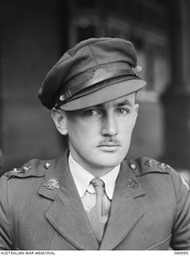

Lieutenant R.W. (Bill) Rowed –June 1945,

Australian War Memorial Collection <https://www.awm.gov.au/collection/P65132>

**Contents**

Introduction 2

Early Life and Education 2

Career 2

Personal Life and Interests 4

Bibliography 8

# Introduction

Reginald Wilfred Whiting (Bill) Rowed (28 August 1916 - 10 June 1990) was an [official Australian Second World War artist](https://en.wikipedia.org/wiki/Australian_official_war_artists) and printed textiles lecturer who taught at the Royal Melbourne Institute of Technology ([RMIT](https://en.wikipedia.org/wiki/RMIT_University)) from 1948 to 1976. He was also a well-known painter of the Australian high country, especially as a watercolourist, an avid skier and raconteur.

# Early Life and Education

Rowed was born in [Melbourne](https://en.wikipedia.org/wiki/Melbourne) in 1916 to a renowned [engineer](https://en.wikipedia.org/wiki/Engineer) come, [Anglican](https://en.wikipedia.org/wiki/Anglican_Church_of_Australia) clergyman, [Canon](https://en.wikipedia.org/wiki/Canon_(priest)) Augustine Bithray Rowed,[1] and Ada Jane nee Whiting.[2] He grew up in [Albert Park](https://en.wikipedia.org/wiki/Albert_Park,_Victoria) where his father was the vicar at [St. Silas Church](https://www.churchhistories.net.au/church-catalog/albert-park-vic-st-silas-and-st-anselm-anglican) - the church he built - for over thirty years. From 1934 to 1938, Rowed studied painting and drawing at the Melbourne Technical College, later RMIT, under [Napier Waller](https://en.wikipedia.org/wiki/Napier_Waller) and [John Rowell](http://adb.anu.edu.au/biography/rowell-john-thomas-nightingale-8284).[3]

# Career

After graduating, he worked as a commercial artist until 1940, mostly painting murals. Examples included [Flinders Street railway nursery crèche,](https://theculturetrip.com/pacific/australia/articles/12-things-you-didnt-know-about-flinders-street-station-melbourne/) Nursery of Mercy Hospital and Captain Cook's landing, in Peninsula House on Collins Street, Melbourne. In 1940, Rowed and [Daryl Lindsay](https://en.wikipedia.org/wiki/Daryl_Lindsay) designed recruitment posters which were selected from among 200 submissions and were used in connection with the Mural of Time film.[4]

In 1940, Rowed enrolled in the Army and later began pilot training in the [RAAF](https://en.wikipedia.org/wiki/Royal_Australian_Air_Force). In April 1945, he was appointed an official war artist of the [Australian War Memorial (AWM)](https://en.wikipedia.org/wiki/Australian_War_Memorial) and was commissioned to depict the war in the [New Guinea Campaign](https://en.wikipedia.org/wiki/New_Guinea_campaign). Located in [Bougainville](https://en.wikipedia.org/wiki/Bougainville_campaign), Rowed drew the Australian troops, the Japanese and the consequences of the war. After the [Japanese surrendered in August 1945](https://en.wikipedia.org/wiki/Surrender_of_Japan), he moved to [Rabaul, Nazab and Wewak](https://en.wikipedia.org/wiki/Aitape%E2%80%93Wewak_campaign) in order to experience the after-effects of the war. His pictures depict the opening of the [war trials](https://en.wikipedia.org/wiki/International_Military_Tribunal_for_the_Far_East) and departure of the [Japanese prisoners of war](https://en.wikipedia.org/wiki/Japanese_prisoners_of_war_in_World_War_II), the Australian troops at recreation and the circumstances of the native population and the country post-war.[5]

In 1946, he returned shortly to Melbourne where he finished the paintings from sketches he had made in New Guinea later joining the [occupying troops](https://en.wikipedia.org/wiki/Occupation_of_Japan) in [Hiroshima,](https://en.wikipedia.org/wiki/Hiroshima) Japan. There he recorded the effects of the [atomic bomb](https://en.wikipedia.org/wiki/Atomic_bombings_of_Hiroshima_and_Nagasaki), the graveyards and the hardships faced. The AWM holds Rowed's works from both New Guinea and Japan and has noted that 'the differences between the two are quite apparent'.[6]

In 1948, he was approached to establish a new Diploma course in printed textiles at RMIT where he remained as a lecturer until his retirement in August 1976.[7] Perhaps Rowed's most famous [alumnus](https://en.wikipedia.org/wiki/Alumnus) was fashion designer [Prue Acton](https://en.wikipedia.org/wiki/Prue_Acton) who graduated from his course in 1963.[8] Acton described Rowed as a 'very good teacher...who also introduced me to skiing'.[9]

In 1949 and 1950, Rowed had a number of works on display at exhibitions including the Melbourne Book Club Gallery[10] and [Georges](https://en.wikipedia.org/wiki/Georges_(store)) Gallery in Melbourne where it was stated that he had 'an interesting display of watercolours' and a style 'marked by extreme eclecticism'. Rowed was by this time displaying his love of the high country with works depicting scenes of the Victorian Alps as well as several seascapes of the Sydney coast; all which suggested that the artist was 'already effecting a new and expressive technique'.[11] In 1950, he shared the second prize for the Dunlop Award in oil painting for his work 'Tin Castle', coming behind Sidney Nolan who won the first prize.[12] In 1951, the [National Gallery of Victoria](https://en.wikipedia.org/wiki/National_Gallery_of_Victoria) purchased his work ['Mountain Landscape](https://www.ngv.vic.gov.au/explore/collection/work/2936/)', [Mount Feathertop](https://en.wikipedia.org/wiki/Mount_Feathertop) from the Razorback, a work of oil on canvas on plywood.

Rowed participated in an exhibition called 'Victoria's Snowlands' at the [Victorian Artists Society](https://en.wikipedia.org/wiki/Victorian_Artists_Society) in 1953, where it was stated that he had 'derived real inspiration from the subject, namely in his "The Road to Hotham," with its richly contrasting blues'.[13] And in 1954, he was part of the Twelve Melbourne Painters at the [Johnstone Gallery](https://en.wikipedia.org/wiki/Johnstone_Gallery) in [Brisbane](https://en.wikipedia.org/wiki/Brisbane) which included the likes of [Charles Bush and his partner/wife Phyl (Phyllis) Waterhouse](http://adb.anu.edu.au/biography/bush-charles-william-12272) as well as [Robert Grieve](https://www.robertgrieveart.com/) amongst others.[14]

Rowed continued with his snow country themes over the decades in oil, watercolours, screen printing, original Christmas cards and Club logbook entries with his works adorning the walls of many ski enthusiasts and friends, especially in Victoria.[15] When he retired from RMIT he opened a small studio, 'Kandahar Gallery' (which was a spoof on one his characters 'Colonel Kandahar', a blimpish military type, no doubt inspired by his time in the army), in Brighton, Victoria, where he displayed and sold his paintings and sketches.[16]

In more recent years, some of Rowed's works painted at Hiroshima have been included in exhibitions such as ['Reality in flames: Modern Australian Art and the Second World War'](https://www.awm.gov.au/media/press-releases/special-exhibition-reality-flames-modern-australian-art-and-second-world-war-opens)[17], curated by the Australian War Memorial and ['Black Mist Burnt Country: Testing the Bomb – Maralinga and Australian Art 2016-2019'](https://blackmistburntcountry.com.au/)[18], which was a national touring exhibition concerning the British atomic tests in Australia in the 1950s and 1960s.

# Personal Life and Interests

Rowed, a confirmed bachelor, developed his passion for [skiing](https://en.wikipedia.org/wiki/Skiing_in_Australia) in 1939, rekindling his interest after the [Second World War](https://en.wikipedia.org/wiki/World_War_II) and in 1948 joined (later becoming a life member) the [Wangaratta Ski Club](https://www.wangskiclub.org.au/Home.php) which has its lodge at Mount St. Bernard[[14]](https://en.wikipedia.org/wiki/Draft:Reginald_Wilfred_Rowed#cite_note-14) near [Mount Hotham](https://en.wikipedia.org/wiki/Mount_Hotham) in the [Victorian Alps](https://en.wikipedia.org/wiki/Victorian_Alps).[19]

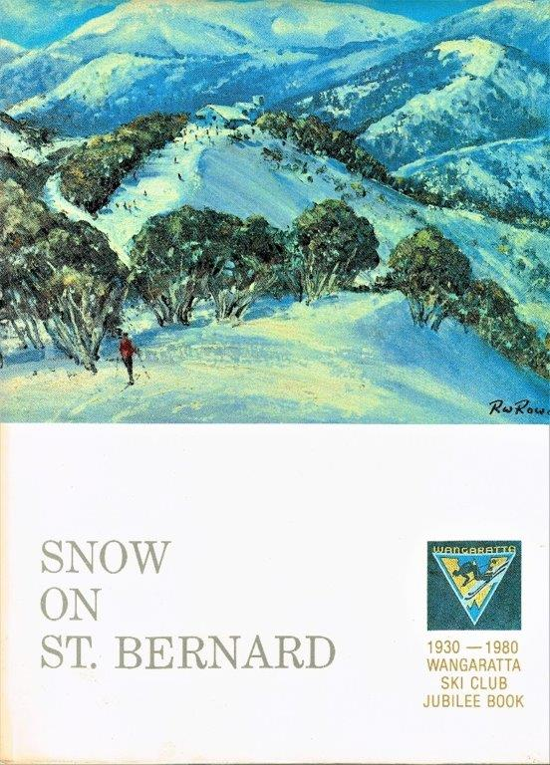

The cover of the 1980 Wangaratta Ski Club jubilee book was painted by Bill Rowed.

In the 1954 [Australian Ski Year Book](https://catalogue.nla.gov.au/Record/1615948), Rowed wrote about [skiing at Mount St. Bernard](https://www.australianmountains.com/australianskilifts#17), saying that it had modest possibilities compared to other ski areas and that the Wangaratta Ski Club was based there and had cleared runs in the area. The main slope of St. Bernard was considered moderate but more interesting diversions could be had by going over the cornice on the southside and making one's way down the [Dargo Road](https://www.dangerousroads.org/australia-and-oceania/australia/3968-dargo-high-plains-road.html), thence left down into the big timber in the valley far below. The Club also had a [langlauf](https://en.wikipedia.org/wiki/Langlauf) [(cross country skiing)](https://en.wikipedia.org/wiki/Cross-country_skiing) course which took in part of the Dargo Road and then detoured through the hill beyond.[20]

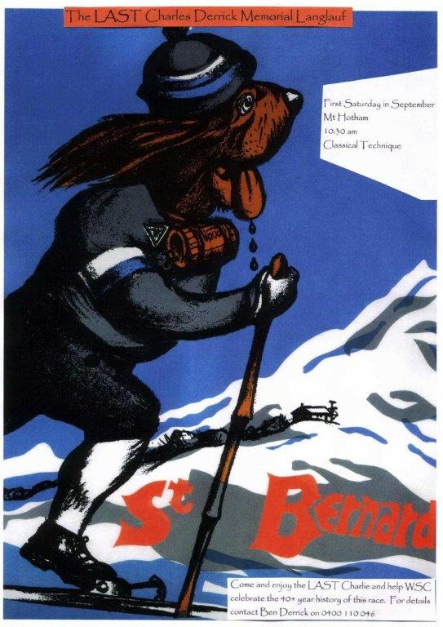

**The Final Charlie Derrick Memorial Langlauf – 5 September 2009**[21]

The poster for the Charlie Derrick cross country ski race was first designed by Bill Rowed in the 1970s

In 1959, Rowed invited a colleague from RMIT, [Victor Vodicka](https://en.wikipedia.org/w/index.php?title=Victor_Vodicka&action=edit&redlink=1), who had become homesick after nearly a decade away from his native [Czechoslovakia](https://en.wikipedia.org/wiki/Czechoslovakia) to the club and he joined it shortly afterwards in 1960.[22] Both men were foundation members of the [Mount Bogong Club](https://mtbogongclub.org.au/), which was formed in 1965 to promote the safe recreational use of [Mount Bogong](https://en.wikipedia.org/wiki/Mount_Bogong), Victoria's highest peak, and to maintain the [Cleve Cole Memorial Hut](https://mtbogongclub.org.au/cleve-cole-hut/) and the [Michell Refuge](https://mtbogongclub.org.au/michell-refuge/). For nearly three decades, Vodicka joined Rowed on cross country ski trips to the Victorian high country in winter and bushwalking and other social activities during the summer months.[23]

In 1961, ['Schuss' ski magazine](https://trove.nla.gov.au/work/6197137?q&versionId=7166246), first published Rowed's renowned article/speech on 'Why I Ski'. This was classic Rowed doggerel designed to satirize politicians, the military and the clergy (including his 'Bishop of [Porepunkah](https://en.wikipedia.org/wiki/Porepunkah" \o "Porepunkah)' character) and contained his warning that Australia faced a menace 'not only from the North...but - and let us all most fully alive to this fact - from the South...I can state quite categorically...that the Penguins are marching on us, marching resolutely and indomitably, northward. Already they have proved themselves a well-organised and well-disciplined force. They have been conducting landing exercises on the at our own beautiful Phillip Island and have even gone to the extent of building and erecting barbed-wire barricades. They have sent scouting parties into Port Phillip Bay and even as far as the lower reaches of the Yarra River.'[24]

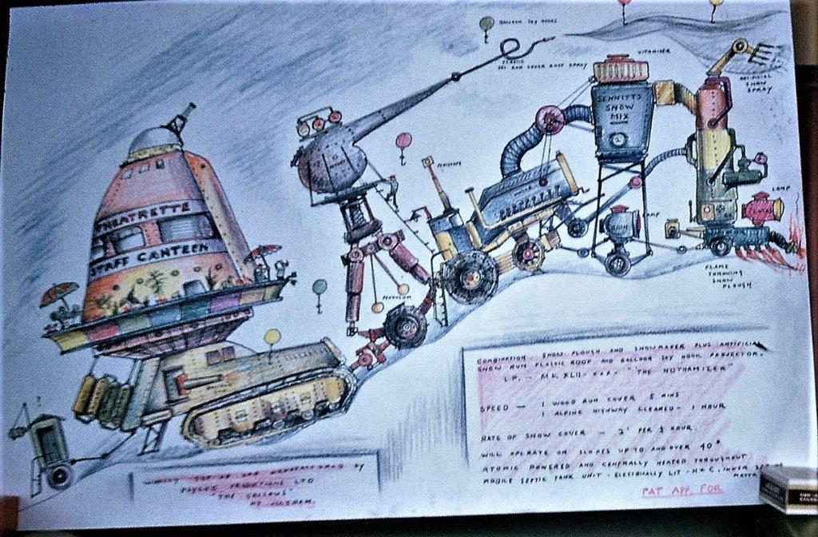

Bill Rowed - ‘Combination Snow Plough and Snowmaker plus Artificial Snow Run Plastic Roof and Balloon Sky Hook Projector’ circa the 1960s

At his 75th birthday celebrated at the Cleve Cole Hut in October 1984, pioneer Mount Hotham skier and Mount Bogong Club president, [P.E. (Mick) Hull (1909 - 1995)](https://brookfarm.com.au/about/inspiration/), noted that Rowed 'did his inimitable "invasion" by the Penguins, with his rendition of [Dame Clara Butt](https://en.wikipedia.org/wiki/Clara_Butt) as an encore'. Hull described Rowed as a 'prolific artist' who was 'a staunch companion of many an "up Bogong" venture' and accompanied Hull on overseas ski trips to Austria. Rowed also painted the cover of Hull’s book, 'Mountain Memories'.[25]

Throughout the 60s, 70s and 80s Rowed continued his romance with skiing both in Australia and abroad, his art and his satirical 'sermons', dying peacefully at the [Alfred Hospital](https://en.wikipedia.org/wiki/The_Alfred_Hospital) in Melbourne in June 1990, aged 73.[26]

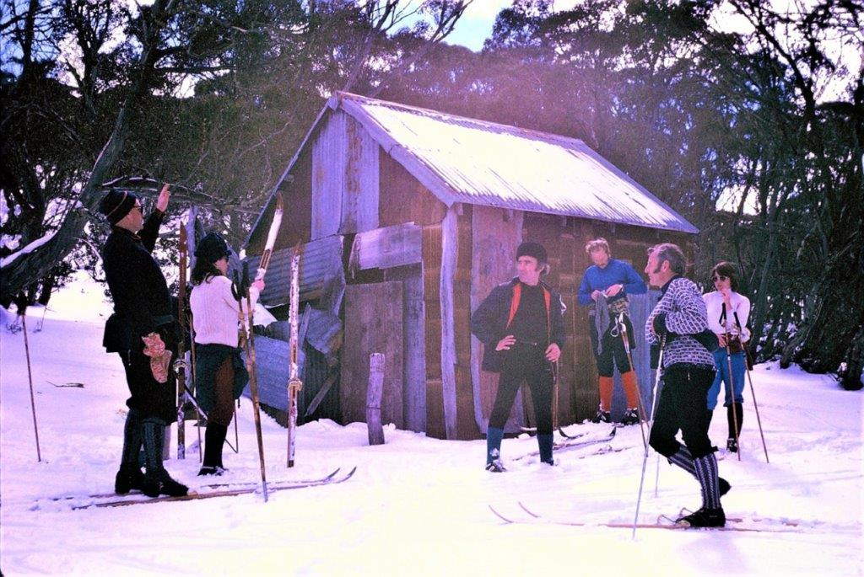

Bill Rowed (left) delivering a ‘sermon’ to fellow ski tourers at Maddison’s (Aertex) Hut on Mt Bogong in 1973

# Bibliography

[‘Art Exhibitions’](http://nla.gov.au/nla.news-article206070729), Age, Melbourne, 5 April 1949. Retrieved 11 December 2019.

[‘Art Notes’](http://nla.gov.au/nla.news-article205374086), Age, Melbourne, 26 September 1950. Retrieved 11 December 2019.

‘[Art Notes’](http://nla.gov.au/nla.news-article206234733), Age, Melbourne, 6 June 1950. Retrieved 11 December 2019.

[‘The 60s rebel with designs on fashion’](https://www.newspapers.com/image/120724388/), Age, Melbourne, 6 March 1987. Retrieved 22 December 2019.

Allan, Christopher, [‘Australian War Memorial's Reality in Flames offers insight into WWII’](https://www.theaustralian.com.au/arts/review/australian-war-memorials-reality-in-flames-offers-insight-into-wwii/news-story/5e7834bd0c3887d3566a0f4376501e11), The Australian, 22 March 2014. Retrieved 25 December 2019.

Ancestry.com.au, Reginald Wilfred (Bill) Rowed, [R.W. Rowed Entry](https://www.ancestry.com/family-tree/person/tree/155100131/person/292048923510/facts). Retrieved 29 December 2019.

Lieutenant Reginald Rowed, The Australian War Memorial, www.awm.gov.au. Retrieved 10 December 2019.

['Black Mist Burnt Country: Testing the Bomb – Maralinga and Australian Art 2016-2019'](https://blackmistburntcountry.com.au/) Website. Retrieved 25 December 2019.

[‘Melbourne artists have an attractive show’](http://nla.gov.au/nla.news-article50569293), Courier-Mail, Brisbane, 31 March 1954. Retrieved 11 December 2019.

Derrick, Ben, ‘Charlie's Final Farewell’, Kangaroo Hoppet Australia's International Ski Marathon Website, 23 July 2009, <https://www.hoppet.com.au/xc/xcfiles/general/winter09.htm#july23>. Retrieved 28 December 2019.

[‘Art Review’](http://nla.gov.au/nla.news-article249177146), Herald, Melbourne, 10 February 1953. Retrieved 11 December 2019.

‘The Angry Mountain’, Herald, Melbourne, 23 August 1973. 

Mick Hull, *Mountain Memories: Sixty Years of Skiing*, South Yarra, Victoria, MH Books 1990.  [ISBN](https://en.wikipedia.org/wiki/International_Standard_Book_Number) [0-7316-9606-9](https://en.wikipedia.org/wiki/Special:BookSources/0-7316-9606-9). [OCLC](https://en.wikipedia.org/wiki/OCLC) [27605534](https://www.worldcat.org/oclc/27605534).

[‘Prue Acton](https://www.mervmoriarty.com/prueacton_awards)’, Prue Acton Website. Retrieved 22 December 2019.

‘The Final Call - Augustine Bithray Rowed’, Record, Emerald Hill, Victoria, 24 August 1940. Retrieved 28 December 2019, from <http://nla.gov.au/nla.news-article164971535>

Osborne, Bruce and Callander, Bill (eds.), *Snow on St. Bernard: the Wangaratta Ski Club jubilee book, 1930-1980*, illustrated by: Bill Rowed and Graham Welsh, Wangaratta Ski Club, 1980.

[Rowed, R.W., 'The St. Bernard Area', in *Australian Ski Year Book, 1954*, pp 65-6.](https://www.khuts.org/images/stories/ASYB/Victorian%20Articles/ASYB1954_StBernard_Rowed.pdf) Retrieved from Kosciuszko Huts Association 29 December 2019, <https://www.khuts.org/images/stories/ASYB/Victorian%20Articles/ASYB1954_StBernard_Rowed.pdf>

[‘Bill Rowed leads friends across the Eskdale spur at Mt Bogong to celebrate his sixtieth birthday in the Cleve Cole Memorial Hut, Mt Bogong, Victoria, 1976’](https://nla.gov.au/nla.obj-141724514), Retrieved December 29, 2019, from <http://nla.gov.au/nla.obj-141724514>.

[Death Notice, The Sydney Morning Herald, 13 June 1990, p. 46](http://www.newspapers.com/image/120723568/), Newspapers.com. Retrieved 12 December 2019.

Vodicka, Victor, Speech on the retirement from RMIT of RW (Bill) Rowed by his colleague VV Vodicka, 19 August 1976 (Copy in possession of the author).

1. Augustine Bithray Rowed, ‘The Final Call’ (24 August 1940), *Record (Emerald Hill, Vic.: 1881 - 1954)*, p. 7. Retrieved 28 December 2019, from <http://nla.gov.au/nla.news-article164971535>
2. Reginald Wilfred (Bill) Rowed, [R.W. Rowed Entry](https://www.ancestry.com/family-tree/person/tree/155100131/person/292048923510/facts), Ancestry.com.au.
3. Lieutenant Reginald Rowed, The Australian War Memorial, www.awm.gov.au. Retrieved 10 December 2019.
4. Ibid.
5. Ibid.
6. Ibid.
7. Speech on the retirement from RMIT of RW (Bill) Rowed by his colleague VV Vodicka, 19 August 1976. [[1]](https://en.wikipedia.org/wiki/File:RW_(Bill)_Rowed_Farewell_Speech_on_his_retirement_by_VV_Vodicka_19_August_1976.pdf)
8. [‘Prue Acton](https://www.mervmoriarty.com/prueacton_awards)’, Prue Acton Website. Retrieved 22 December 2019.
9. [‘The 60s rebel with designs on fashion’](https://www.newspapers.com/image/120724388/), The Age Melbourne Victoria Australia. 6 March 1987. Retrieved 22 December 2019.
10. [‘Art Exhibitions’](http://nla.gov.au/nla.news-article206070729), Age (Melbourne, Vic.: 1854 - 1954). 1949-04-05. p. 2. Retrieved 11 December 2019.
11. [‘Art Notes’](http://nla.gov.au/nla.news-article205374086), Age (Melbourne, Vic.: 1854 - 1954). 1950-09-26. p. 2. Retrieved 11 December 2019.
12. ‘[Art Notes’](http://nla.gov.au/nla.news-article206234733), Age (Melbourne, Vic.: 1854 - 1954). 1950-06-06. p. 2. Retrieved 2019-12-11.
13. [‘Art Review’](http://nla.gov.au/nla.news-article249177146), Herald (Melbourne, Vic.: 1861 - 1954). 1953-02-10. p. 11. Retrieved 2019-12-11.
14. [‘Melbourne artists have an attractive show’](http://nla.gov.au/nla.news-article50569293), Courier-Mail (Brisbane, Qld.: 1933 - 1954). 1954-03-31. p. 2. Retrieved 2019-12-11.
15. Bruce Osborne and Bill Callander (eds.), *Snow on St. Bernard: the Wangaratta Ski Club jubilee book, 1930-1980*, illustrated by: Bill Rowed and Graham Welsh, Wangaratta Ski Club, 1980, pp. 91, 133 & 166-7.
16. Ibid. and Lieutenant Reginald Rowed, The Australian War Memorial.
17. Christopher Allan, [‘Australian War Memorial's Reality in Flames offers insight into WWII’](https://www.theaustralian.com.au/arts/review/australian-war-memorials-reality-in-flames-offers-insight-into-wwii/news-story/5e7834bd0c3887d3566a0f4376501e11), The Australian, 22 March 2014. Retrieved 25 December 2019.
18. ['Black Mist Burnt Country: Testing the Bomb – Maralinga and Australian Art 2016-2019'](https://blackmistburntcountry.com.au/) Website. Retrieved 25 December 2019.
19. Bruce Osborne and Bill Callander (eds.), op cit.
20. [R.W. Rowed, 'The St. Bernard Area', in *Australian Ski Year Book, 1954*, pp 65-6.](https://www.khuts.org/images/stories/ASYB/Victorian%20Articles/ASYB1954_StBernard_Rowed.pdf) Retrieved from Kosciuszko Huts Association 29 December 2019, https://www.khuts.org/images/stories/ASYB/Victorian%20Articles/ASYB1954_StBernard_Rowed.pdf
21. The final Charles Derrick Memorial Langlauf at Mt Hotham was held on 5 September 2009. The first race was first held in 1966, the year following the death of Wangaratta Ski Club (WSC) member Charles Derrick’s attempt to ski from Mountain Creek at the foot of Mt Bogong to Mt Hotham in a day and ran for over 40 years. The race and weekend developed into more than just a race and represented the spirit and camaraderie of cross-country skiing as well as a time to remember a skiing enthusiast whose life was cut short in pursuit of a goal. In later years, numbers attending the race and the weekend fell dramatically. The WSC race committee tried changing the date to earlier in the season and the course, with little effect on participation levels so it was felt that the race had literally run its course. It was decided that 2009 would be the final staging of the race. It was moved back to its traditional date on the first Saturday in September on the original course around Mt Loch with the traditional party back at the WSC lodge at Mt St Bernard after the event. Ben Derrick, ‘Charlie's Final Farewell’, Kangaroo Hoppet Australia's International Ski Marathon Website, 23 July 2009, <https://www.hoppet.com.au/xc/xcfiles/general/winter09.htm#july23>. Retrieved 28 December 2019.
22. V. Vodicka, op cit. and Bruce Osborne and Bill Callander (eds.), op cit.
23. ‘The Angry Mountain’, The Herald (Melbourne), 23 August 1973, p. 37 and [‘Bill Rowed leads friends across the Eskdale spur at Mt Bogong to celebrate his sixtieth birthday in the Cleve Cole Memorial Hut, Mt Bogong, Victoria, 1976’](https://nla.gov.au/nla.obj-141724514), Retrieved December 29, 2019, from <http://nla.gov.au/nla.obj-141724514>.
24. Bruce Osborne and Bill Callander (eds.), op cit.
25. Mick Hull, *Mountain Memories: Sixty Years of Skiing*, p. 208. 
26. [Death Notice, The Sydney Morning Herald, 13 June 1990, p. 46](http://www.newspapers.com/image/120723568/), Newspapers.com. Retrieved 12 December 2019.