**ROY MACONACHIE, PMS 1934-35**

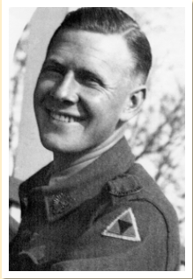

Roy David Maconachie was born in Dundee, Scotland, on 31 May 1920. The family migrated from Scotland and settled in Bassendean at 53 Government Road. Roy was the eldest of four surviving children. He had red hair and was known to his sister Rhoda and brothers Norman and Gordon as “Big Ginge”. His father, David, was a grocer and died in 1940 at the age of 48. His mother, Flora, died in 1970 at the age of 75.

He commenced his second year of high school at Perth Modern School on 6 February 1934. Remarks on his record in 1934 include, “Done quite well… seems not strong - guard against over-work” (April) and “Managed very well – good earnest lad” (August). In third year in 1935 comments are “Continues to advance and is doing well (April) and “Greatly improved” (August). He was absent from school for a fortnight in June 1935 with Scarlet Fever.

In 1935 Roy passed his Junior examinations in English, French, History, Maths A, Maths B, Physics, Chemistry and Geography. He obtained a job at Cox Brothers department store in Perth. He later worked as a clerk at Goldsborough Mort and Company Limited, auctioneers and wool brokers.

Roy enlisted in the Australian Military Forces at the Claremont Showgrounds on 6 December 1940 at the age of 20. He was appointed to the 2/4th Machine Gun Battalion on 9 January 1941 and qualified as a Signaller on 1 May 1941. During that time, he became engaged to Irene Gilby of Shenton Park.

On 30 December 1941 the Battalion departed from Darwin on the *Westralia* and the *Marella* to Port Moresby where they transhipped to the Cunard Liner *Aquitania*. The *Aquitania*, only half full, sailed south to Sydney to take on more soldiers before sailing onto Fremantle. No shore leave was permitted so Roy and his good friend from Bassendean, Archie Mackintosh, went absent without leave for 15 hours to visit their families (Archie died on the Burma Railway on 10 November 1943). The *Aquitania* arrived in Singapore on 24 January 1942.

Aquitania

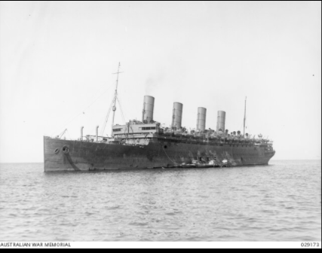

The Japanese had invaded Malaya on 8 December 1941. By the time the Battalion arrived in Singapore, the Japanese had pushed the surviving British forces down the Malayan Peninsula and onto Singapore Island. The gunners of the 2/4th Machine Gun Battalion fought hard and well defending the island but suffered heavily. Between 8 and 15 February the 2/4th had 137 men killed or missing, 106 men wounded, and 24 described as having "shell shock". These casualties constituted almost one-third of the battalion. Two of them were Modern School students Manson Butcher (1936-39) who was killed on 11 February aged 19, and Benjamin Hansen (1925-27) who was killed on 12 February, aged 29.

The survivors became prisoners of war (POW) when the British commander, Lt General Percival, surrendered all British forces on 15 February 1942. POW #1067 Roy Maconachie was interned in Changi gaol until 8 July 1942 when, as a member of “B” Force comprising 1,495 Australians, he was transported on the cargo-passenger ship *Ume Maru* to Sandakan in North Borneo (now the Malaysian State of Sabah) to construct a military airfield. On arrival 10 days later, they marched 13 kms to Sandakan No. 1 POW Camp.

The construction work was hard and conditions were hot, humid and oppressive. Their clothes and boots disintegrated and their rations were at the survival level. Tropical illnesses such as malaria, beriberi and tropical ulcers, and an absence of medical supplies, took a severe toll. Regular random thrashings by the “bash gangs” resulted in more deaths. A runway was completed in September 1943. However, frequent Allied bombing put the aerodrome out of action by December 1944.

In early 1945, the Japanese High Command ordered that no prisoners were to survive the war. Those still able to walk were sent on three series of death marches through the mountains to the town of Ranau, 260 kms from Sandakan. The first series of marches occurred between January and March 1945. They comprised 470 prisoners in 10 groups of around 50 prisoners each. Prisoners who collapsed from exhaustion were killed or left to die on the track.

**Sandakan-Ranau Route Where Roy Died**

|  |  |
| --- | --- |
|  |  |

Roy was in the second series of marches which consisted of 536 prisoners. Roy left the Sandakan camp with the first group on 29 May 1945. He died 42 kms from Sandakan on either 3 June (CWGC) or 5 June (NAA) from acute enteritis (inflammation of the small intestine). He was one of the 353 who died on the track and is remembered on Panel 18 of the Labuan Memorial. When those who survived the second march arrived at Ranau on 24 June 1945, only six of the 470 men of the first series of marches were still alive.

The final march began on 9 June 1945. Only 75 of the remaining 250 prisoners we able to walk. None survived 50 kms. When they fell a Japanese guard shot them. The remaining prisoners at Sandakan were either killed or left to die of sickness and starvation.

A handful of prisoners escaped while on the marches or from Ranau. Six of these, all Australians, survived. They are the only survivors of the 2,434 Allied prisoners at Sandakan, on the track or at Ranau, 1,787 of whom were Australians. The Sandakan death marches remain the greatest single atrocity committed against Australians in war.

Federal parliamentarian Adair Blain was also a prisoner in Sandakan. A Modern School student when it opened in 1911, Adair was arrested in Sandakan in 1943 for planning an escape attempt. He was severely bashed and transported to the notorious Outram Road gaol in Singapore to serve an 18-month prison term which undoubtedly saved his life.

Former Modern School student and signaller Roy Maconachie was 25 when he died. He is remembered on Panel 18 of the Memorial in the Labuan War Cemetery on Labuan Island, just off the west coast of Borneo and 326 kms by air west of Sandakan.

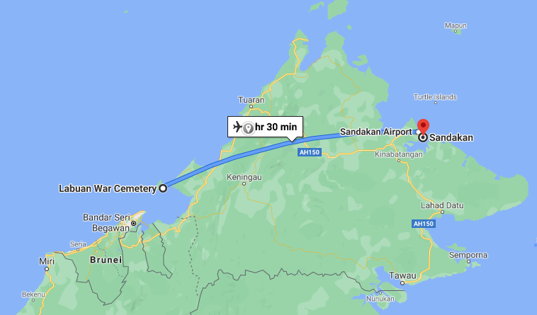

**LEST WE FORGET**

References:

The landmark work on Sandakan is Lynette Ramsay Silver’s “Sandakan, A Conspiracy of Silence”. Author Bryce Courtenay, in his historical fiction story *Four Fires*, states, “It is a formidable work of scholarship by a very persistent woman…A Conspiracy of Silence ought to be compulsory reading for every Australian.”

Other references are listed below:

* Cody, Les, *Ghosts in Khaki, The History of the 2/4th Machine Gun Battalion, 8th Australian Division, AIF*, Hesperian Press, Victoria Park, 1997
* Ewen, Murray, *Colour Patch: The Men of the 2/4th Australian Machine Gun Battalion,* Hesperian Press, Victoria Park, 2003.
* Firkins, Peter, *From Hell to Eternity*, Westwood Ho, 1979.
* 2/4th Machine Gun Battalion Ex-members Association <http://2nd4thmgb.com.au/soldier/wx9801/> , http://2nd4thmgb.com.au/wp-content/uploads/2016/09/Sandakan10final-1.jpg
* Australian War Memorial <https://www.awm.gov.au/collection/C335189?image=1> , <https://www.awm.gov.au/collection/U56173>
* Commonwealth War Graves Commission

<https://www.cwgc.org/find-records/find-war-dead/casualty-details/2143506/ROY%20DAVID%20MACONACHIE/>

* Department of Veterans’ Affairs <https://www.dva.gov.au/documents-and-publications/sandakan-memorial-park>
* National Archives of Australia <https://recordsearch.naa.gov.au/SearchNRetrieve/Interface/ViewImage.aspx?B=6463534>
* WA Government Births Deaths and Marriages <https://bdm.justice.wa.gov.au/_apps/pioneersindex/default.aspx>
* Wikipedia <https://en.wikipedia.org/wiki/Sandakan_Death_Marches> , <https://en.wikipedia.org/wiki/Goldsbrough_Mort_%26_Co>