**Leading Aircraftman – Colin Robert Caporn - 153238**

Colin Robert Caporn was born on as the first child of Leonard Caporn and Doris Maud Caporn (née Martin) on 3 February 1926. Colin had 3 sisters Evelyn Maud born on 1 September 1928, Sybil Joan born on 7 July 1930 and Clara Lorna born on 2 February 1932. Colin’s uncle was Lt. Col. Stanley Sibb Caporn and his cousin Sargent Robert Ian Caporn.

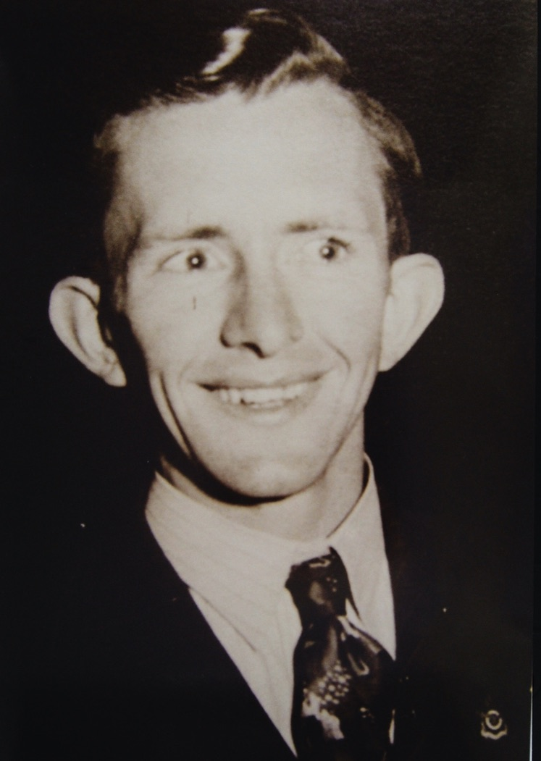

Living in Kilkenny, Colin went to school at Kilkenny SA. Colin’s mother died in 1933 when he was 7 years old and his father lost his job at the same time leading to discussion about splitting up the family. However his paternal Grandmother and aunts took in the family moving to Semaphore living at the back of a shop at 39 Semaphore Road and changing to Le Fevre School near Glanville Station.

From there Colin went to Woodville High and then got his first job in the Testing Laboratory at Adelaide Brighton Cement at Birkenhead. From Adelaide Cement, Colin started on a course at Adelaide Technical School which was part of Adelaide University when he received his call up papers in 1942. Not wanting to join the Army, Colin applied to the RAAF where he gained entrance by passing an examination in letters and numbers similar to Morse Code.  He joined the RAAF on 27 June 1944. From there Colin went to Buckland Dam training camp at the Grampians in winter and then to Point Cook Signals School to train as a telegraphist. From there Colin was sent to Darwin at North West Area headquarters at 57 mile south camp.

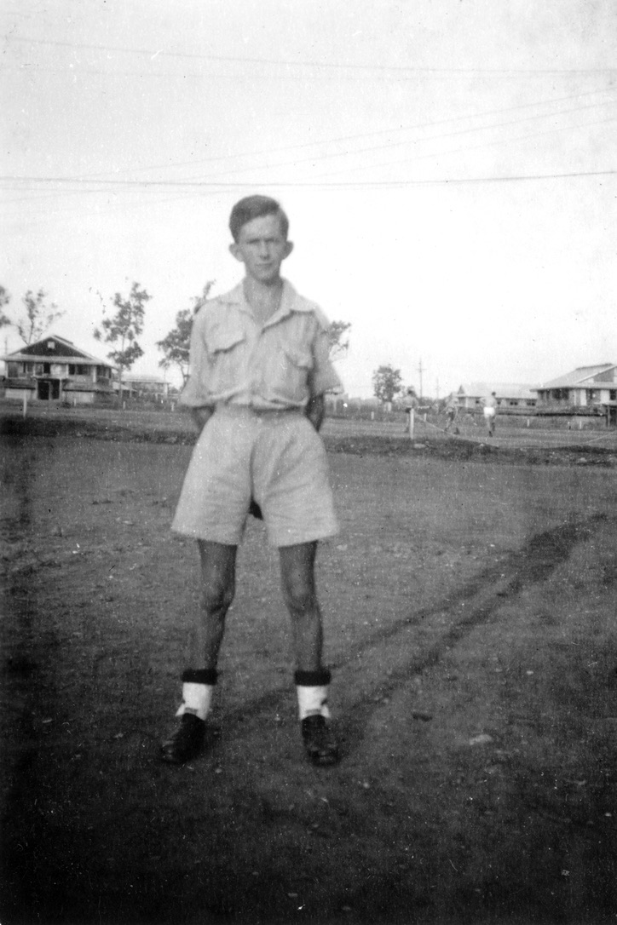

The War ended and Colin was asked if he would be interested in joining the Occupation Force in Timor. After some further training Colin was the last person to be sent to Timor travelling in a Catalina Flying Boat to West Timor arriving at Penfui aerodrome in the Capital of Kupang. Colin arrived on 2 October 1945. The next day was a surrender ceremony of the Japanese Forces at the Penfui base involving the Australian Army and the Dutch (then Netherland East Indies) Armed Forces. Attending the march past ceremony Colin was surprised to be greeted by 3 Japanese Army Officers, one of whom on sighting Colin formally saluted Colin (the photos below were taken by Colin and capture the moment).

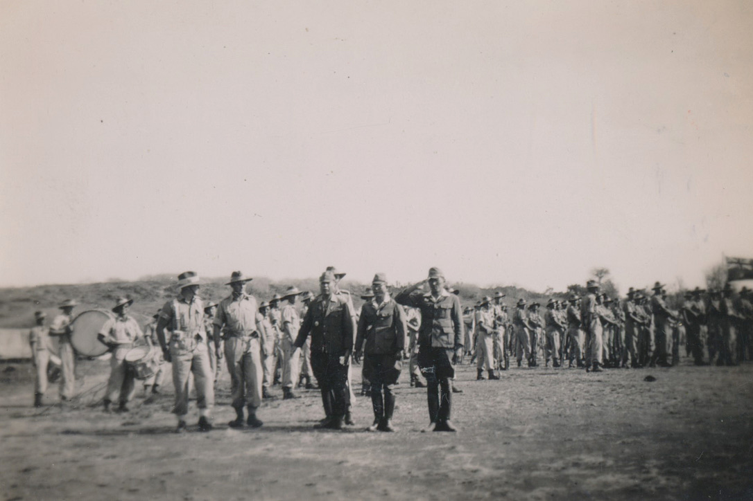 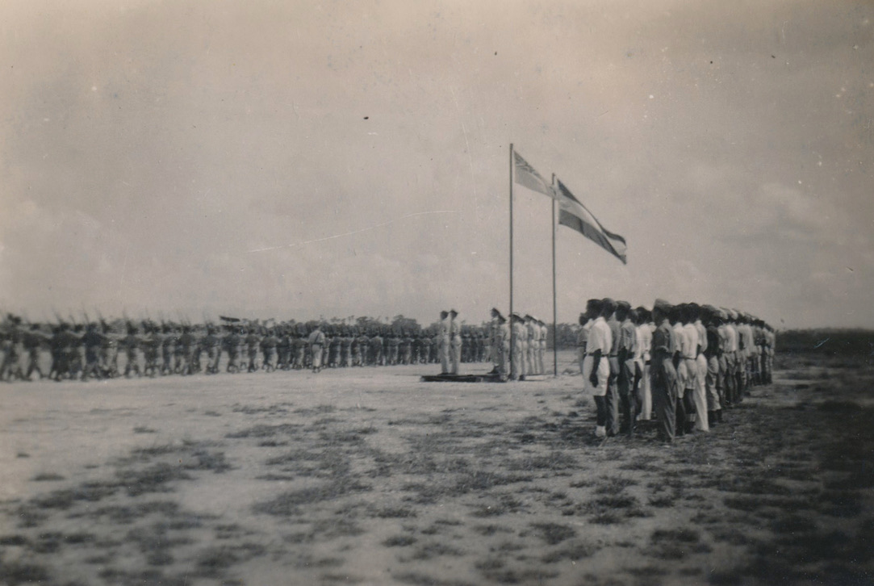

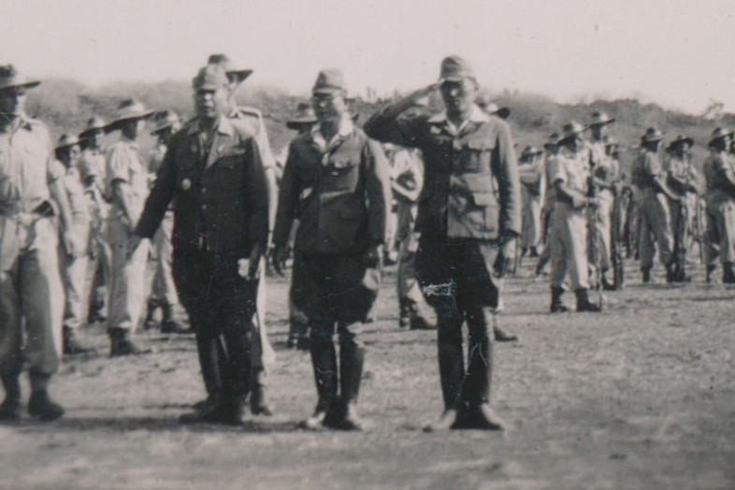

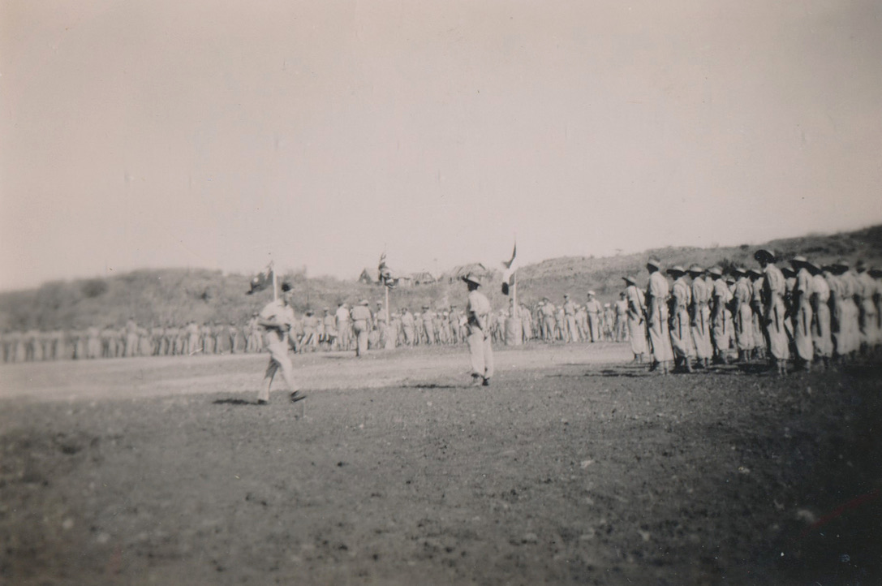 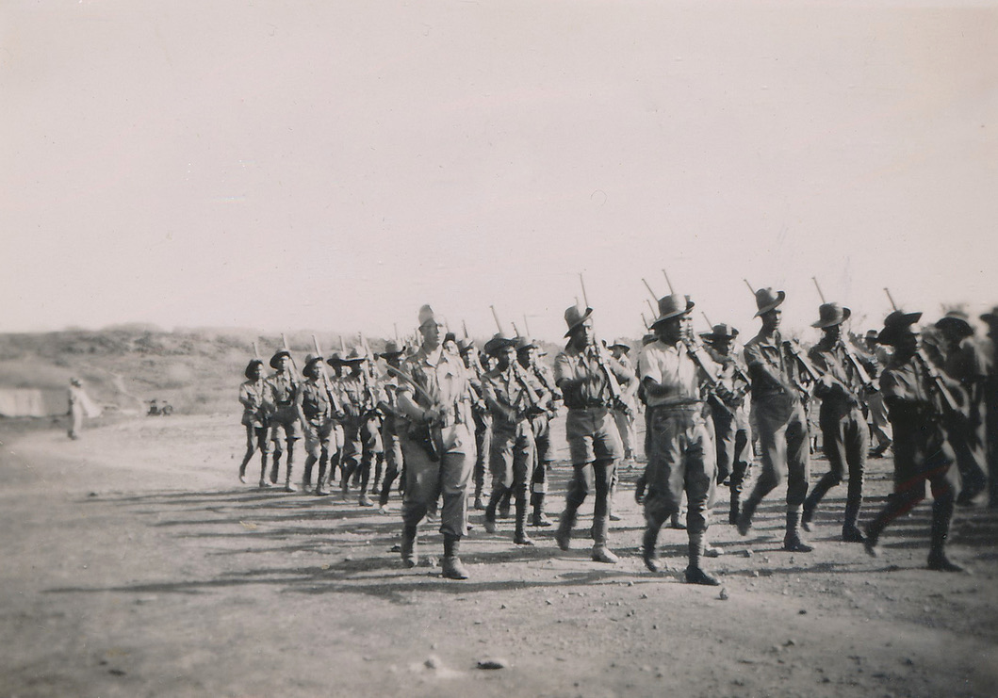

It transpired that the Japanese Naval Forces had surrendered on HMAS Moresby in September while the land forces formally surrendered at the Penfui Aerodrome 3 October 1945. Photos below show many of the different aircraft using the hanger facilities at Penfui Aerodrome during the time, as well as photo of the hanger in more modern times.

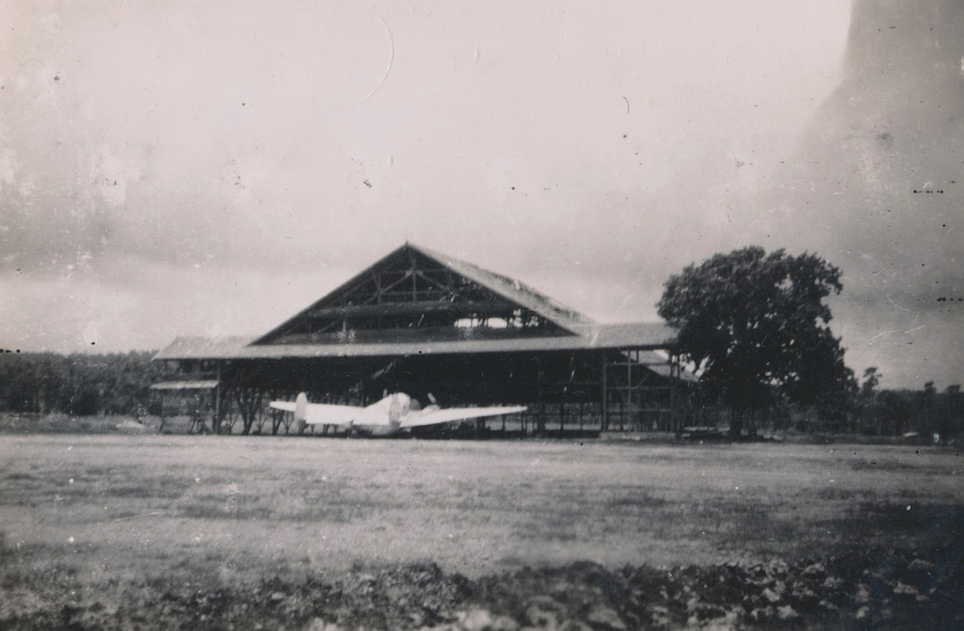 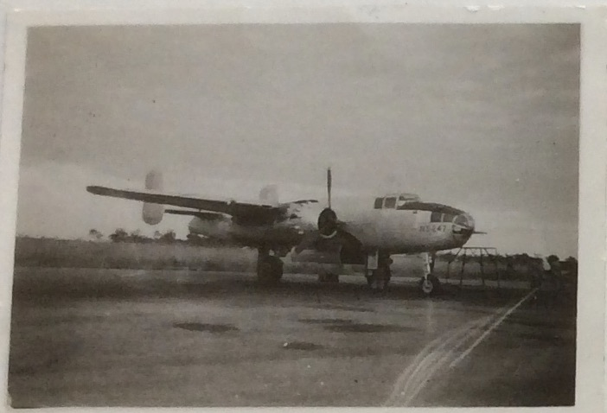 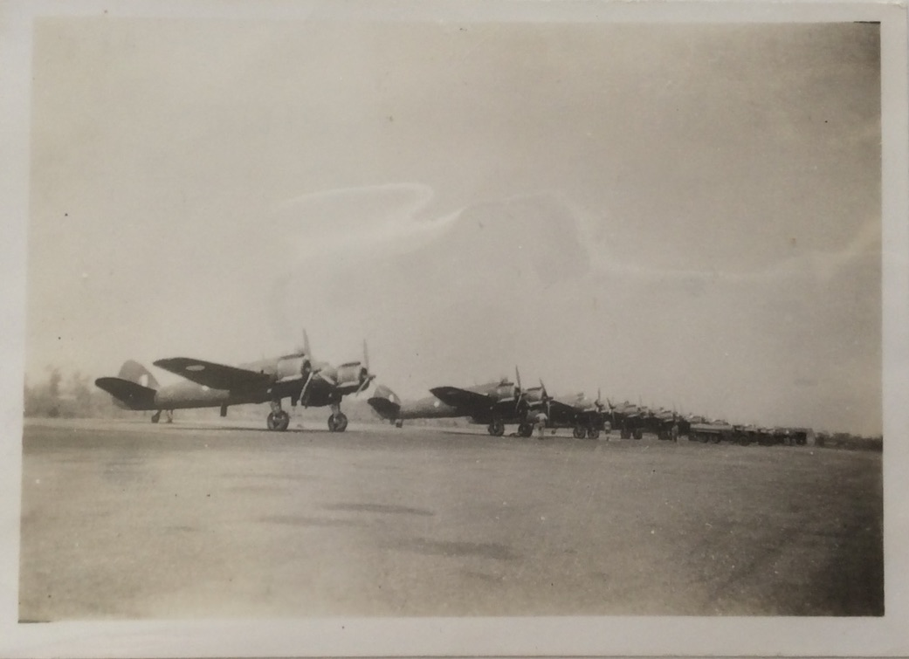

Aircraft & hanger at Penfui Mitchell B25 Bristol Beaufighter

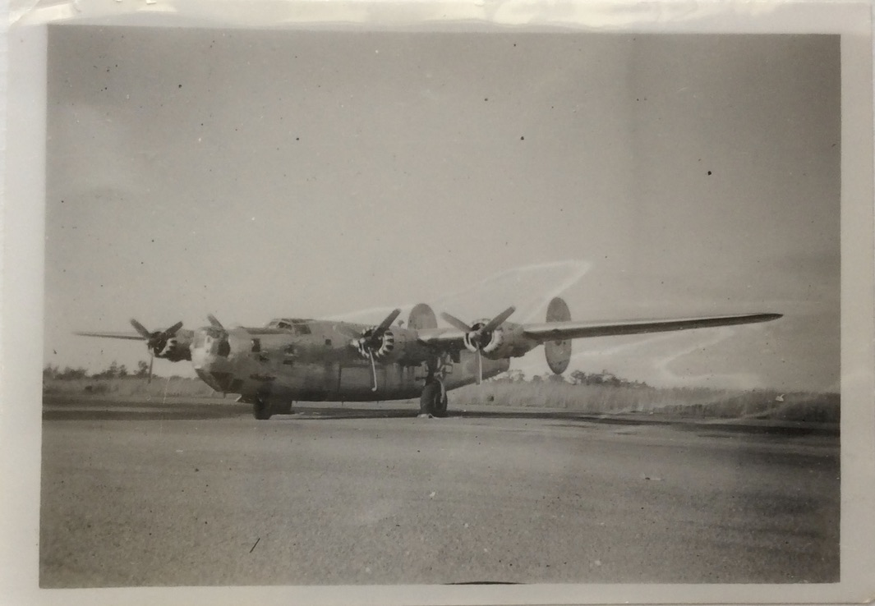 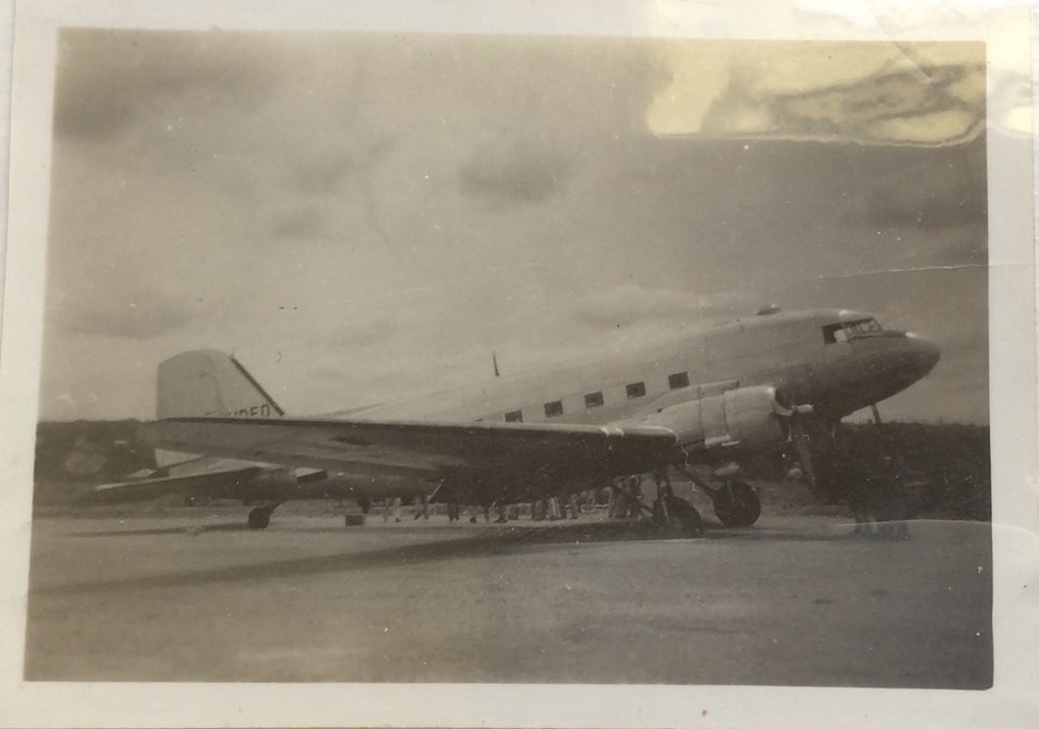 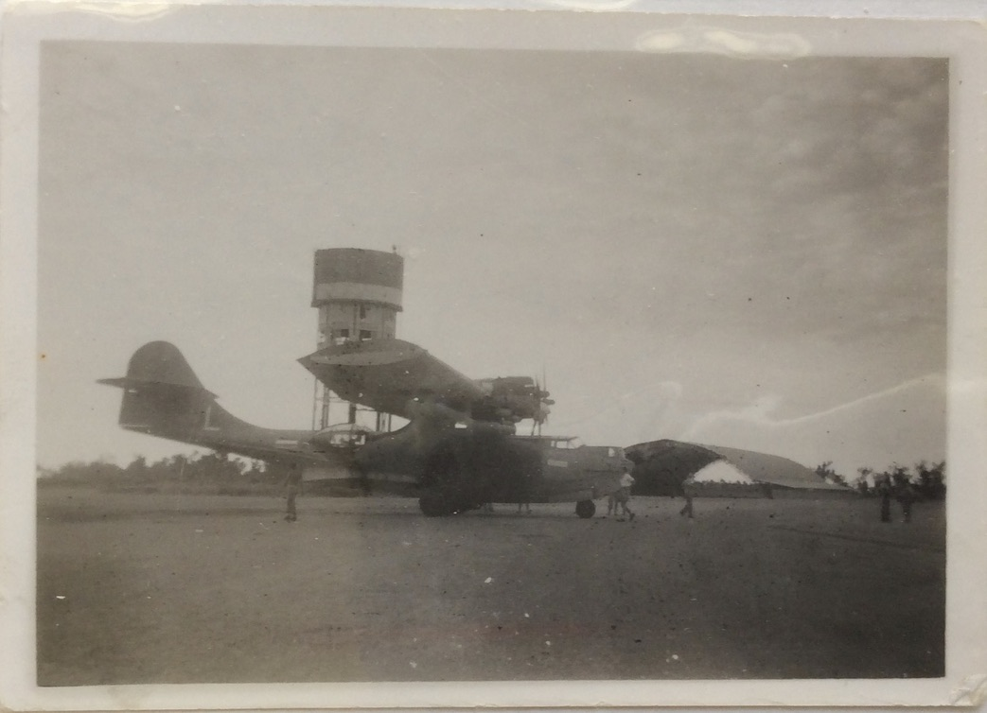

Liberator at RAAF Darwin Dutch Dakota – landed with blown tyre 22/12/45 Dutch Catalina at RAAF Darwin

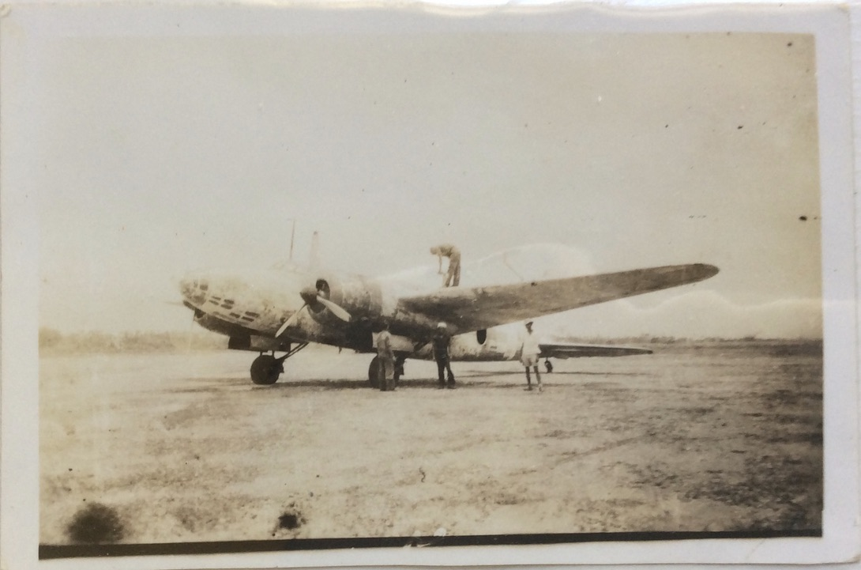 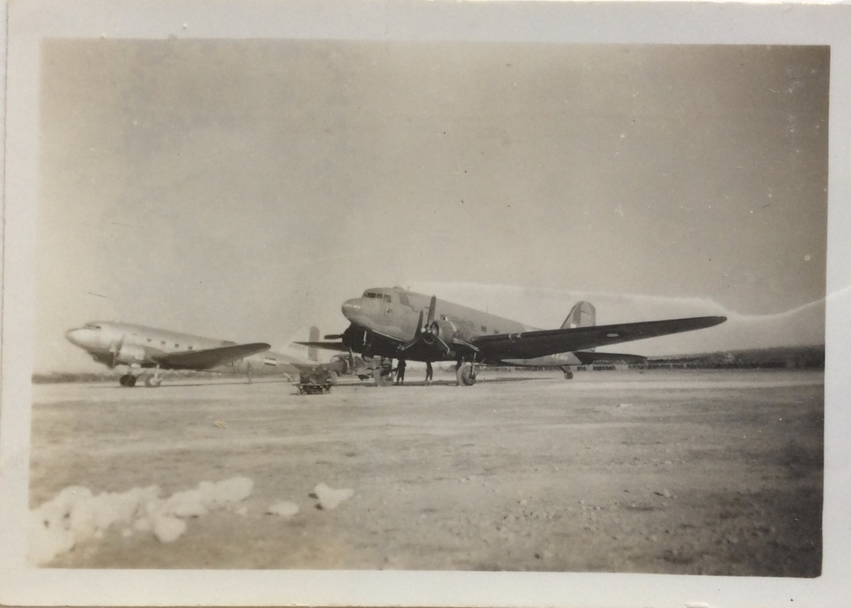 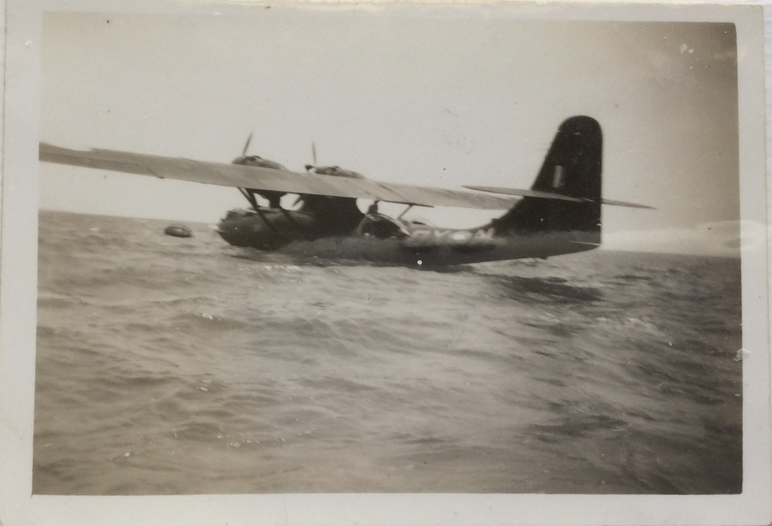

Japanese “Sally” (Tokyo Rose) 4/3/46 Dutch & RAAF Dakotas RAAF Catalina at Kupang 17/10/45

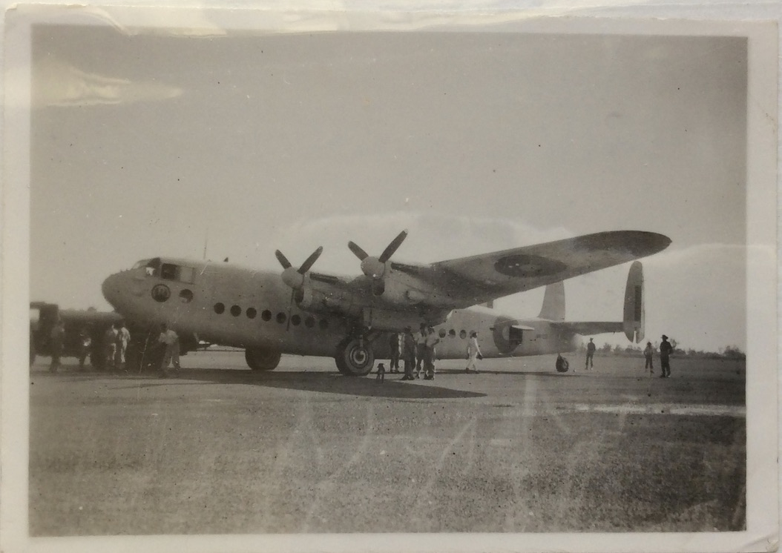 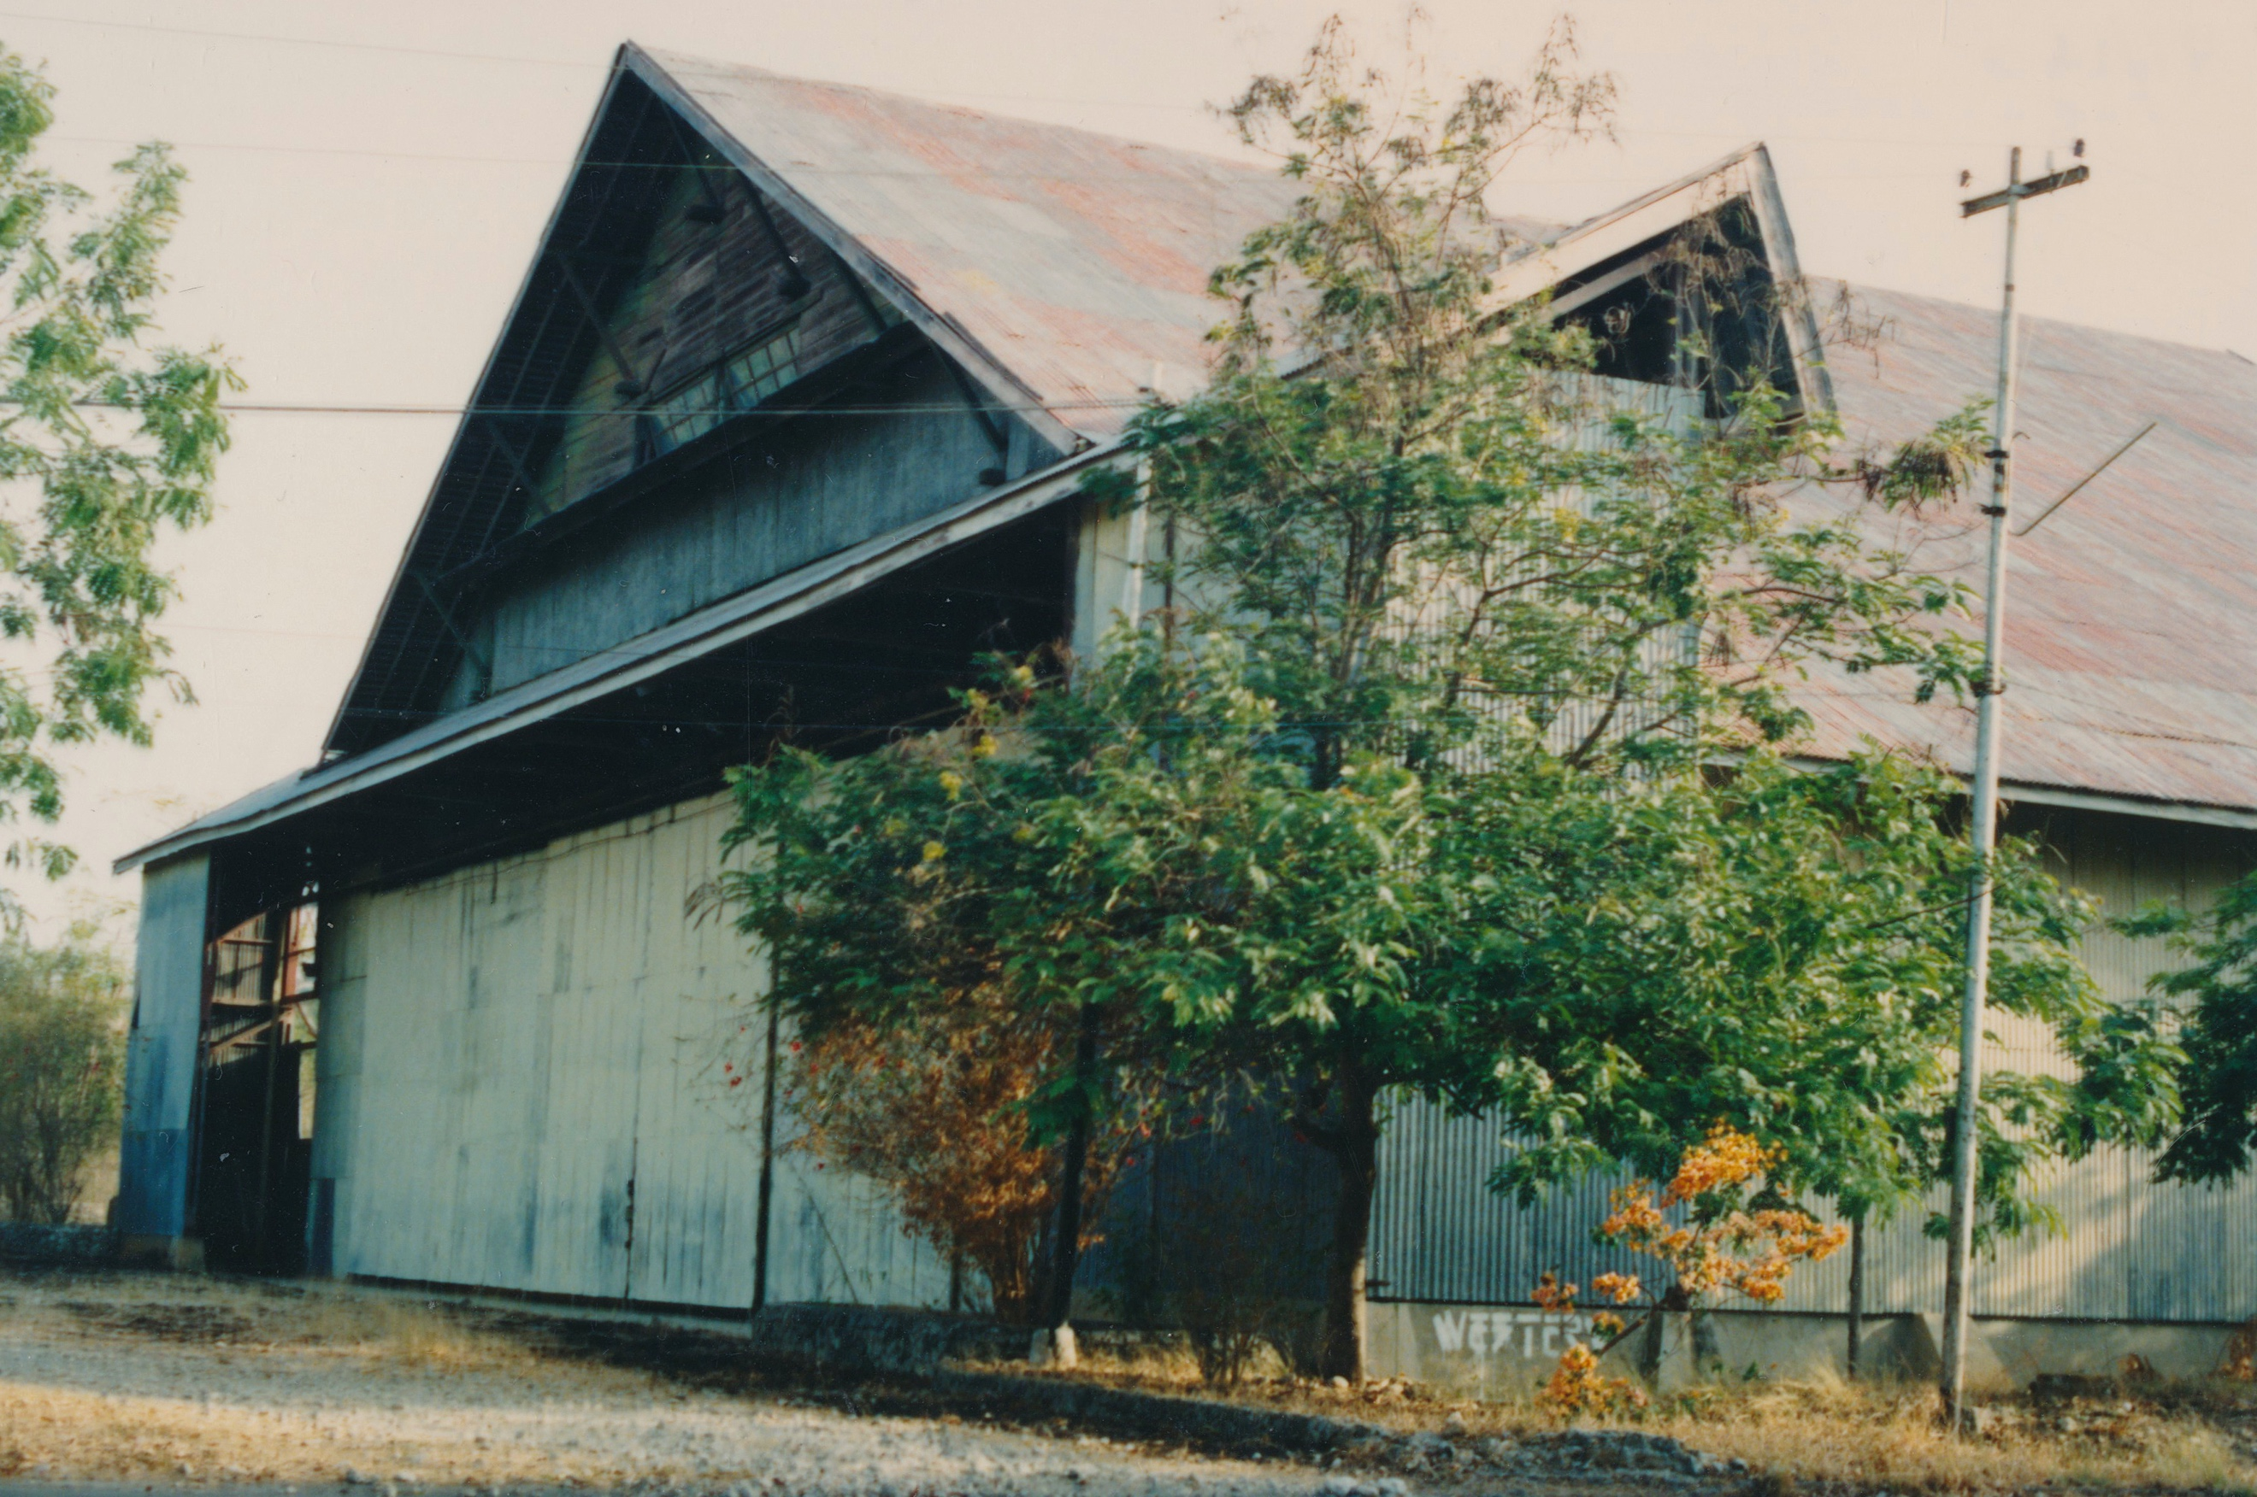

Lord Louis Mountbatten’s Avro York at Darwin Penfui Hanger in 1991

Colin stayed in West Timor for about 6 months as part of the Occupying Force.  
The main task of the Occupying Force was to assist in the repatriation of Allied Prisoners of War from the islands in the North West Pacific Area. The POWs were sent via West Timor to Australia. Colin’s role was as a Telegraphist communicating mainly with Darwin on the transport of POWs being transported on Douglas C47s (military DC3s) via the Penfui Aerodrome base. Colin’s posting to West Timor was completed in 1946 and he returned to Allied Headquarters in Darwin.

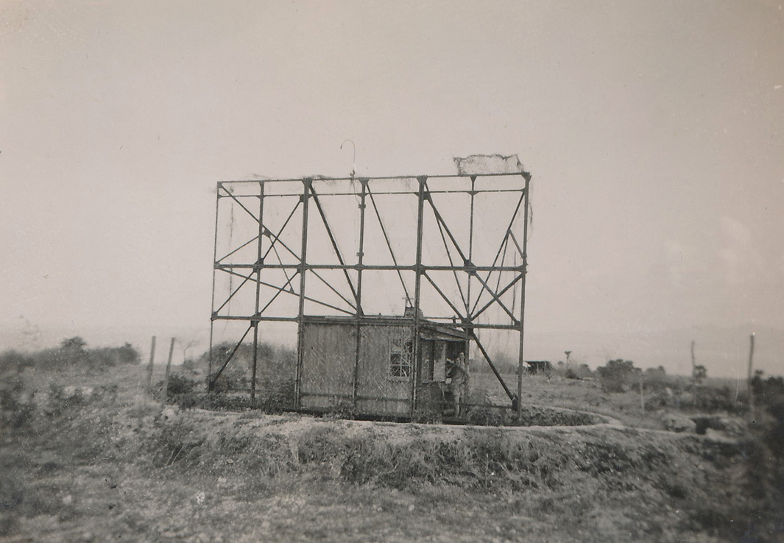 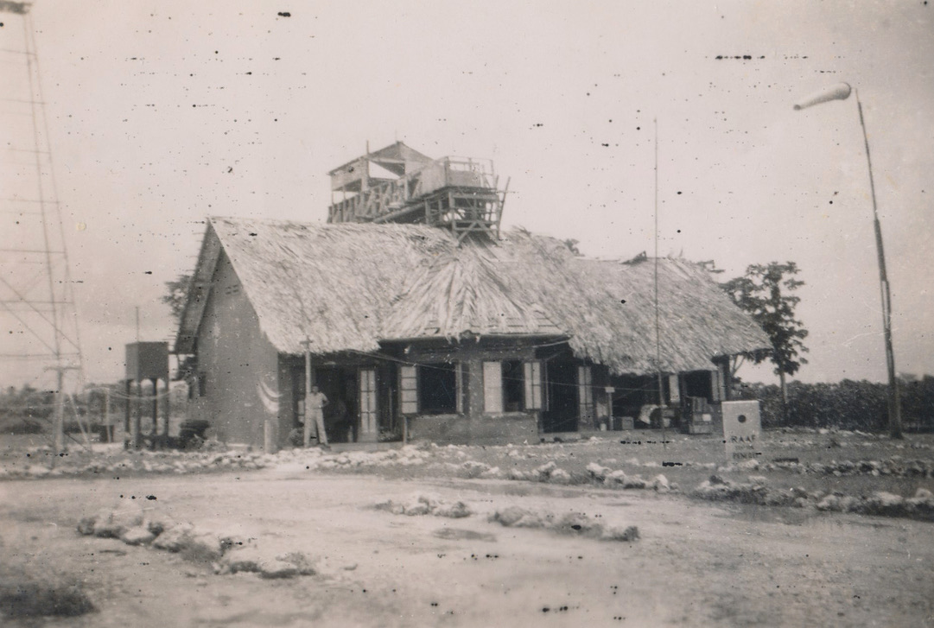

Japanese ‘radar’ Penfui Signals and aircraft control

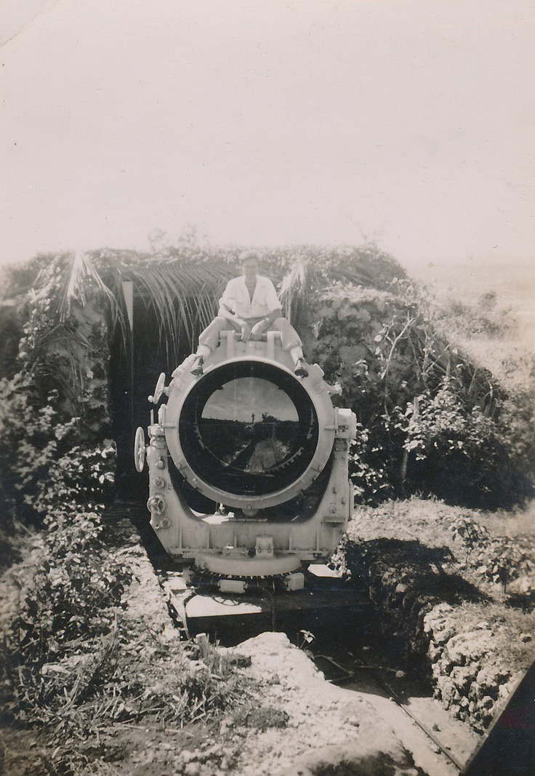 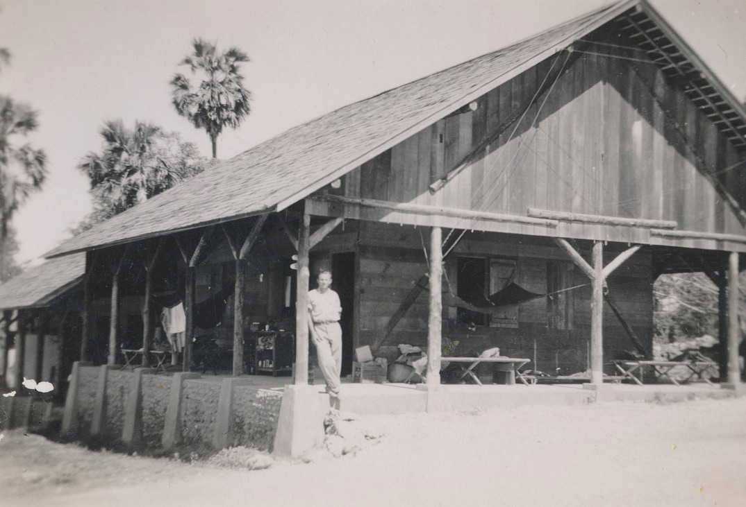 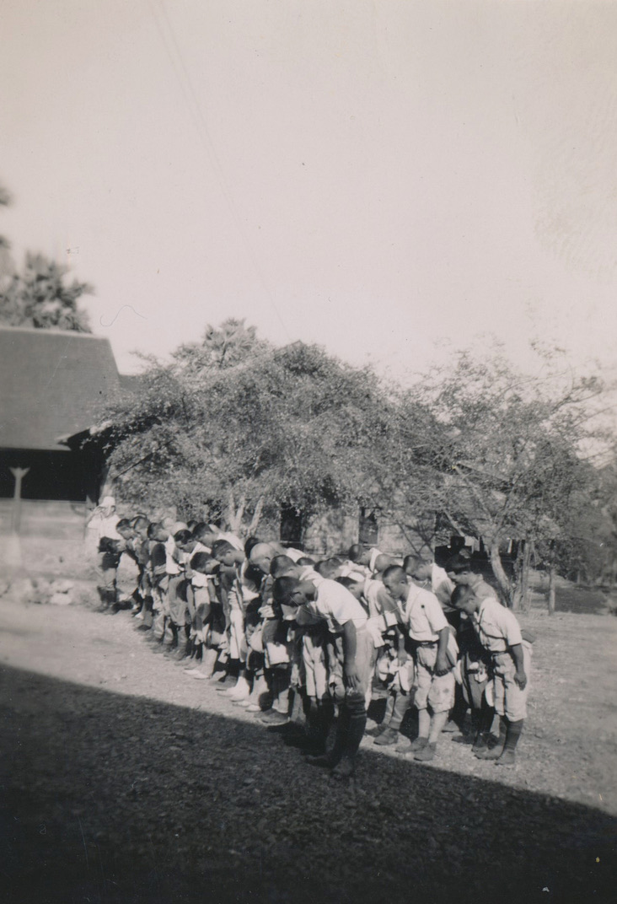

A mate sitting on Japanese searchlight Penfui hut accommodation Penfui Japanese bow to flag

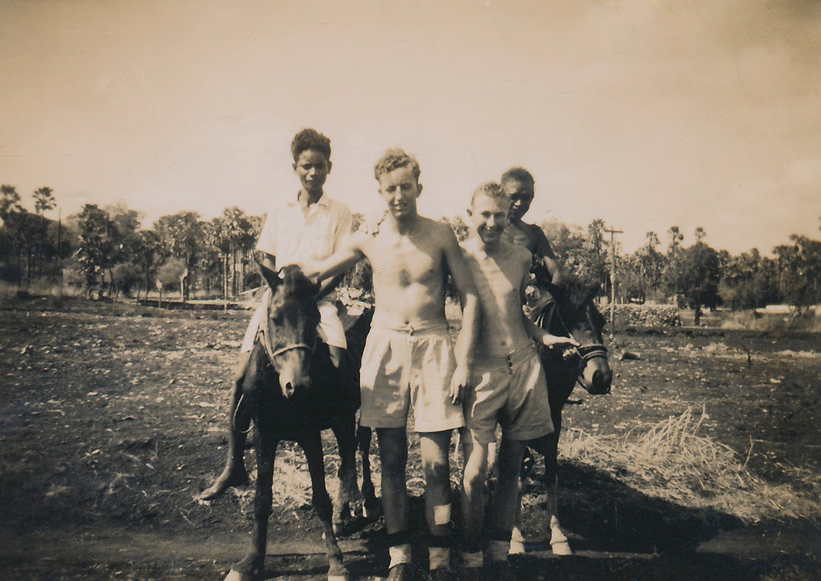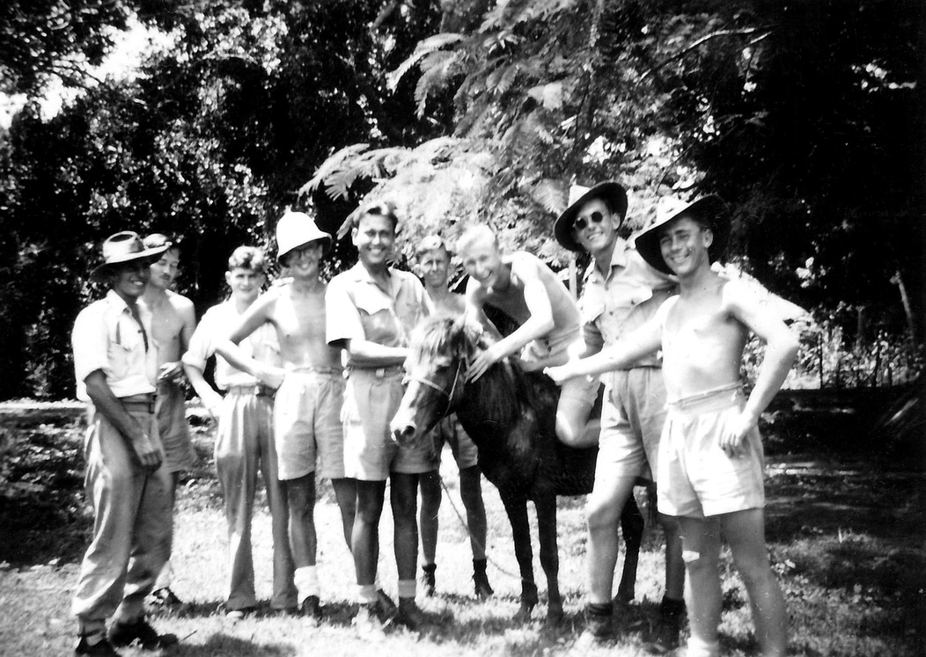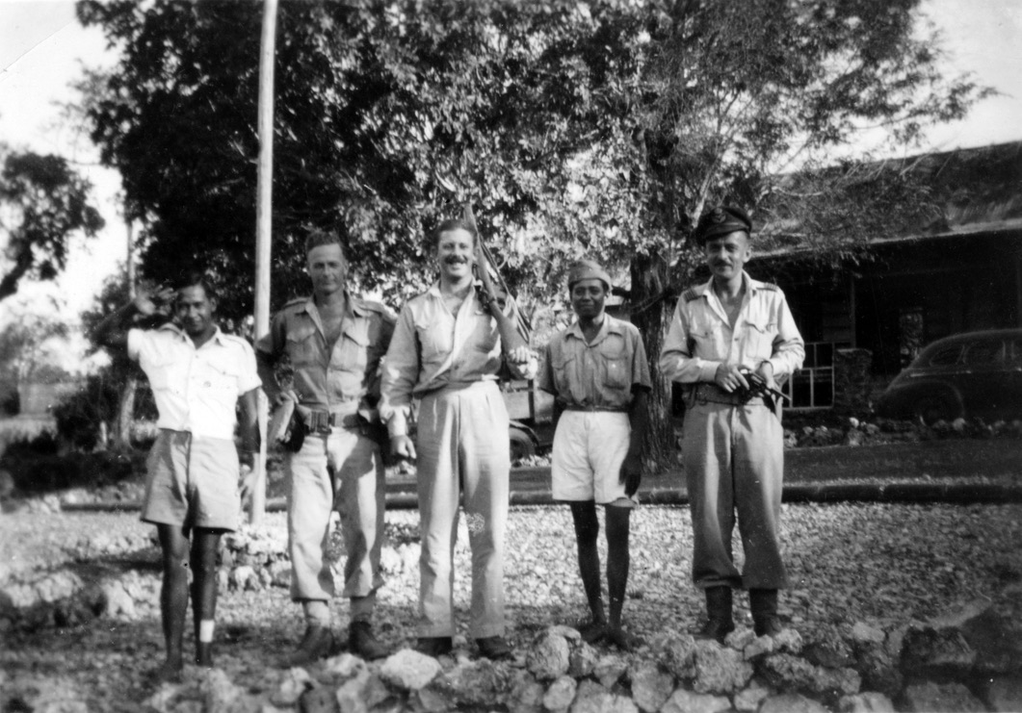

Two boys and ponies Walk with Timor pony - Colin 6th from left Vandersluys, Rofe, O’Mahoney

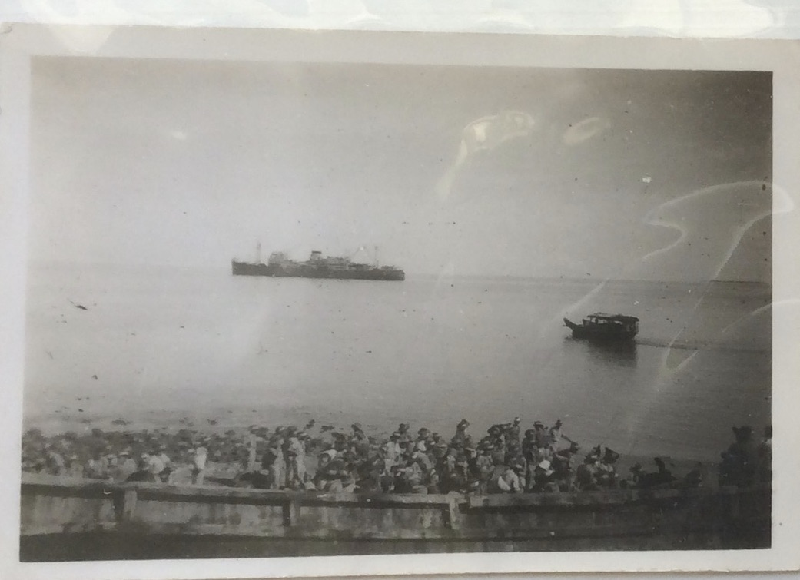

HMAS “Manoora” & Japanese Barge at Kupang when AIF & RAAF Departed Timor 19/3/46

Colin returned to Australia on HMAS “Manoora”

After the War Colin joined the Post Master General’s Department as a trainee technician involved with the installation of telephone exchanges. His first position was at Melrose in SA which at that time utilised magneto driven telephones. After many calls to places such as Orroroo SA Colin was promoted to a Senior Technical Officer and eventually retired having completed 46 years in the PMG and marrying Violet May Pitt who passed away on Sept 25 1957 after the birth of Margaret Anne in August 1957. Colin then married Laurel Gwen Pengilly (1924-2008) in December 1958. They had two son Peter (1960) and Malcolm (1964)

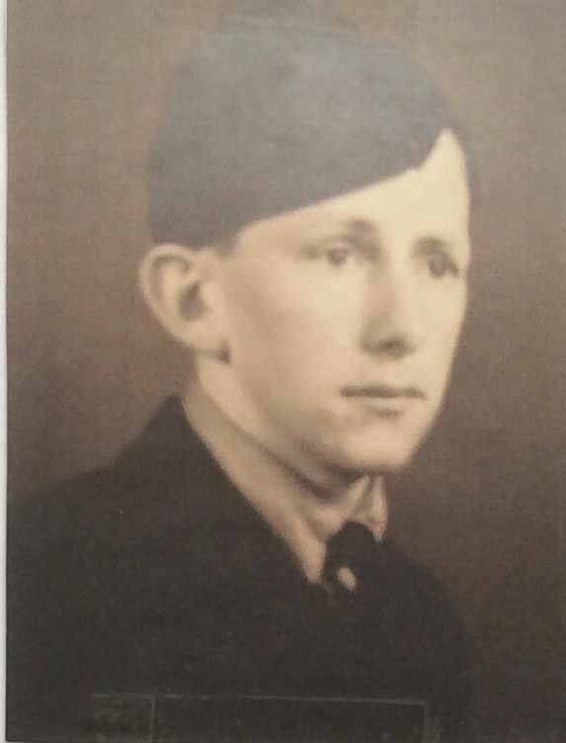

Colin RAAF 1944/1945

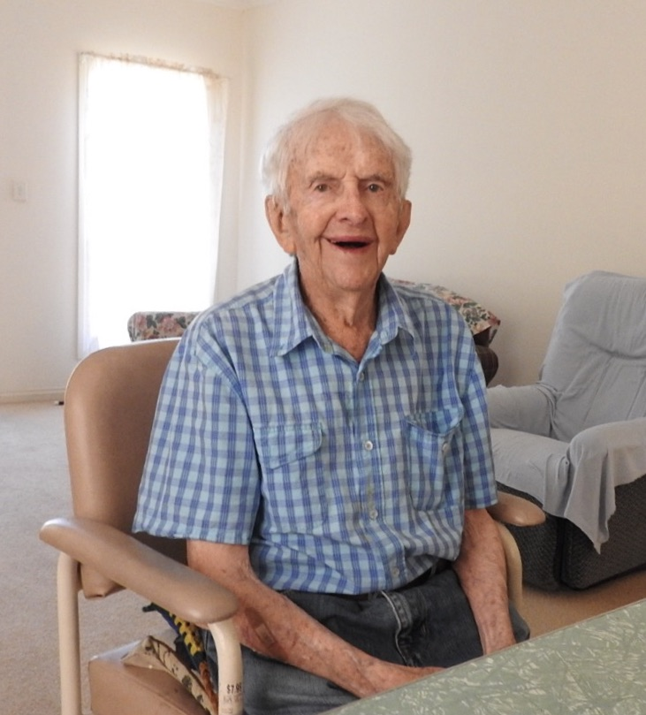

Colin February 3, 2021

*February 3, 2021*