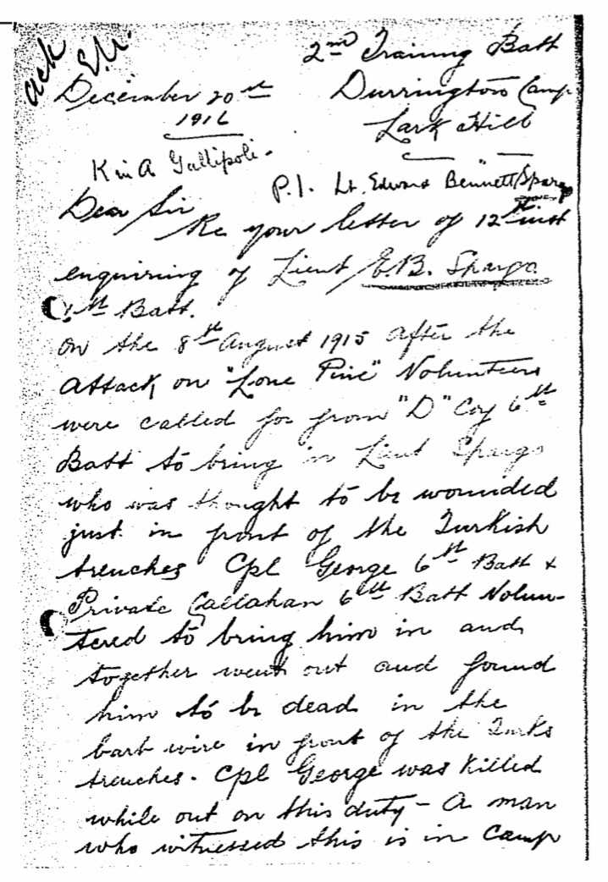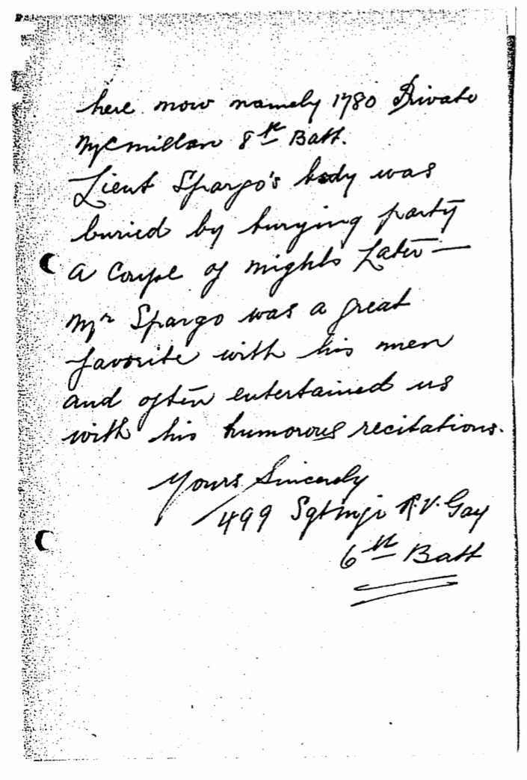

TRANSCRIPT
December 20th 1916
2nd Training Battalion
Durrington Camp
Lark Hill
Killed @ Gallipoli P.I. Lt. Edward Bennett Spargo
Dear Sir,
RE your letter of 12th [unclear] enquiring of Lieutenant E.B. Spargo 6th Battalion.
On the 8th of August 1915 after the attack on “Lone Pine” volunteers were called for from “D” Company 6th Battalion to bring in Lieutenant Spargo who was thought to be wounded just in front of the Turkish trenches. Corporal George 6th Battalion and Private Callahan 6th Battalion volunteered to bring him in and together went out and found him to be dead in the barb wire in front of the Turks tranches. Corporal George was killed while out on this duty. A man who witnessed this is in Camp here now namely 1780 Private McMillan 8th Battalion. Lieutenant Spargo’s body was buried by burying party a couple of nights later—Mr Spargo was a great favourite with his men and often entertained us with his humorous recitations.

Yours Sinerely
499 Sgt Major R.V. Gay 6th Battalion

